

CODE OF PRACTICE

Road and traffic management at Western Australian mines

**Disclaimer**

The information contained in this publication is provided in good faith and believed to be reliable and accurate at the time of publication. However, the information is provided on the basis that the reader will be solely responsible for assessing the information and its veracity and usefulness.

The State shall in no way be liable, in negligence or howsoever, for any loss sustained or incurred by anyone relying on the information, even if such information is or turns out to be wrong, incomplete, out-of-date or misleading.

In this disclaimer:

**State** means the State of Western Australia and includes every Minister, agent, agency, department, statutory body corporate and instrumentality thereof and each employee or agent of any of them.

**Information** includes information, data, representations, advice, statements and opinions, expressly or implied set out in this publication.

**Loss** includes loss, damage, liability, cost, expense, illness and injury (including death).

**Citation**

The recommended citation for this publication is:

Department of Energy, Mines, Industry Regulation and Safety, 2025, Traffic management for Western Australian mines – Code of practice: Resources Safety, Department of Energy, Mines, Industry Regulation and Safety, Western Australia, 35 pp.

© Government of Western Australia (Department of Energy, Mines, Industry Regulation and Safety) 2025

The Department of Energy, Mines, Industry Regulation and Safety supports and encourages the dissemination and exchange of its information. The copyright in this publication is licensed under a Creative Commons Attribution 4.0 International (CC BY) licence.

Under this licence, you are free, without having to seek our permission, to use this publication in accordance with the licence terms.

We also request that you observe and retain any copyright or related notices that may accompany this material as part of the attribution. This is also a requirement of the Creative Commons Licences.

For more information on this licence, visit creativecommons.org/licenses/by/4.0/legal code.

This publication is available on request in other formats for people with special needs.

Further details of resources safety publications can be obtained by contacting:

Department of Energy, Mines, Industry Regulation and Safety

100 Plain Street

EAST PERTH WA 6004

Telephone: +61 8 9358 8001 (general queries)

+61 8 9358 8154 (publication orders)

NRS: 13 36 77

Email: ResourcesSafety@dmirs.wa.gov.au (general queries)

SafetyComms@dmirs.wa.gov.au (publication orders)

**Acknowledgement**

This code of practice was developed with the assistance of mine operators, industry groups, other regulators and agencies, original equipment manufacturers (OEMs) and suppliers.

# Foreword

## Basis for code of practice

An approved code of practice is a practical guide to achieving the standards of health, safety and welfare required under the WHS Act and the Work Health and Safety (Mines) Regulations 2022 (WHS Mines Regulations).

A code of practice applies to anyone who has a duty of care in the circumstances described in the code. In most cases, following an approved code of practice will achieve compliance with the health and safety duties in the work health and safety laws in relation to the subject matter of the code. Like regulations, codes of practice deal with particular issues and do not cover all hazards or risks that may arise. The health and safety duties require duty holders to consider all risks associated with work, not only those for which regulations and codes of practice exist.

Codes of practice are admissible in court proceedings under the WHS Act and WHS Mines Regulations. Courts may regard a code of practice as evidence of what is known about a hazard, risk, risk assessment or risk control and may rely on the code in determining what is reasonably practicable in the circumstances to which the code of practice relates. For further information, see the [Interpretive guideline: How to determine what is reasonably practicable to meet a health and safety duty.](https://www.wa.gov.au/system/files/2021-11/211100_GL_PCBU_0.pdf)

Compliance with the WHS laws may be achieved by following another method, such as a technical or an industry standard, if it provides an equivalent or higher standard of work health and safety than the code.

An inspector may refer to an approved code of practice when issuing an improvement or prohibition notice.

## Scope and application

This code provides guidance for a person conducting a business or undertaking on meeting the requirements of the WHS Mines Regulations in relation to establishing and implementing a traffic management plan.

For more information regarding PCBUs, see the [Interpretive guideline: The meaning of ‘person conducting a business or undertaking’ (PCBU)](https://www.wa.gov.au/system/files/2021-11/211100_GL_PCBU_0.pdf).

It is designed to provide guidance on:

* Establishing a risk management process for operating mobile plant
* Developing a principal mining hazard management plan (traffic management plan)
* Defining principles for haul road design
* Defining haul road maintenance standards
* Establish principles for the selection, operation and maintenance of powered mobile plant

The code focuses on using the risk management process and ensuring effective traffic management controls are used within any applicable workplace.

## Who should use this code of practice?

This code of practice should be used by those who have functions and responsibilities for planning, designing, implementing, and maintaining roads or vehicle operations on a mine site. It may also be useful for supervisors, operations personnel, and safety and health representatives who need to understand the responsibilities associated with traffic management procedures.

## How to use this code of practice

This code of practice includes references to both mandatory and non-mandatory actions. The words “must”, “requires” or “mandatory” indicate a legal requirement exists that must be complied with. The word “should” is used to indicate a recommended course of action, while “may” is used to indicate an optional course of action.

# Contents

Foreword 3

Basis for code of practice 3

Scope and application 3

Who should use this code of practice? 4

How to use this code of practice 4

Contents 5

1 Introduction 7

1.1 What are the key considerations for road and traffic management at a mine site? 7

1.2 Who has health and safety duties for road and traffic management at a mine site? 7

1.3 What is involved in managing risks associated with road and traffic management? 8

1.4 Principal mining hazard management…………………………………………………………..9

2. Road and traffic management controls and considerations 10

**2.1** **Systems (regulations)** 10

2.1.1 Traffic management plan 11

2.1.2 Site access 11

2.1.3 Driving rules 12

2.1.4 Speed management 13

2.1.5 Communication 13

2.1.6 Access into restricted areas 14

2.1.7 Management of single-lane sections 14

2.1.8 Escorting 15

2.1.9 Journey management 15

2.1.10 Environmental conditions 15

2.1.11 Incident reporting…………………………………………………………………………….15

2.1.12 Change management 16

**2.2** **Roads (infrastructure**) 16

2.2.1 Safety in design – mine design and pre-planning 16

2.2.2 Mine road types 18

2.2.3 Safety in design – mine road design and construction 19

2.2.4 Safety in design – underground specific precautions 20

2.2.5 Traffic signs 22

2.2.6 Road delineation 22

2.2.7 Road structural design and construction 23

2.2.8 Road maintenance 25

2.2.9 Parking areas 26

2.2.10 Lighting………………………………………………………………………………………..27

2.2.11 Other traffic management devices/measures 27

**2.3** **Users (operators and pedestrians)** 27

2.3.1 Information, training, instruction and supervision 27

2.3.2 Pedestrian management 30

2.3.3 Health consideration for traffic management planning 30

**2.4** **Vehicles (mobile equipment)** 34

2.4.1 Safety in design – mobile plant sélection 34

2.4.2 Mobile plant (vehicle) operating practices 39

2.4.3 Mobile plant maintenance 43

2.4.4 Underground mobile plant standards 47

2.4.5. Mobile autonomous systems in mining operations 48

3. Road Design 50

3.1 Separation/segregation of vehicles 50

3.2 Road Widths 50

3.3 Cross fall/camber 52

3.4 Road alignment (horizontal and vertical curvature) 53

3.5 Superelevation 56

3.6 Grade 57

3.7 Drainage 59

3.8 Intersections 60

3.9 Windrows 66

4. Traffic signs 72

5. Design of parking facilities 74

6. Roads in the vicinity of powerline crossings and roads in the vicinity of infrastructure 76

7. Buried services 78

8. Emergency management 79

9 Monitor and review 80

9.1 Monitoring 80

9.2 Audit……………………………………………………………………………………………... 80

9.3 Review 81

Appendices 82

**Appendix 1** – **Legislative provisions** **82**

**Appendix 2** – **Selected standards** **83**

**Appendix 3** – **Further information and guidance** **84**

**Appendix 4** – **Glossary** **85**

**Appendix 5** – **Recommended content of a site traffic management plan (TMP)** **86**

**Appendix 6** – **General information** **87**

What are the key considerations for road and traffic management at a mine site? 87

Who has health and safety duties for road and traffic management at a mine site? 87

What is involved in managing risks associated with road and traffic management? 93

Information, training, instruction and supervision 95

**Appendix 7** **The risk management process** **97**

Identify the hazards 98

Principal mining hazard management 102

Developing a principal mining hazard management plan 104

PMHMP Review 106

Roads and other areas where mobile plant operate 107

Safety in design 109

# 1 Introduction

## 1.1 What are the key considerations for road and traffic management at a mine site?

Road and traffic management must encompass the design and characteristics of roads, the vehicles selected for operations, operating procedures, training and competency of operators and interactions between mobile plant, other plant and pedestrians.

Under the Work Health and Safety (Mines) Regulations 2022 (WHS Mines Regulations) roads and other areas where mobile plant operate are a principal mining hazard. Principal mining hazard management plans must be developed in order to manage these risks as part of the mine safety management system (MSMS) for the mine.

Controls must be developed to eliminate or reduce interactions between different types of vehicles and mobile plant, interactions between mobile plant and fixed plant and structures, and between mobile plant and pedestrians.

Under the WHS laws, transport infrastructure, such as temporary or permanent roads or pathways constructed, are considered to be structures.

With regard to traffic management, powered mobile plant is defined as any machinery, equipment, appliance, container, implement or tool, or any component and fitting, which is provided with some form of self-propulsion.

## 1.2 Who has health and safety duties for road and traffic management at a mine site?

There are several duty holders who have a role in managing the risks of roads and traffic at mine sites. These include:

* persons conducting a business or undertaking (PCBUs), including the mine operator
* PCBUs involving the management or control of fixtures, fittings or plant
* designers, manufacturers, importers and suppliers of plant, substances or structures
* installers, constructors and commissioners of plant, substances or structures
* WHS service providers
* officers
* workers
* other persons at the workplace

Workers and other persons at the workplace also have other duties under the WHS Act, such as the duty to take reasonable care for their own health and safety at the workplace.

Workers who carry out work for the business or undertaking are entitled to be consulted if they are (or are likely to be) directly affected by a health and safety matter. The definition of “workers” includes contractors and subcontractors and their employees, on-hire workers, outworkers, apprentices, trainees, work experience students, volunteers and other people who are working for the PCBU. This duty to consult is based on the recognition that worker input and participation improves decision-making about health and safety matters and assists in reducing work-related injuries, diseases and illnesses.

Workers are entitled to be represented in consultations by a health and safety representative who has been elected to represent their work group.

A person can have more than one duty, and more than one person can have the same duty at the same time.

For further information about the roles of the duty holders to manage the risks of road and traffic at mine sites, see Appendix 6.

## 1.3 What is involved in managing risks associated with road and traffic management?

**WHS Mines Regulations Part 3.1 r. 32–38**

Managing risks to health and safety

**WHS Mines Regulations r. 203**

Management of risks to health and safety

**WHS Mines Regulations r. 631**

Movement of mobile plant

Road and traffic operations may present a risk of injury from:

* contact or collision with other plant, structures or people
* falls from height or falling objects
* being trapped or caught between
* fires/explosion
* failure to maintain plant (such as steering, braking)
* tyre maintenance activities
* uncontrolled release of energy
* environmental conditions or extreme weather
* occupational exposures (noise, vibration, dust, chemical and fumes like diesel particulate or silica dusts)
* fatigue, drugs, alcohol, or
* psychosocial hazards (such as high job demands, remote or isolated work, or poor physical environments).

As a PCBU, you must manage the risks by using the following systematic processes:

* identify hazards – find out what could cause harm
* assess risks—understand the nature of the harm that could be caused by the hazard, how serious the harm could be and the likelihood of it happening. This step may not be necessary if you are dealing with a known risk with known controls
* eliminate risks, so far as is reasonably practicable
* control risks – if it is not reasonably practicable to eliminate the risk, minimise the risk by implementing the most effective control measures that are reasonably practicable in the circumstances in accordance with the hierarchy of control measures, and ensure they remain effective over time
* review control measures to ensure they are working as planned.

This code provides guidance on how to manage the risks associated with road and traffic design and conditions by following the hierarchy of control measures.

Further guidance on the risk management process is in the [Code of Practice: How to manage work health and safety risks](https://www.worksafe.wa.gov.au/publications/code-practice-how-manage-work-health-and-safety-risks).

### See Appendix 6 for guidance on specific requirements for risks associated with road and traffic management:

* psychosocial
* consulting workers
* consulting, cooperating and coordinating activities with other duty holders
* information, training, instruction and supervision.

**1.4 Principal mining hazard management**

**WHS Mines Regulations r. 627**

Identification of principal mining hazards and conduct of risk assessments.

A principal mining hazard (PMH) is any activity, process, procedure, plant, structure, substance, situation or other circumstance relating to the carrying out of mining operations that has a reasonable potential to result in multiple fatalities. These may be in a single incident or a series of recurring incidents.

PMHs have been identified in legislation for special consideration because they are hazards that have the potential to cause an incident with very serious consequences, even when the likelihood of that incident occurring may be low.

The management of PMHs is an important component of the MSMS, as they require special consideration due to the potential to create incidents with serious consequences.

Further guidance on principal mining hazard requirements is available in the [Code of practice: Mine safety management system](https://www.worksafe.wa.gov.au/publications/code-practice-mine-safety-management-system).

For further information about principal mining hazard management, see Appendix 7.

# 2. Road and traffic management controls and considerations

This code of practice promotes the use of a systematic approach to addressing road and traffic management risks on mining operations in Western Australia by considering the four key elements: **systems (regulations), roads (infrastructure), users (operators and pedestrians)** and **vehicles (mobile equipment)**.

**WHS Mines Regulations r. 5C**

Meaning of mine operator

**WHS Mines Regulations r. 7A**

References to person conducting a business or undertaking includes references to mine operators

**WHS Mines Regulations r. 34**

Duty to identify hazards

**WHS Mines Regulations r. 35**

Managing risks to health and safety

**WHS Mines Regulations r. 36**

Hierarchy of control measures

**WHS Mines Regulations r. 37**

Maintenance of control measures

**WHS Mines Regulations r. 38**

Review of control measures

**WHS Mines Regulations r. 297**

Management of risks to health and safety

**WHS Mines Regulations r. 617**

See also regulations 631, 631A, 631B, 631C, 631D, 635, 640, 641, 641A, 642A, 643A, 646, 657, 658 and 675EA in relation to complying with this regulation

**WHS Mines Regulations r. 621**

Duty to establish and implement mine safety management system

**WHS Mines Regulations r. 621A**

General requirements for mine safety management system

## 2.1 Systems (regulations)

The systems, procedures and plans used to manage the risks posed by hazards are used to define the safe systems of work and are important elements of the MSMS. Depending on the nature of the mine and how the MSMS is structured, the systems, procedures and plans may exist in other documents and manuals that are referenced within the MSMS.

Procedures and work instructions are developed to provide guidance and document the safe system of work, by analysing an activity into clearly understood steps, conducting a risk assessment and developing a method of carrying out the activity in a safe and desired manner. Procedures provide guidance to everyone who uses them and help achieve consistent quality and a safe method of carrying out a task.

While developing procedures, consideration should be given to the following:

* considering all available information, including documents from the designer, manufacturer, supplier and/or constructor of plant and equipment
* consulting with persons who will use the procedure
* using language that is easy to understand.

Where work instructions or procedures are inadequate or do not exist, such as new plant or change in task sequence, the mine operator must implement a change management and task-based risk assessment process that provides workers with the ability to assess the tasks they are completing and suggest changes within the task to further reduce the risks. The change management and task-based risk assessment process must be authorised by the statutory supervisor as a minimum.

The task-based risk assessment should then be utilised to develop a safe system of work in consultation with the workers.

## 2.1.1 Traffic management plan

Traffic management documentation does not, on its own, mitigate the risks associated with the known hazards of vehicular interactions. Vehicle dangers present one of the greatest risks to personnel and equipment at mines. Well planned and effective traffic management can help to reduce these risks. A site-specific Traffic management plan (TMP) should be developed and approved by the site senior executive.

Preparation of a detailed TMP and Principal mining hazard management plan (PMHMP) along with implementation of measures identified in the approved plans is essential to ensure the safety of all workers at site.

TMPs are a fundamental component of integrated traffic management systems and are an important tool for improving traffic safety. They should be developed as high-level documents that provide a repository and a reference point for various operational documents that regulate traffic activities in an organisation or on an operation.

In order to be effective, TMPs have to cover all four key components of the transport design: systems, roads, users and vehicles.

A TMP should be regularly monitored and reviewed to ensure it is effective and considers changes at the workplace.

For further information about TMPs, see Appendix 5.

## 2.1.2 Site-access

The site must outline the approach to prevent access to unauthorised vehicles and persons. This should include members of local communities, and traffic relating to adjacent operations. Where appropriate, and deemed required following a risk assessment, prevention of unauthorised or inadvertent access should be implemented by providing effective signage, security fences, gates, earth bunding or similar physical barriers.

The following standards should be implemented to maintain mine access roads:

* access restriction, security and danger signage displayed at the start of the mine access road
* speed and traffic control signs displayed along the access road
* directions signs along the mine access road and at the mine entry point
* measures implemented at all mine access points to prevent inadvertent access
* marker guides and reflectors along the mine access road
* safety signage to warn of a hazard and prevent incidents displayed along the mine access road
* road line markings provided and maintained on sealed access roads
* roadside hazards removed or protected by a suitable barrier
* measures to control dust from vehicle traffic on mine access roads
* measures to advise users of access roads of restrictions caused by inclement weather, damage to the road, active roadworks and work activities in the vicinity of the road (including restrictions during blasting).
* Secondary means of egress from the site in the event of a bushfire or other emergency situation that may impact the primary access road.

Access to the site must be controlled to ensure that unauthorised persons cannot progress to a location where they may be at risk from the site operations. This could be in the form of signage, automated barrier controls or personnel-controlled areas – such as security or a weighbridge operator.

Careful consideration must be given to contractors and visiting drivers who are required to access the site, such as maintenance personnel, plant operators, delivery drivers and contractor vehicles. Their needs should be assessed and where applicable these people should be inducted accordingly, to ensure that they are aware of the local rules and procedures and what is expected of them. For example, small vehicles, such as plant maintenance vans, which are invariably required to attend breakdowns in operational areas, should have their access strictly controlled with escort vehicles and close supervision. Consideration should be given to issuing visiting drivers with a site plan so that their movements and operations are safe.

## 2.1.3 Driving rules

The site must specify and list the various rules that apply to driving vehicles and operating mobile equipment on site. This can be a reference to the Western Australian road rules that apply on public roads or site-specific rules that regulate interactions between mining vehicles.

Drivers best respond to driving conditions which are similar to those on public roads. Consequently, the driving rules on mines must be aligned with those on public roads to the maximum practical extent.

Where special rules for operating vehicles are required, these need to be clearly defined in the TMP. The TMP needs to specifically cover the priority control rules which apply at intersections and other places where mine traffic interacts.

Driving rules should also specify the requirements for overtaking. As a general rule, overtaking on mines must be discouraged. In cases where overtaking is required (such as for slow-moving equipment) there must be clear protocols in place so that this type of interaction can be completed safely. Similarly, guidance must be provided about safe following distances between moving vehicles.

## 2.1.4 Speed management

The site must outline the approach for establishing speed zones (limits), the implementation strategy (such as appropriate signage) as well as the methods to ensure compliance, including enforcement as well as technological measures which can be used for this purpose (such as in-vehicle monitoring systems).

The site should develop a speed limit zone map to identify the speed limits that apply in various areas of the operation. The number of speed limits should be a maximum of three or four and be in multiples of 10km/h. Appropriate speed limit signage should be installed on the left hand side of roads where they serve as a repeater sign and ideally on both sides of the road where speed limits change. The optimal speed limits should be determined by undertaking a robust risk assessment. Speed limits should provide a reasonable balance between safety, driver perception of the road environment and operational requirements. Speed limits should be logical, safe, practical and achievable. They should reflect the condition of the road infrastructure to which they apply.

Speed limits lower than that which the road configuration allows cause some drivers to disregard the posted limits and drive at speeds that they perceive as appropriate. This behaviour can then lead to a disregard for other speed limits, convey the wrong message to road users and devalue the relevance and authority of traffic and safety signage.

There are a number of principles for establishing speed zoning.

Speed zones should be of adequate length to assist with driver compliance; there should not be too many speed limit changes over a short distance, as large numbers of different speed limits have the potential to confuse drivers.

The number of speed limits within an area should be limited to three or four.

Speed limits should not be so low that they are deliberately or accidentally ignored.

Speed limits should not be applied specifically to compensate for isolated geometric design deficiencies – redesign the geometry as opposed to lowering speed limits.

The speed signs should be the same signs as are used on public roads.

It is, however, paramount that road users are aware that posted speed limits are the maximum permitted speed in ideal circumstances (i.e. not affected by environmental, road surface or driver’s physical conditions). Drivers should adjust their speed for the prevailing environment and always drive to conditions.

## 2.1.5 Communication

The site should have a policy/rule which specifies the requirements for effective operational communication, such as the use of positive communication (like avoiding personal names and only referring to position call signs or vehicle/machinery identification numbers). The policy/rule should also specify the management of radio channels as well as the proper protocols for two-way radio communication. All radio transmissions should be acknowledged before carrying out the instruction, requirement or request.

Radio procedures should be developed, and an appropriate number and type of radios need to be available. Workers must be trained in their use and used appropriately.

Site supervisors should monitor radio communication and take appropriate action to ensure that instructions are properly communicated and understood. Radios should be used to communicate for operational purposes only.

Emergency procedures should include the use of radios and emergency call signs.

#### **Mobile phones and other media**

The use of mobile phones and other electronic devices, while driving or operating plant or equipment, should be prohibited or otherwise controlled. The mine operator must determine how communications systems will be used while driving or operating plant or equipment safely.

## 2.1.6 Access into restricted areas

Some parts of mines are commonly deemed as more hazardous than others. Areas which are normally access restricted include run of mines (ROMs), tailings and blast patterns. These have specific operational restrictions and usually require special training or familiarisation before personnel are allowed access.

In order to minimise the risk for non-inducted personnel, measures must exist which ensure that chances of inadvertent access are minimised. This is typically achieved by installing appropriate barriers together with protocols for obtaining permission to enter these areas.

The site must develop the approach for closing off unused roads or restricted work areas. Appropriate measures for demarcation and closure have to be established and based on the duration of the closure and the nature of the hazards in these areas. Preference should be given to hard barriers such as windrows, as opposed to the use of cones or bollards.

## 2.1.7 Management of single-lane sections

Mining roads are generally designed as dual-lane roads, carrying simultaneous movements of traffic in both directions. Traffic movements in one direction only occurs where running width of a mining road falls below this standard.

Depending on the available line of sight between the two entrance points, single-lane roads and road sections can operate:

1. with line of sight – two operators can see each other as they approach, enter and drive through the single-lane road
2. without line of sight – two operators cannot see each other as they approach, enter and drive through the single-lane road.

The level of risk, and consequently the expected controls, with the latter are generally higher.

In most cases, existing dual-lane mining roads are narrowed because of geotechnical reasons, wall failures or environmental or heritage protection limitations. In some cases, mining roads are designed and constructed as single-lane roads. There are various reasons for which a mine operator may decide to purposely construct a single-lane road.

The decisions to operate with a single-lane road on a mine network should be supported and justified by a robust risk assessment. This risk assessment should also identify measures that will be implemented to address the risk of vehicle interactions on single-lane sections. These may include signage, communication protocols, right of way rules and provision of pull over bays.

## 2.1.8 Escorting

The mine should develop protocols for escorting vehicles or drivers that do not comply with the site access requirements. This can also include clearly defined routes for regular access by non-compliant vehicles such as freight delivery vehicles.

The escorting protocols should include the requirements for vehicles and drivers that will escort the non-compliant vehicles and drivers as well as the communication and other protocols for interacting with other site traffic.

## 2.1.9 Journey management

Some mining operations require workers to drive off-site such as travelling to remote work areas (such as exploration sites, water bores, rail access roads, etc.) or travelling on public roads (between isolated operations).

These operations should develop a procedure for managing the risk during off-site driving (i.e. journey management). This procedure should stipulate requirements such as provisions for pre-journey planning and approvals, additional vehicle equipment, PPE, training/permit requirements, fatigue management and emergency procedures. This operational pre-planning should also include the use of GPS tracking devices in mine vehicles as a control measure to ensure the safety of workers conducting remote work, and to assist in locating workers in case of emergencies.

Incidents and accidents involving workers driving for work either on the mine site or off the mine site that could result in significant harm should be reported in accordance with 2.1.11 Incident Reporting.

## 2.1.10 Environmental conditions

The mine should develop and document procedures outlining the management of traffic under adverse environmental conditions such as heavy rain, lightning and fog. These measures can include stopping all or some vehicle movements, lowering the vehicle speeds, restricting access into certain areas and communication requirements.

There should be clear requirements for reporting, road closures and post-event protocols such as inspection of affected roads, measures to determine the safety and operability of roads as well as processes for reopening roads. Particular attention must be given to crossings of weather-affected water streams.

## 2.1.11 Incident Reporting

The mine operator must develop procedures for notifiable and reportable incident reporting, response and investigation. Incident reporting should form part of the Mine Safety Management System.

Further guidance on reporting of incident to DEMIRS is available at <https://www.wa.gov.au/system/files/2023-02/231149_GL_IncidentNotification.pdf>.

## 2.1.12 Change management

Many mining incidents have resulted from a change in the traffic management system. A process must exist to ensure the effective management of change, inclusive of provisions for differentiating between levels of change (such as minor change or major change), the risk assessment process and the communication strategies that will be used to manage the change.

**2.2 Roads (Infrastructure)**

Very often, particularly on existing operations, mining roads are seen as “associated” features without being given a full appreciation of their importance for safe and efficient movement of mining vehicles.

Mining operations often do not provide sufficient consideration of appropriate road design, construction and maintenance. The design of haul roads is usually done with production requirements as a primary consideration, while the safety aspects of roads are seldom addressed.

Ideally, mining organisations should have site-specific road management manuals or guidelines, based on relevant standards, best industry practices and local knowledge. A formalised approach for road management can ensure that road safety is adequately addressed during road design, construction and maintenance stages.

In the absence of a standalone road management manual, the TMP must include the basic parameters relevant to the design, construction and maintenance of roads on a mine, including mining haulage roads, service/access roads as well as sealed roads where present.

## 2.2.1 Safety in design – mine design and pre-planning

The initial design and planning of any workplace, in consultation with all relevant bodies, is vitally important to all future operations. Initial design decisions will ultimately create the operational environment for all plant and people working within it and should include effective collision prevention controls. Mine roads should be designed and constructed to provide safe and efficient operation of the mine vehicle fleet and to minimise transportation costs and maintenance requirements.

Mine designs and layouts may change over time. The following should be considered:

* geology and topography of the site
* mining method and lifecycle
* geotechnical structures
* day to day operational patterns
* road and ramp design:
  + construction methods and materials
  + size, width and anticipated loads
  + location
  + gradients
  + intersections
  + drainage
  + room for safety features (bunds, signage, delineation and emergency run offs)
  + corners and curves (horizontal and vertical)
* the vehicle-to-vehicle, vehicle-to-pedestrian and vehicle-to-infrastructure interactions that may occur
* the use of traffic islands at intersections and corners to keep heavy and light vehicles in their lanes preventing the cutting of corners
* learnings from accidents, incidents or other relevant industry information (such as safety alerts and bulletins)
* prevailing environmental and weather conditions
* glare, sun and reflected light that can impact a person’s visibility
* size, type and speed of mobile plant and operating limits
* location of fixed plant, services, stockpiles, dams, standpipes, pumps, drains, sumps and other infrastructure
* magazines, fuel bays and other hazardous areas
* location of offices, crib rooms, workshops and other buildings
* position of pedestrian access points
* access to and from site
* site security
* parking bays and hardstands
* potential public interaction
* ability to separate LV and HV interaction
* operation of mobile plant inside structures.

To help identify potential and actual vehicle interactions, sites should compile plans and other information that show all mine roads, infrastructure, services and other areas where mobile plant and pedestrians may interact. Such information should be used in risk assessments, preparing work instructions and improving training programs.

It can also be used to examine the impacts from planned changes in road layout before they are actually implemented (management of change).

The design parameters for mining roads must be based on an established hierarchy of roads where each road category will have different design parameters. For example, primary main haul roads have to be designed for a high level of service and durability as compared to short-term roads on dumps or pit floors. Roads carrying heavy mining vehicles have to be designed differently to access roads which are normally used only by light vehicles.

A mine should develop a map of the road network with the roads presented and categorised under the site hierarchy of roads.

## 2.2.2 Mine road types

Mining road networks consist of different categories of roads used for transporting personnel, freight, ore and waste materials across a mine. There are two main categories of roads on a mining operation: haul roads and access roads.

The type of a mining road dictates its design, construction and maintenance requirements. Mining roads should be categorised based on factors such as: expected lifespan, vehicle fleet composition, design vehicle requirements and frequency and mass of vehicle loading. A typical mining operation consists of the following road types.

#### **P****rimary haul roads**

These are permanent (long-term or life of mine) roads used for haulage of ore and/or waste material over, usually, longer distances. This also includes permanent haulage ramps. Some of the main design considerations for primary haul roads include heavy loading (frequency and gross vehicle mass), all-weather trafficability and permitting higher vehicle speeds.

#### **Secondary haul roads**

These are semi-permanent (from a few weeks to few months) roads used for haulage of ore and/or waste material over longer and shorter distances. These roads also can carry heavy loads to destinations such as waste dumps and loading faces. They are generally made redundant with the advance of the pit or mining area.

#### **Temporary haul roads**

These are short-term (up to a few weeks) roads used by the mining vehicle fleet accessing dump or load faces. These roads are formed and removed on a frequent basis and the design standards are usually lower than with the previous two haul road types.

#### **Underground roads**

These are roads located underground. They can be long-term (such as decline roads) or temporary (such as development roads) and are accessed by heavy and light vehicles. The design of underground roads is normally dictated by the mine development requirements and access is normally restricted to authorised vehicles and operators.

#### **Primary access roads**

These roads serve as site access roads and are generally used over an extended period of time (usually life of mine) by light and medium vehicles, including large freight vehicles transporting goods to and from site as well as transporting the processed materials to rail or port loading points. They can extend over a significant distance from adjoining public roads, normally supporting high vehicle speeds and frequently can be accessed by the general public.

The design of new roads or upgrading and maintaining existing public (gazetted) roads must be carried out in consultation with key stakeholders including, community groups, local government and Main Roads Western Australia. Particular attention must be given to the interaction between primary access roads and public roads. The design of public roads is not covered by this code of practice.

#### **Secondary access roads**

These are the permanent internal roads used by light and medium vehicles. They connect and run through various areas within a mining operation such as accommodation camps, administration areas, processing plants and similar. The design standard of these roads should also be used for separated LV-only roads established within the active mining areas of an operation. These roads are normally posted with moderate to low-speed limits. The design standards for these roads should be used as basis for the design of railway access roads.

#### **Supporting roads**

These are roads that normally carry low volumes of traffic and are access restricted to personnel involved with specific tasks on a mining operation. They connect mine sites with destinations such as bore fields, exploration areas, infrastructure corridors and similar. Due to the nature of their use, the design standards are generally lower than for the other types of access roads. However, due consideration should be given to the possibility that some of these roads are upgraded to a higher standard road in the future.

## 2.2.3 Safety in design – mine road design and construction

In general terms, the provision of mining roads should follow a formalised process consisting of:

1. road planning
2. geometric road design
3. structural road design
4. traffic management elements

The four elements listed above are not exclusive and they should all be considered as interdependent elements of a road design process.

The following elements should be considered when designing mining roads, noting that several of these will be heavily influenced by the type of road:

* Road planning
  + expected lifespan of the road
  + primary purpose of the road
  + frequency of usage of the road
  + the vehicles that are expected to use the road and the design road speed
* Geometric road design
  + the road layout
  + the geometric design parameters for the road
  + the road width
  + the driver line of sight when using the road
  + the radii of horizontal curves of the road
  + vertical curves (crests, dips)
  + the road gradient, including the change of gradient and the road’s cross slope
  + drainage and water crossing management
  + lighting
* Structural road design
  + the mobile plant available for constructing the road
  + the material available for constructing the road
  + road’s construction material
  + the load bearing capacity of the road
  + the time of year (or expected weather conditions) that the road is expected to be constructed
  + the time of year (or expected weather conditions) that the road is expected to be used and road maintenance processes such as expected watering practices
* Traffic management
  + traffic flow priorities
  + intersection location, layout and basic configuration
  + applicable driving rules
  + road delineation and signage
  + roadside treatments (windrows, berms, or barriers)
  + the proximity of roads to overhead power lines and buildings and other structures
  + interaction with public roads and railways

## 2.2.4 Safety in design – underground specific precautions

#### **Mine Planning**

Mine planning starts from the early stages of orebody exploration and continues throughout the mine life. Orebody characteristics, geological and topographical conditions are the key factors to determine a suitable mining method to access the orebody.

Underground shafts and roads are designed to transport personnel and material throughout the mine, the main haul road (or decline) carries the traffic of ore and waste rock throughout the life of the mine. Some mine designs utilise shafts for the carriage of personnel and ore between the surface and the underground.

Initial design decisions will ultimately create the operational environment for all plant and people working within it and should include effective collision prevention controls. Mine designs and layouts may change over time. The following should be considered:

* geology and topography of the site
* mining method and lifecycle
* day to day operational patterns
* ventilation system capacity to ensure that ventilation volume rate of not less than 0.05 m3 per second per kilowatt of the maximum rated engine output for each compression ignition engine
* change management process and risk review
* ramp and decline design
  + construction methods and materials
  + size, width and anticipated loads
  + geology and ground conditions
  + ventilation and services
  + dust suppression
  + gradients
  + intersections
  + drainage
  + room for safety features (bunds, signage, delineation, remote control barriers and passing bays)
  + corners and curves (horizontal and vertical)
* side and top clearance from workings for proposed mobile plant
* clearance from rock support, power lines, pipes, vent bags and other overhead items
* hazards arising from using mobile plant near open holes or voids with a steep fall
* control of traffic near sharp bends or narrow openings and intersections underground
* the vehicle-to-vehicle, vehicle-to-pedestrian and vehicle-to-infrastructure interactions that may occur.
* historical mining activity (old workings, drill holes, etc.)
* learnings from accidents, incidents, or other relevant industry information (such as safety alerts, bulletins)
* prevailing environmental and weather conditions
* glare, sun and reflected light when entering or exiting portal
* size, type and speed of mobile plant and OEM operating limits specific to the underground design and gradients proposed
* location of:
  + fixed plant
  + services
  + stockpiles, ore/waste passes, drill cuddy’s
  + ventilation, escape rises/shafts, fresh air rises and refuge chambers
  + pumps, drains and sumps
  + magazines, fuel bays and other hazardous areas
  + crib rooms
  + workshops
  + any other infrastructure
* Autonomous, semi-autonomous or remote-control operations, separation and segregation.

## 2.2.5 Traffic signs

While only an administrative measure, traffic signs are important for safe traffic movements on mines. It is therefore important that the various practical aspects of the management of traffic signs are established. This must include the reference to the relevant Australian Standards, the requirements for the installation of non-standard signs, size, installation methods, inspection and maintenance of signs.

Traffic signs and delineation are important traffic management measures on mining roads to ensure orderly and predictable movement of traffic. To be effective, signs and delineation should be consistent, clearly visible, easy to understand and positioned so that drivers have sufficient time to identify, read and react.

Traffic signs tend to lose their effectiveness if used unnecessarily and too frequently. Their use should be restricted to the minimum required to promote safety. For example, warning signs should not be used if under normal conditions the driver can be expected to see and appreciate the potential hazard ahead.

While every attempt should be made to address hazards according to the hierarchy of controls approach, hazards that cannot be addressed in other ways should be signposted with appropriate signage.

Refer to Chapter 4 for further guidance on the use and application of traffic signs on mining roads.

## 2.2.6 Road delineation

During periods of poor visibility, drivers require effective delineation of mining roads to ensure that they position their vehicles correctly. The delineation of roads, through the use of appropriate guideposts, must be consistent across the mine.

Guideposts are used to demarcate the edge of road formations and indicate the alignment of the road ahead to road users. Delineation is particularly important on curves.

Guideposts shall be installed on all primary haul roads, secondary haul roads, temporary haul roads, primary access roads and secondary access roads to define the edge of the running surface. Delineators on haul roads should be 1.5 - 2.4m high and should be able to reflect the headlights of mining vehicles, HVs and LVs. On access roads, highway style guidepost should be used with 1.5m high reflectors.

Red reflectors should be installed on the left side of the road and white reflectors installed on the right side of the road. Single-lane, one-way, roads shall be delineated with yellow delineators.

On straight road sections, delineators on primary haul roads and secondary haul roads shall be installed at a 50m spacing. The spacing should be reduced on curves to approximately 25m to ensure that at least two pairs of delineators are visible at all times. Reduced spacing should also apply at locations subject to fog or other conditions frequently reducing the visibility.

On crests, guideposts shall be spaced at 40m (two pairs must be visible at all times). Culverts should be delineated with two to four guideposts.

Delineators shall not be installed on metal star pickets and the installation method should reduce the likelihood of guideposts turning around and facing the wrong direction. On haul roads, delineators should be installed on windrows at approximately 2/3 height of the windrow.

Delineators should be cleaned as part of an ongoing maintenance program and particularly after wet weather events. Missing or damaged posts should be replaced. The maintenance and inspection program should also ensure that delineators are visible during night-time driving conditions to drivers of mining vehicles, HVs and LVs.

## 2.2.7 Road structural design and construction

The structural design of mining roads refers to the development of the appropriate layers of materials that form the profile of a road. An appropriate structural design of roads is likely to result in:

* safety improvements
* reduction of surface defects, including creation of airborne dust
* improved trafficability and vehicle control on good road surfaces
* reduced frequency of remedial interventions, reducing exposure to vehicle interactions
* efficiency and cost savings
* reducing rolling resistance
* reducing downtime caused by road maintenance interventions
* reducing wear and tear on the mining fleet
* reducing road maintenance costs.

The structural design of Primary haul roads and Primary access roads should follow industry recognised pavement design processes to ensure the road profile is adequately designed to suit the material selected and vehicle wheel loading. The typical construction profile of these roads should comprise:

* sub-grade
* sub-base
* base course
* wearing or running surface.

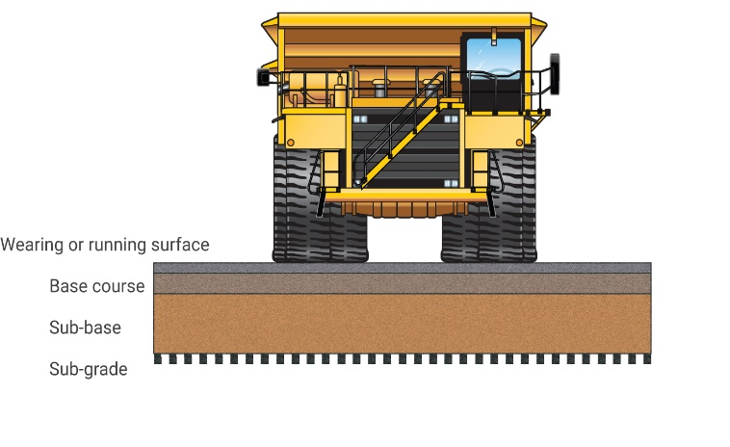

*Figure 1. Typical construction profile*

The structural design of these roads will depend on the quality and condition of the natural ground as well as the availability of appropriate road construction materials and road construction machinery. The design of these roads may require laboratory testing of road construction materials. These can then be used in the development of road construction charts and the establishment of appropriate thickness of various layers.

The structural design of other types of roads should also follow the general design principles. However, the design of these roads will be guided by factors such as the expected duration of a road, the expected vehicle fleet use, the location of a road and the availability of road construction materials.

#### **Sub-grade**

The sub-grade is the in-situ material on which a road is constructed. The sub-grade usually consists of natural material in its existing form. It is important to determine the bearing capacity of the sub-grade as this will define the composition of upper road construction layers.

#### **Sub-base**

The sub-base typically constitutes the majority of a road strength. The sub-base should be composed of sufficient rigid material capable of bearing the weight of the design traffic. The thickness and construction process of the sub-base is dependent on the bearing capability of the sub-grade, the bearing capability of the material utilised and the weight of vehicles expected to use the road. The design and construction of the sub-base should start forming the final running surface profile and drainage. As the sub-base is typically thick, it is important that the construction material is placed in layers and appropriately watered and compacted.

#### **Base course**

The base course is the platform for the wearing or running surface. It is a supplementary layer usually composed of better quality and high bearing capacity material to increase the thickness of the pavement when sub-grades are weaker. The base course material should be placed in layers no thicker than 300mm with adequate compaction of each layer occurring. The base course should be shaped to suit the design road geometry profile of the final running surface and to accommodate the drainage elements.

#### **Wearing or running surface**

The wearing or running surface is the layer upon which vehicles operate. The material selection and construction process should provide a hard and smooth surface with an appropriate friction co-efficient value while minimising dust generation.

The particle size (or grading), moisture content and drainage of the wearing surface are key elements in reducing running surface defects and dust creation.

The design of sealed roads should be undertaken by qualified and experienced civil design contractors.

#### **Design of structures**

Structures such as bridges and concrete or corrugated steel culverts should be designed in accordance with relevant engineering design principals and standards.

The mine operator shall ensure that appropriate controls are implemented to ensure safety during construction activities for construction personnel as well as passing traffic.

## 2.2.8 Road maintenance

Roads and other vehicle operating areas should be regularly maintained so they do not develop surface defects that can impact the safety and efficiency of mining vehicles. Some of these defects include corrugation, loose gravel, bumps, ruts and potholes. These may make control of vehicles difficult or cause health problems due to whole body vibration.

The mine operator should establish a program of proactive and reactive road maintenance activities on the overall road network. If road conditions may impact on the safety of workers, then the Mine Operator must communicate and consult with affected workers to assess the risk and develop controls to reduce road condition impacts.

Some of the main aspects of road maintenance include:

* dust suppression (both proactive and reactive) – appropriate equipment, personnel and procedures should be established to minimise the impact the effect of airborne dust on visibility and health, including the effect of road watering and overwatering on safety
* surface damage repairs (usually reactive interventions) – surface damage can be an indicator of substantial repairs required to lower road layers
* road surface improvements (ideally proactive and based on established schedules) – maintenance grading, road profile reshaping, adding or replacing running surface materials. This also includes sweeping of accumulated gravel from sealed road surfaces and maintenance of road markings
* intervention after adverse weather conditions (reactive) – with clear processes in place for inspections, communication, traffic management restrictions and re-opening
* proactive maintenance of drainage, windrows, barriers, signs and road delineation.

Road maintenance activities should be covered by robust safety controls and measures, particularly if it takes place under live traffic conditions. This includes appropriate roadworks traffic management protocols (such as signs, traffic lights, traffic controllers) as well as communication with all affected road users.

## 2.2.9 Parking areas

The operation should develop typical layouts for parking areas to be used across the site. If built in a consistent manner, the potential for confusion and mistakes when using parking areas can be minimised. The design must recognise the different types of parking areas (such as heavy vehicle, in-pit servicing, light vehicle, sealed surface parking areas and others).

Some of the most important considerations when designing parking areas include separation between vehicles, provision of protected pedestrian walkways, lighting, appropriate speed limits, signage and measures to prevent uncontrolled vehicle movements.

The site should consider the following controls for parking areas:

* visitors and/or employee parking area
* directions from site entry (signage)
* separation from operating areas
* proximity to office, to limit unescorted access to site
* designated tarping and tip-off areas
* working at height issues
* sufficiently separated from haul roads and major thoroughfares
* heavy vehicle parking area that includes:
* restricted to heavy vehicles
* separation of haul trucks from other plant
* runaway prevention (spoon drain or hump)
* open flat area free of obstructions and other congestion
* physical separation between trucks
* blind spot consideration of operators (such as travel in an anticlockwise direction)
* one-way entrance/exit
* limited pedestrian access (dedicated walkways)
* restricted light vehicle access with appropriate protocols for LV access
* adequate lighting
* general parking on site
* light vehicle designated parking areas
* separation of LV and HV parking
* fundamentally stable parking principles
* provision of safe pedestrian facilities
* parking in active mining areas
* assigned parking areas segregating light and heavy vehicles
* exclusion zones
* assigned parking areas for hot seat employee transfer and pedestrian interaction
* proximity detection
* cameras and sensors to minimise blind spot hazards
* blind spot training.

## 2.2.10 Lighting

Lighting should be provided in all areas with significant pedestrian movements to minimise interactions with vehicles as well as to reduce trip and slip falls.

Lighting of digger operations and haul truck tipping areas should be established in consultation with operators to:

* ensure mobile plant operators and the plant they operate are no exposed to hazards like spillage in travel path of haul trucks
* tip edge illumination to assist operators in identifying tip head when reversing to prevent trucks from driving through a tip head windrow
* stockpile illumination to prevent trucks from running wheels up stock-piles creating a roll over risk.

It is important that the type of lighting sources as well as its orientation does not blind and distract drivers in the vicinity.

Lighting towers installed in open pit operations should be protected from mobile plant operations with a regular service and inspection schedule to ensure they are maintained and operational.

## 2.2.11 Other traffic management devices/measures

Some mines implement other traffic management devices and measures to regulate specific traffic interactions. These can include roundabouts, boom gates (manual or automatic), traffic lights underground lights.

Mine operators should ensure that these are designed and installed by the suppliers or qualified specialists and that there are clear operational, inspection and maintenance, regimes in place.

The systems should be chosen based on their functionality under mining conditions (dust, vibration), failsafe design and availability of backups in case of failure.

## 2.3 Users (operators and pedestrians)

## 2.3.1 Information, training, instruction and supervision

#### **Introduction**

Before any vehicles or mobile plant are used on site, the mine operator or PCBU must provide anyone who will use it with the information, training, instruction and supervision necessary to protect them and others from the risks associated with roads and other vehicle operating areas.

Workers including contractors who are required to perform duties associated with traffic management should be trained to perform those duties. The training should be provided to workers by a competent person.

Responsibilities for health and safety management must be clearly allocated. It is important each worker, contractor, subcontractor, visiting driver and other relevant person clearly understands their role in following safe work practices and taking reasonable care of themselves and others.

The mine operator must provide supervision to ensure safety procedures are being followed, particularly if they are relying on administrative control measures to minimise risks. The mine operator must ensure so far as is reasonably practicable, that everyone who has access to the workplace including visitors are provided with information necessary to protect themselves from risks to their health and safety, for example instructions on designated safe routes, parking areas, pedestrian exclusion zones and speed limits. This could be addressed through an induction process at the workplace.

Visitors should report to the reception area or site office and be given information on the safety procedures for the workplace before they are allowed into areas where vehicles and powered mobile plant are used.

As a minimum a visitor should:

* be made aware of the site rules
* not carry out unrestricted operation of vehicles
* be supervised by a competent worker if operating in a restricted mode.

A record of all training and assessment given to workers must be kept as part of worker records. These records must be maintained and be available.

#### **Training**

Training helps people share knowledge and develop skills. It can help influence behaviours and improve health and safety.

As a minimum, this training and assessment should be mapped to a recognised training standard and cover:

* the controls and rules to prevent vehicle collisions and how to ensure that they are effective
* critical controls
* site familiarisation prior to unrestricted operation
* emergency response
* extensive in-vehicle practice prior to assessment.

#### **Verification of competency**

The mine operator or PCBU must ensure a process for verification of competence of workers who have previous experience in operating plant to ensure the worker is competent for each type of plant to be operated.

#### **Training records**

The mine operator or PCBU must ensure a training record of any instruction, training, retraining, assessment or reassessment including verification of competence is recorded for all workers who work on the mine site.

The training record must be kept for the duration the worker works at the mine and for at least 2 years after the worker ceases to work at the mine.

#### **Supervision**

The mine operator must ensure persons who are appointed to supervisory positions are trained and competent to be appointed. The following primary duties of supervisors must be prioritised:

* communication of any handover information from an outgoing supervisor
* allocation of tasks to supervised workers for which they are trained and competent to complete
* supervising and controlling workers and other persons at the workplace
* Inspecting areas where workers and other persons travel to the appointed place for risks or hazards to those persons
* steps to ensure, so far as is reasonably practicable, that workers and other persons are not exposed to risks or hazards in the appointed place
* written shift handover report if the supervisor if being replaced by another supervisor.

Supervisors should ensure that:

* site traffic movements are organised and controlled so that vehicles can be driven safely and the risk of collisions is minimised
* entry, parking and exit to active heavy plant areas such as haul routes, waste dumps, stockpiles, excavations and workshops by vehicles especially light vehicles and pedestrians is authorised and controlled so as to limit the risk of collision with heavy plant to as low as is reasonably practicable
* they monitor through regular visual inspections from a safe vantage point that site vehicle operations are being carried out in compliance with these rules
* that one-way systems and segregated routes are used and reversing movements are minimised
* access to any haul roads or ramps not suitable for use is restricted by placing a physical barrier at the entrance to the restricted area
* haul roads and ramps are suitably constructed avoiding steep gradients, sharp bends or blind dips wherever possible
* adequate edge protection is provided on haul roads, tip edges, water bodies and other locations where there is a drop edge or other hazard
* roads are adequately maintained with re-grading, slurry and debris removal and dust suppression, etc as necessary
* unforeseen incidents such as vehicle breakdowns, bogged vehicles, rock falls, subsidence, etc are promptly dealt with, with a suitable risk assessment and remedial action
* all sub-contractors with vehicles will be assigned to the control of a supervisor or authorised person and be escorted to and from their place of work. A hand-held radio must be provided and appropriate instructions issued
* appropriate corrective action is taken to address any breaches of these rules, reporting non-compliances to the site manager as appropriate
* during periods of dry, windy weather, water shall be evenly applied at regular intervals to the surface of the haul roads and benches so as to suppress dust and prevent it from becoming airborne and causing a visibility nuisance. The quantity and frequency of water application must not create a soft, slippery surface, particularly on slopes and bends
* in adverse weather conditions, supervisors must ensure that plant operators drive to the prevailing conditions. An assessment must be made of deteriorating conditions to establish if operations can continue safely or if vehicle movements must be suspended
* any safety concerns are reported immediately to the site manager as appropriate and the necessary remedial action taken.

#### **Workplace inspection**

The mine operator must ensure that regular inspections of the workplace are carried out by a statutory supervisor. The inspection must be based on the risk assessment of the workplace and must be documented.

#### **Shift handover communication**

Where a mine site operates continuously or has a rostered supervisor coverage, the mine operator must establish a system of work where the outgoing supervisor provides a written report to the incoming supervisor in relation to the state of the mine workings and plant and any other matters that relate to work health or safety.

The incoming supervisor must communicate the report to the workers (including contractors) who are working under that supervisor.

## 2.3.2 Pedestrian management

Pedestrian interaction with mobile equipment should be kept to a minimum. Pedestrians should be managed so that they do not enter operational areas. The site should consider:

* designated pedestrian walkways
* clearly marked pedestrian crossings on roadways (with a defined site-wide rule of priority between pedestrians and vehicles at crossings with priority, ideally, given to vehicles)
* hi-visibility clothing and PPE
* pedestrian no-go areas
* the use of handheld 2-way radios in operational areas
* escorting of visitors
* visitor/employee/contractor induction
* positive communication between pedestrians and mobile equipment
* a rule that pedestrians should never approach operating equipment.

## 2.3.3 Health consideration for traffic management planning

#### **Fitness for work**

The mine operator must ensure systematic a risk management process is in place to manage risks to health and safety associated with fitness for work for operators of mobile plant and vehicles.

The concept of fitness for work is broad. It deals with the relationship between a worker and their ability to undertake their role in the job safely and competently. This goes beyond qualifications and experience – fitness for work deals with personal factors such as the effect of:

* fatigue
* alcohol and/or other drug use
* physical fitness
* medical conditions
* mental health and wellbeing.

Driving mobile plant is a complex task. A range of medical conditions, disabilities and treatments may influence driving ability. Such impairment may adversely affect driving ability, possibly resulting in a crash causing death or injury.

#### **Fatigue management**

Fatigue is more than feeling tired and drowsy. In a work context, fatigue is a state of mental or physical exhaustion (or both) that reduces a person’s ability to perform work safely and effectively. It may result from prolonged or intense mental or physical activity, sleep loss or extended wakefulness or disruption of a person’s circadian rhythms.

The mine operator must ensure that each worker at the mine is given suitable and adequate information, training and instruction in the implementation of control measures relating to the work being carried out by the worker, including control measures in relation to fatigue, the consumption of alcohol and the use of drugs. While mine operators cannot control what workers do in their time off, fitness-for-work is an employer’s legal responsibility.

A planned and systematic approach to assessing and managing the risks associated with fatigue can improve the health and safety of workers. PCBUs should conduct a risk assessment that considers the fatigue risk factors relevant to their operation and develop a fatigue management plan.

Where practicable driver fatigue monitoring and in vehicle monitoring systems should be implemented.

#### **Health management plan**

The mine operator must prepare a health management plan for the mine. It must set out how the operator will manage the risks to health associated with the mining operations undertaken at the mine.

The health management plan must address how the following hazards will be monitored and controlled:

* + noise and vibration
  + dust, diesel particulates and fumes
  + working in extremes temperatures and humidity
  + manual handling and lifting
  + electro-magnetic hazards (such as to workers with pacemakers)
  + hours of work and fatigue
  + ultraviolet and ionising radiation
  + biological hazards
  + hazards associated with the consumption of drugs or alcohol
  + any other hazard that may adversely affect the health of workers.

The health control plan should be developed in the context of the whole mine safety management system and not in isolation from other plans, processes and procedures that rely on the management plan. This will ensure gaps and overlaps in information and procedures are identified and used in the implementation of suitable controls to minimise the likelihood and potential risks and impacts.

#### **Exposure monitoring**

Health hazards have varying effects on human health and are dependent on the dose or level of exposure. The longer a worker is exposed to a hazard or agent, the greater probability is of an unfavourable outcome. Exposures standards are scientifically established and exist for a variety of chemicals including airborne contaminants and other hazards such as noise.

The mine operator must ensure exposure monitoring is undertaken by a statutory appointed person to determine if there is a risk to health and safety of workers from airborne contaminants or noise.

#### **Diesel particulates exposure management**

The physical properties of diesel engine exhaust mean it can accumulate in an enclosed space where there is an insufficient rate or quality of ventilating air. Diesel fuel produces harmful emissions made up of aerosols, vapours, gases and particulates when not fully combusted. Exhaust from diesel engines is more likely to produce harmful health effects over regular fuels because of its higher ignition point.

To be successful in reducing and controlling the hazards associated with diesel engine exhaust, a whole of site approach is required.

Engineering controls are the most effective strategy for reducing the exposure to diesel emissions and diesel particulate matter.

Administrative controls (including changes to the way work tasks are performed) and personal protective equipment may also be required. Controls include:

* good ventilation − an essential control measure in underground mines, enclosed work environments and workshop areas (such as provide *not less than 0.05 m3 per second per kilowatt of the maximum rated engine output specified by the manufacturer* of ventilation current)
* controlling the amount of diesel vehicles or plant operating in an area
* maintaining well-tuned engines
* use of low sulphur fuels
* use of alternate power engines such as electric/battery or other approved fuel source
* improving road conditions, such as reducing potholes which will help reduce the over-revving of the engine
* educating workers on how driver behaviour affects emissions
* Fitting catalytic converters on diesel equipment which can assist in reducing harmful emissions by more fully oxidising organic substances
* fully enclosed and well-sealed driver cabins.

#### **Silica exposure management**

Silica is a common naturally occurring mineral. Inhaling respirable crystalline silica dust can lead to serious lung conditions such as silicosis. Silica dust is a significant health hazard for workers. Very small particles of silica dust cannot be seen under normal lighting or with the naked eye and stay airborne for long periods of time. When airborne, workers can easily inhale the small silica dust particles deep into their lungs where it can lead to a range of respiratory diseases, including:

* silicosis (an incurable lung disease, with inflammation and scarring of the lungs, causing shortness of breath, coughing, fatigue and other symptoms). Silicosis can develop either quickly or slowly depending on exposure levels. It is a potentially fatal condition
* progressive massive fibrosis
* chronic obstructive pulmonary disease
* chronic bronchitis
* lung cancer.

Silica dust also increases the risk of developing chronic kidney disease, autoimmune disorders (such as scleroderma and systemic lupus erythematosus) and other adverse health effects, including an increased risk of activating latent tuberculosis, eye irritation and eye damage.

The WHS Regulations require that exposure to silica dust is prevented where practical. If exposure can’t be prevented, the risk must be reduced as far as reasonably practicable. Examples of controls for crystalline silica include:

* choosing materials (such as abrasive blasting agents) that are silica free or have the lowest silica content
* designing buildings with recesses for services to reduce the amount of chasing required.
* providing vehicles with enclosed cabs fitted with high efficiency air filters, for dusty earthworks or mining
* using wet work methods to reduce dust (such as wet cutting or polishing, water sprays during earthworks)
* using water spray or rubber curtains around conveyor transfer points
* using local extraction ventilation, either fixed or on-tool (such as for mixing, crushing, milling, drilling or chasing)
* shadow vacuuming (such as during drilling)
* vacuum clean-up rather than sweeping
* not blowing dust with compressed air
* In addition to other controls, PPE such as an appropriate respirator (selected in accordance with Australian/New Zealand Standard AS/NZS 1715 *Selection use and maintenance of respiratory protective equipment*) may be required, depending on the task and the effectiveness of the other controls.

## 2.4 Vehicles (mobile equipment)

**WHS Act s.21**

**WHS Mines Regulations**

Chapter 5 Plant and Structures

**Schedule 19 4(d)**

**2.4.1 Safety in design – mobile plant selection**

The PMHMP or traffic management system should also incorporate selection and procurement standards that consider vehicle interaction. These standards must be implemented consistently across the mine:

* Vehicle specifications:
* fuel or power system type
* braking system requirements
* warning devices (horns, reversing alarms)
* exhaust treatment device fitted (if required)
* fire suppression device fitted
* visibility (lights, beacons, reflective strip, flags)
* identification (unique ID numbers visible from adequate distance to enable positive communication)
* operating specification/envelope (gradient, stability, speed, operator visibility)
* after market accessories that reduce operator visibility
* on board communication and cameras
* collision avoidance /awareness system
* OEM manuals, engineering documents and service records
* NCAP or ANCAP Ratings and impacts on the ratings.
* Operator protective devices for the control of:
  + overturning or roll over (ROPS)
  + falling objects (FOPS)
  + operator being ejected (seat belts)
  + collision avoidance
  + prevention of operation of controls or movement of mobile plant from outside of the operator cabin or when the operator’s seat is not occupied (such as safety switch in seat or seatbelt)
  + uncontrolled energy release from pressurised elements of plant
  + exposure to air borne contaminants – diesel particulate, dust, mining gases.

Periodic review of existing plant must be conducted to ensure that the plant continues to meet the site standards.

The PCBU/Mine Operators must establish processes to ensure that non-mine owned plant to be operated on the mine are compliant with the traffic management plan. This should include:

* the plant is fit for purpose and will not be operated outside of its design envelope.
* is inspected/risk assessed before commencing work
* maintained to site requirement’s (OEM specifications as a minimum)
* If a road going vehicle – it is maintained in road worthy condition
* complies with site standards (including any additional safety features)
* is compatible with plant and systems operated and used on site
* training and assessment of operators

#### **Mobile plant design and selection**

Prior to acquiring mobile plant or structures, a risk-based approach should be undertaken to determine the suitability and compatibility of the type of plant and infrastructure selected as part of the procurement process. The risk management process should address as a minimum the following questions:

* what is the intended use of the plant or structure? (such as operating environment, pay load requirements, maintainability etc.)
* what are the potential scenarios for plant and infrastructure incidents?
* what are their potential consequences in terms of safety and health?
* what controls are available in terms of safety and health?
* what controls are required to control the hazard?

The results of the risk assessments should be documented, and the type of plant or structure procured should be based on these outcomes.

The mine operator or PCBU should specify to the supplier and manufacturer their expectations for achieving the requisite safety standards including the relevant standards and guidelines the plant is to comply with.

The designer, manufacturer, supplier and PCBUs using the plant have obligations under the WHS Act and WHS Mines Regulations, and should work together to manage issues such as:

* identifying safety requirements
* specifying how the plant or structure is to be used in the workplace
* standards required
* how the life cycle of the plant or structure is to be maintained
* the type of guarding based on Australian Standards, exposure risk and work patterns.
* who will provide, install and commission the plant or structure?
* integration with other plant or structures
* the working environment in which the plant or structure will operate
* any hazardous exposures arising from use of the plant or structures such as noise or fumes
* who will train and supervise the operators?
* operations and maintenance procedures
* preventative maintenance and internal inspections required.
* potential blockages or out-of-the-ordinary situations
* competency requirements of worker to operate and maintain plant
* how isolation from hazardous energies can be achieved

Where the plant or structure is being designed and manufactured in-house, the mine takes on the responsibilities of the designer and manufacturer under WHS laws. These duties also apply when the mine modifies plant or structure. That is, the mine takes on the responsibilities of the designer and manufacturer in relation to the modifications and any effect they have on the plant.

All plant and structures shall be designed by competent personnel with recognised expertise in their field.

The mine (the designer) must take into consideration what is reasonably practicable in relation to a duty to ensure health and safety, taking into account:

* likelihood of the hazard or risk occurring
* degree of harm that may result from the hazard or risk
* relevant legislation, codes of practice and standards
* what the person knows, or reasonably ought to know about the hazard or risk associated with plant or structures and ways of eliminating or minimising the risk once assessed

If a newly purchased plant or structures is not safe because of the way it has been designed, constructed, supplied or installed, do not use it until the unsafe aspects have been assessed and suitably rectified taking into consideration the hierarchy of controls. The manufacturer or supplier (or installer if relating to the installation) should be contacted to resolve the issue.

The mine should establish an introduction to site process to ensure that plant and structures are safe to operate at the mine.

The following are minimum factors to consider before purchasing mobile plant:

* the effectiveness of the braking system, bearing in mind the slopes on which it is expected to work
* adequate all-round visibility for the driver
* stability under all foreseeable operating conditions
* protection for the driver and any passengers from falling objects (falling object protective structure (FOPS)), overturning (roll-over protective structure (ROPS)) and seat belts. Further information is available in the Australian Standard AS 2294.1 Earth moving machinery – Protective structures. (This Standard also has adopted in parts international standards ISO 3471 and ISO 3449, which are commonly used for vehicles manufactured overseas, and these are seen on the ROPS/FOPS compliance labels.)
* safe access and egress to and from the cab and other areas of the vehicle where access may be required
* adequate fall from heights protection when accessing and egressing the cab, as well as around working areas that are at elevated heights (such as engine bays)
* engine firewall and fire suppression equipment
* lights, windscreen wipers, horn and other warning devices (such as flashing lights and reversing alarms)
* guarding for dangerous parts during use or maintenance work
* protection devices to prevent operation of controls or movement of plant when operators are not in the operator seat of mobile plant.
* protection for the driver and any passengers from rain, high and low temperatures, noise, dust and vibration
* suitable seating for the driver and any passengers
* maximum loads that may be carried or towed.

Where vehicles are not fitted with safety features, consider retro-fitting them where the hazard identification and risk assessment process has recognised a significant hazard.

For vehicles expected to enter sites in darkness, whether or not work is scheduled to take place, additional supplementary lighting should be provided (i.e., forward and rearward facing spotlights) or additional vehicle-mounted work lights. Any permanently fitted lights must comply with the WA Road Rules and the Australian Design Rules when being driven on public roads.

#### **Driver visibility**

Many vehicles have substantial blind spots, not only immediately behind the vehicle, but also alongside and immediately in front of it. Improving visibility requires a combination of approaches such as reversing cameras, collision avoidance systems, proximity sensors and mirrors.

Studies suggest that, when used appropriately (i.e. drivers’ glance at the system at the appropriate time), reversing cameras can successfully mitigate the occurrence of reversing crashes, particularly when paired with an appropriate audible warning system.

Accidents can occur when vehicles drive off or turn while a pedestrian or vehicle is passing or parked in a blind spot. As a guide, the driver should be able to see a one-metre-high object one metre away from any danger point of a vehicle. The driver should be able to detect the presence of other vehicles and pedestrians in their intended line of travel when moving off or when reversing.

There should be a procedure (commonly known as the 1-2-3 horn principle) to be followed before a vehicle drives off:

* starting the mobile plant – a single beep from the horn with a five second delay before starting engine
* moving forward – two beeps from the horn, with a five second delay before driving forward
* moving in reverse – three beeps from the horn with a five second delay before reversing.

#### **Collision avoidance and proximity detection equipment**

The effectiveness of collision avoidance and proximity detection technology has progressed significantly with mining equipment suppliers now include this within their vehicle specifications. Mine Operators must consider this technology as a control within the principal mining hazard risk management process or provide reasoning as to why this control measure was not considered or implemented.

Collision avoidance equipment warns the driver of fixed obstacles or other vehicles along the route and stops the vehicle from colliding. Collision avoidance systems usually use GPS or local area wireless technology (i.e. Wi-Fi or Bluetooth) to determine vehicle position, speed and heading. Vehicle locations and paths are calculated and sent via a radio link to all other outfitted vehicles in the area. Where two or more vehicles may collide, audible and visual warnings are sent to the drivers to alert them to take evasive measures.

#### **In vehicle monitoring systems (IVMS)**

In-vehicle monitoring systems (IVMS) can be a powerful tool for improving driver behaviours across an organisation. The drivers and supervisors information that will help them work together to improve driver performance and avoid crashes and injuries.

IVMS Systems are also able to detect fatigue and driver distractions and provide early warning to operators and Supervisors.

#### **Closed circuit television (CCTV)**

CCTV cameras can be mounted on the front, side and rear of a vehicle. Images are relayed to a screen located inside the cabin. Some cameras are equipped with infrared illuminators, so the driver has a comprehensive view even when it is dark. Thermal imaging systems are also available and may be suited to sites where night operations are a concern.

#### **Reversing alarms**

Reversing alarms warn anyone in the vicinity that the vehicle is in reverse gear. They rely on the driver having a clear view and the pedestrian or other vehicles moving out of the way.

#### **Visibility of light vehicles**

Light vehicles are at risk of being crushed by heavy vehicles. They should be kept away from areas where heavy vehicles operate. Where this is not practicable they should be fitted with rotating or flashing beacons, high visibility buggy whips or flagged aerials, high visibility and reflective markings and other appropriate measures. This makes them readily visible to drivers of other vehicles. The use of vehicle hazard lights alone is not deemed adequate and should be discouraged as being the only warning provided.

#### **Protection of drivers, operators or passenger’s operator protective structures (ROPS and FOPS)**

Operators of heavy vehicles are at high risk of serious or fatal injury by crushing if their vehicles roll over or tip on to their sides or if objects enter the cab. Generally, the risk depends on the type of vehicle, the terrain and how the vehicle is driven. There is a low risk on flat, stable ground and high risk on steep or unstable ground or on work adjacent to embankments, excavations or on top of old mine workings.

#### **Seat belts**

All drivers and passengers must wear appropriate seat belts. They should be checked as a part of regular maintenance.

Refer to OEM maintenance procedures as some seat belts must be replace at set service intervals.

#### **Transporting people**

People must only be transported in vehicles designed to carry passengers with forward or rear facing seats and seatbelts. These vehicles should also comply with vehicle visibility standards. Vehicles not specifically designed for carrying people should not be used for this purpose.

#### **Fire prevention**

Typical causes of vehicle fires include component failure and poor or inadequate maintenance. When completing a risk assessment for prevention of fires consider:

* the design – for example:
  + hydraulic components are like for like and considered suitable for use. Always consult the original equipment manufacturer (OEM) before making change
  + any maintenance, installations or design modifications that are undertaken off-site are verified before use and are equivalent to the OEMs standards and design
  + implementing quality checks or audits by OEM authorised service providers periodically as a cross check for site maintenance
  + using low flammability hydraulic fluids and coolants
* the mine operator of an underground mine must ensure that suitable fire suppression devices are provided on underground vehicles and should consider them for surface vehicles as well.
* workers must be trained in the use of fire prevention equipment when fitted to mobile plant.

PCBU and mine operators should refer to *Code of practice: Managing the risks of plant in the workplace* for practical guidance on how to manage health and safety risks associated with managing risks of plant in the workplace.

**2.4.2 Mobile plant (vehicle) operating practices**

## WHS Mines Regulations r. 631

Movement of mobile plant

**WHS Mines Regulations r. 631C**

Quarry operations

The following practices should be assessed and incorporated into procedure and plans. Some of them are classified as preventative administrative controls while others will be engineering and separation controls that are critical to prevent an unwanted event. These actions will require verification and maintenance to ensure they remain effective at all times.

The practices include:

#### **Vehicle start up**

Prior to a vehicle or mobile plant being operated the following vehicle start up procedure should be adopted:

* before starting a vehicle, the operator should ensure that precautions are taken to prevent any unplanned vehicle movement
* an Inspection is completed by a competent person prior to start-up of vehicle to confirm the vehicle is safe to operate following any OEM recommendations
* a competent and authorised operator should be always in control of the vehicle when the engine is running
* before moving the vehicle or plant in any direction the operator must take all reasonable steps to ensure that the surrounding area is clear.

#### **Vehicle driving**

When driving a vehicle on site, the following points should be considered when preparing vehicle rules:

* use of a warning device to warn pedestrians/other plant of mobile plant movement
* specific mobile plant operating procedures are developed
* operator training incorporates operation and equipment breakdown procedures including emergency procedures.

#### **Operator controls**

When mobile plant is being operated, procedures and controls should be developed to prevent the operation of controls or movement of mobile plant from outside of the operator cabin or when the operator’s seat is not occupied (such as there is a safety switch in seat or seatbelt interlock).

#### **Entry into a loading zone (active mining area)**

The loading zone is defined by the maneuvering zone of the excavator or loading shovel and the maneuvering zone of the trucks being loaded or waiting to be loaded.

Controls must be established to manage mobile plant interaction with other plant, vehicles and pedestrians within the loading zone.

#### **Loading operations**

Procedures should be established to ensure control of the loading operations within the loading zone are managed and clear communication processes are established.

#### **Tipping operations**

Procedures should be established to ensure control of tipping operations which include:

* suitable edge protection bund/windrow/berm must be maintained at tipping edges
* bund placement and stand-offs should be designed or considered by the Geotechnical Specialist to ensure stability and allow for the maximum rear axle weights and dynamic loading.
* tip edge berms must be maintained at all times to a suitable profile to prevent plant reversing over an edge.
* tipping locations should clearly delineate where the material is to be dumped

#### **Maneuvering vehicles in restricted areas**

Where vehicle size segregation is not possible, then restricted areas shall be established for working areas. Working areas may be defined as: any area where multiple mobile plant operates.

The movement of all mobile plant must stop before ancillary vehicles or pedestrians enter the working area.

#### **Overtaking**

Where practicable, traffic segregation should be provided to minimise the requirement for utility vehicles, 4WDs etc. to overtake larger vehicles.

Where utility traffic routes are provided, then overtaking can be controlled by the provision of single traffic routes with overtaking bays, so that the one vehicle is stationary while being overtaken.

On main haul roads overtaking should be subject to an approved scheme for overtaking or undertaking.

Consideration should be given to utility vehicles not overtaking dump trucks or water bowsers when the latter are in operation.

In general, no overtaking should take place on road junctions or on bends.

#### **Parking**

Vehicles and plant should be parked on level ground wherever possible to minimise the possibility of them being set in motion.

Vehicles and plant should be parked in authorised parking areas in accordance with fundamentally stable parking rules defined within the Traffic Management Plan. If it is not possible to do so or if a vehicle is broken down, permission must be sought from a supervisor to park elsewhere.

When leaving a vehicle unattended the engine should be switched off. A process should be implemented for management of the ignition key to prevent unauthorised starting of vehicles.

Vehicles and equipment should be parked a suitable safe distance from a quarry face to minimise the risk of being struck by falls of ground. When this is unavoidable due to a breakdown or unforeseen circumstances a risk assessment must be carried out by a manager or supervisor before permission is given for personnel to enter the area.

Ground engaging equipment such as excavator buckets, dozer blades, ripper teeth and scraper bowls should be lowered to the ground when parking and if stopping to be serviced or fueled.

Vehicles should never be parked within the swing radius of an excavator or the maneuvering zone of other operational quarry vehicles unless in accordance with a safe system of work that involves the immobilisation of the other vehicles such as during a maintenance operation.

#### **Dust suppression**

The watering of haul roads to suppress dust has the potential for traffic accidents; either by the water bowser turning over or by the haul roads becoming very slippery because of wet bends and ramps and any other sections of haul road where brakes may be applied.

Water cart operators should at all times ‘patch’ spray haul roads and avoid blanket spray or excessive amounts of water being deposited on the roads (especially in braking areas, gradients, and junctions of haul roads).

#### **Fueling and servicing**

All engines should be switched off and vehicles immobilised during fueling and servicing operations. The key must be removed from the ignition and brakes should be applied and other precautions taken as necessary to prevent unplanned vehicle movements.

#### **External haulage**

External haulage vehicle operators should comply with any site-specific rules applicable.

#### **Deliveries**

All delivery vehicles should report to a designated control point to sign in, to receive site rules and site induction as necessary and to receive instructions regarding points of delivery and who to report to.

The site rules should include traffic routes to be taken, parking arrangements, pedestrian control and the need to observe signs and instructions in relation to traffic control and segregation, where applicable.

**2.4.3 Mobile plant maintenance**

## WHS Mines Regulations r. 205

Preventing unauthorised alterations to or interference with plant

**WHS Mines Regulations r. 206**

Proper use of plant and controls

**WHS Mines Regulations r. 207**

Plant not in use

**WHS Mines Regulations r. 208**

Guarding

**WHS Mines Regulations r. 209**

Guarding and insulation from heat and cold

**WHS Mines Regulations r. 210**

Operational controls

**WHS Mines Regulations r. 211**

Emergency stops

**WHS Mines Regulations r. 212**

Warning devices

**WHS Mines Regulations r. 213**

Maintenance and inspection of plant

**WHS Mines Regulations r. 214**

Powered mobile plant: general control of risk

**WHS Mines Regulations r. 215**

Powered mobile plant: specific control measures

**WHS Mines Regulations r. 218**

Industrial lift trucks

**WHS Mines Regulations r. 219**

Plant that lifts or suspends loads

**WHS Mines Regulations r. 222**

Industrial robots

**WHS Mines Regulations r. 224**

Pressure equipment

A maintenance and inspection program is critical to ensure equipment and machinery is safe to use. Maintenance and inspection programs should consider the plant operational, particularly when subject to corrosion, damage or wear.

Maintenance, inspection and testing must be carried out:

* in accordance with the manufacturer’s recommendations, if any
* if there are no manufacturer’s recommendations, in accordance with the recommendations of a competent person or at least annually

Maintenance and inspection programs should consider the full scope of the installation and operation of machinery or mobile plant including, as appropriate:

* the structure of the machinery (bracing, supports)
* safety features (i.e. emergency stops, guarding, emergency equipment, operator protective devices)
* integrity of walkways, stairs, ladders, railings or guardrails
* integrity of holding vessels (i.e. tanks, bins, hoppers and chutes)
* integrity of lifting equipment (i.e. chains, slings, straps, hooks, gantry cranes, lifting eyes, quick hitches, fall arrest anchors)
* signage and other warning devices (i.e. lights, alarms)

The mine operator should ensure a competent person examines any machinery regularly. Best practice is for a driver to do a shift pre-use inspection before using the vehicle.

#### **Hazards to consider when undertaking maintenance**

Undertaking maintenance activities (including cleaning) can potentially expose workers (and others) to significant hazards. The following hazards should be considered in the mine safety management system:

#### **Inspecting and servicing mobile plant**

The mine operator must establish a program of daily visual checks (or pre-start checks), regular inspections and servicing to schedules according to the original vehicle manufacturer’s instructions and the risks associated with the use of each vehicle.

#### **Working at height**

Maintenance work often involves using access equipment to reach raised sections of machinery or mobile plant. Eliminating the need to access machinery or mobile plant at height by careful design is the most effective control.

Where elimination is not practicable and frequent access is required, platforms, walkways, stairways and stairs/ ladders that comply with AS 1657 (and as may be applicable, the building code) should be provided. For more information on preventing falls from height see [Managing the risk of falls at workplaces - Code of practice](https://www.commerce.wa.gov.au/publications/code-practice-managing-risk-falls-workplaces)

#### **Falls of heavy items**

Heavy items may need to be moved or disturbed, during maintenance work. If a heavy item must be moved or temporarily supported, it is crucial the risks are assessed and action is properly planned, developed and communicated. These lifts, or the use of temporary supports, may be one offs and will inevitably require more knowledge and skill than if done routinely.

#### **Energy sources or stored energy**

Isolation, lock out arrangements and, in some cases, permits to work are essential. Before any work is undertaken maintenance workers should:

* identify all power or energy sources
* isolate the power or energy source
* apply an isolation device (padlock) and a sign (or tag) to indicate that maintenance work is in progress
* dissipate any stored energy (such as hydraulic or pneumatic power)
* test and verify isolation is correctly applied

#### **Isolation and lock-out of energy**

Energy isolation is much more than putting a lock and tag on a switch. To effectively isolate workers from energy, you need to know what energy is, and how it can be safely isolated on specific machinery and mobile plant.

#### **Lock-out and tag-out systems**

Lock-out and tag-out systems are the placement of a lock and tag on an energy-isolating device once isolation has been done. They indicate that the energy-isolated device is not to be operated until removal of the lock and tag in accordance with an established procedure.

Once an item of plant or equipment has been isolated, the form of isolation must be tested for effectiveness (i.e. try and test start the item) and any residual energy dissipated.

#### **Permit to work**

A permit to work system is a formal documented process used to manage work identified as significantly hazardous by making sure all safety measures are in place before work starts.

It is also a way to communicate between site management, plant supervisors, operators and those who carry out the hazardous work (which may often include contractors or other specialists).

#### **Maintenance under hydraulically raised parts of mobile plant**

Many mobile plant use hydraulics to raise, lift or move material or parts of the vehicle (such as truck trays, frontend loader buckets, excavator booms and drilling rigs). These raised parts have stored energy. Physical supports or other devices should be used to prevent raised parts dropping or being lowered while workers are under them.

Consider:

* removing the elevated part before other maintenance work takes place (eliminate the hazard)
* fitting a restraining system to the elevated part
* fitting the tray or bucket with a built-in prop
* ensuring restraining system controls are clearly marked and shrouded or protected from accidental operation
* fitting hydraulic cylinders with over centre valves

Rear dump trucks are to be provided with a means of restraining the dump body when in the raised position for inspection or maintenance. The means of restraint can consist of pins slings or similar. They should have a minimum safety factor of 4 to 1 when applied to maximum possible down-load, which can be exerted on the dump body when the body is in the raised position, except where a load lock type device is fitted on the body lift cylinders. In this case a minimum factor of safety of 2:1 applies.

#### **Brake testing**

A suitable inspection scheme should be in place to ensure brakes are always in good condition. This is often combined with other maintenance work. Electronic brake testing equipment should be used on a regular basis to accurately measure brake performance. This will show deficiencies in the brake system before they become a problem. The maintenance plan should require operation, monitoring and maintenance of brake systems according to original vehicle manufacturer or original equipment manufacturer recommendations, as a minimum.

Correct brake system functioning depends on the condition of system components, which in turn depends on the quality of the maintenance. Any brake system maintenance strategy should focus on detecting and rectifying a defect before it results in a loss of brake function.

#### **Tyre assembly safety**

Working with tyre assemblies is potentially dangerous. This is because of their size, mass, complexity (multi-piece wheels and rims), magnitude of air or gas pressure, the uncontrolled release of stored energy and the presence of combustible materials.

#### **Tyre risk management and lifecycle management**

Tyre assemblies are safety-critical components that should be selected, operated and maintained correctly to reduce the risk of workers’ exposure to associated hazards to as low as reasonably practicable. The lifecycle management of tyres should clearly define the selection, procurement, operation, maintenance and disposal.

The management of these items requires a risk assessment in consultation with the tyre, wheel and rim manufactures, mine designer, plant original equipment manufacturers, operators, tyre, wheel and rim technicians and maintainers, and others as appropriate.

#### **Tyre pyrolysis**

Tyres on trucks, cranes and other heavy vehicles may catch fire under a range of circumstances, with the obvious potential for the tyres to then explode. A lesser-known danger arises when the combustion takes place inside the tyre, with no external signs. Whenever excess heat is developed in or applied to a tyre, it can initiate a process within the tyre known as pyrolysis – the decomposition of a substance by heat. This can cause a build-up of flammable gases and pressure within the tyre, which may ultimately rupture or explode.

This hazard must be recognised, and the possibility of tyre pyrolysis and explosions must be considered in the development of a mine safety management system and emergency plan.

A trigger, action, response plan for tyre fire risks should be developed, including:

* + parking the vehicle
  + establishing an appropriate exclusion zone based on risk
  + an isolation period
  + alerting fire-fighting services.

Further guidance for tyre safety can be found in the [Guideline – Tyre safety for earth-moving machinery on Western Australian mining operations](https://www.dmp.wa.gov.au/Documents/Safety/MSH_G_TyreSafetyEarthMovingMachineryWAMines.pdf).

## 2.4.4 Underground mobile plant standards

The PMHMP or traffic management system should also incorporate selection and procurement standards that consider vehicle interaction. These standards must be implemented consistently across the mine:

* Vehicle specifications
  + fuel or power system type
  + braking system requirements
  + warning devices (horns, reversing alarms)
  + exhaust treatment device fitted
  + fire suppression device fitted
  + visibility (lights, beacons, reflective strip)
  + identification (unique ID numbers)
  + operating specification/envelope (gradient, stability, speed, operator visibility)
  + after market accessories that reduce operator visibility
  + on board communication and cameras
  + collision avoidance /awareness system
  + OEM manuals, engineering documents and service records
* Operator protective devices for the control of:
  + overturning or roll over (ROPS)
  + falling objects (FOPS)
  + operator being ejected. (seat belts)
  + collision avoidance
  + prevention of operation of controls or movement of mobile plant from outside of the operator cabin or when the operator’s seat is not occupied
  + uncontrolled energy release from pressurised elements of plant
  + exposure to air borne contaminants – diesel particulate, dust, mining gases

Periodic review of existing plant must be conducted to ensure that the plant continues to meet the site standards.

The mine operator or PCBU must establish processes to ensure that non-mine owned plant to be operated on the mine are supplied and used in accordance with the Traffic Management Plan. This should include:

* the plant is fit for purpose and will not be operated outside of its design envelope.
* is inspected/risk assessed before commencing work
* maintained to site requirement’s (OEM specifications as a minimum)
* complies with site standards (including any additional safety features)
* is compatible with plant and systems operated and used on site
* training and assessment of operators

NOTE: Surface designed vehicles (light, medium and heavy road going vehicles) are not always suitable for the operating environment underground. Brakes, pay load limits and driver safety devices need to be reviewed to establish if there are any risks to the health and safety of the operator or other persons while operating on the gradients that may be present at the mine.

#### **Underground vehicle operating procedures**

* always test the brakes before entering the portal.
* do not drive down declines on the service brakes. Select the correct gear and use the retarder if fitted
* automatic transmission vehicles must be assessed to ensure suitability for underground
* ensure the tray has been lowered before moving/entering the portal
* only enter excavations designed to suit the size of the mobile plant.
* only operate in areas that have sufficient ventilation
* if a vehicle is emitting a lot of black smoke, report it to your supervisor and remove it from service
* parking standard for vehicles and plant underground
* vehicle interaction and right of way principles defined and controls to reduce interaction, (passing cuddy, radio call points, block light system etc.)
* turn the wheels towards the wall when the vehicle is parked on a slope
* cap lamp signals and communication
* collision avoidance and/or proximity detection.

## 2.4.5. Mobile autonomous systems in mining operations

#### **Mobile autonomous applications**

Autonomy can be used to command and control a variety of plant and equipment used in mining and exploration. Examples include but not limited to:

* haul trucks
* water carts
* drill rigs
* loaders
* underground load-haul-dump (LHD) units (such as boggers)
* dozers
* continuous miners feeding trucks or conveyor systems
* mobile crushing and screening plants
* light vehicles
* haulage trains in loading and unloading applications.
* charge-up (Mobile Manufacturing Unit/Mobile Charging Unit)
* road trains

#### **Decision to automate**

The decision to automate parts or all of a mining operation is based on perceived future gains in productivity, efficiency and safety performance. Many large mining companies and equipment suppliers have been involved with pilot projects in Western Australia for a number of years and are introducing autonomous and semi-autonomous mining equipment into production activities across their operations (both surface and underground). While the decision to automate particular aspects of mining activities depends on the project’s financial and logistical viability, companies are also required to demonstrate to the regulator, through High-Risk Mining Activity notification, that they can effectively accommodate this new mining approach in their mine safety management system and manage the change.

The addition of autonomous mobile equipment can introduce new or different hazardous situations not normally encountered on a conventional manned mining operation. It is important that these safety challenges are identified, assessed and addressed early in the planning cycle to maximise opportunities for solutions high in the hierarchy of control.

Companies considering introducing autonomous mobile mining systems into their operations should consider the following to achieve a safe and successful outcome:

* suitability and availability of automation knowledge and experience to support assessment/study activities
* clear objectives and key deliverable relating to the successful implementation (Success Criteria)
* a comprehensive mine site risk assessment prior to making the decision to introduce autonomous mining:
  + project risks
  + implementation risks
  + operational risks including:
    - * access to autonomous operating zones
      * overwatering of roads creating loss of traction and emergency braking/loss of control
      * minimisation of vehicle interactions and segregation of light vehicles
      * automated fire detection and suppression systems
      * systems of work for access and recovery of autonomous vehicles
      * management of human factors
* a well-documented change management process, including:
  + roles and responsibilities, and
  + the development of strategies
* inclusion of autonomy into mine design, IT/OT systems, mobile equipment maintenance, training and planning as early as possible to ensure an integrated approach
* facilitate active consultation with users throughout the autonomous design and development process

Refer to Department on Mines, Industry Regulation and Safety – Safe mobile autonomous mining in Western Australia code of practice for further details.

# 3. Road Design

## 3.1 Separation/segregation of vehicles

Where practicable the road network shall be designed to provide separate roadways for heavy mobile plant and medium vehicles/light vehicles. When creating roads only for medium vehicles/light vehicles, ensure they are created for a purpose of reducing risk and that they do not increase risk with the establishment of additional medium vehicles/light vehicles and heavy mobile plant intersections.

## 3.2 Road Widths

Mine roads shall be designed and constructed with a trafficable width to accommodate the operating width of the design vehicle, i.e. the largest vehicle regularly using the road. The design vehicle can be different for different road types.

The trafficable width of a road is the useable running pavement clear of guideposts, drains and safety berms. An example of a typical double lane roadway schematic for a haul road and an access road is as follows:

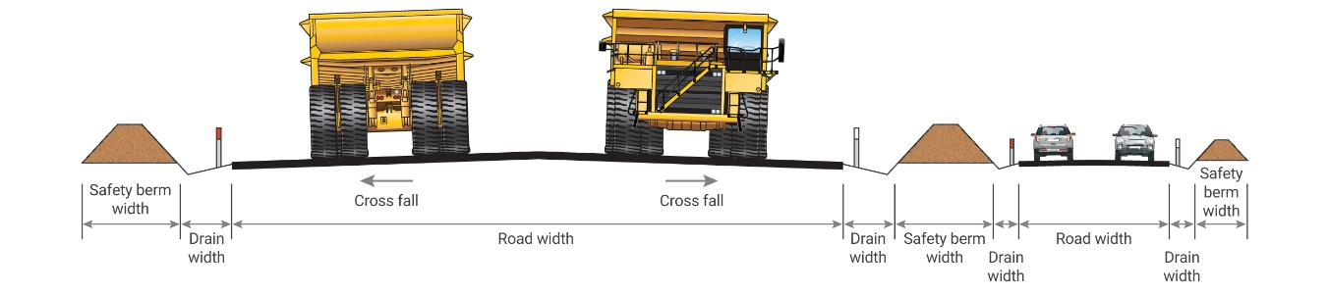

*Figure 2. Typical double lane roadway schematic for a haul road and an access road*

The operating width of the design vehicle is the maximum width of the vehicle during normal operation. The mine operator may decide to use the width of the rigid part of the vehicle (such as rock deflectors) or the width between collapsible extremities (such as mirrors). This decision must be risk assessed and documented.

The following shall be used to determine the required road width for various road types:

|  |  |  |
| --- | --- | --- |
| Type of road | Dual-lane width | Single-lane width |
| Primary haul roads  Secondary haul roads | 3.5 x operating width of the design vehicle# | 1.5 x operating width of the design vehicle |
| Temporary haul roads | 2.5 x operating width of the design vehicle | 1 x operating width of the design vehicle |
| Underground roads | Determined by mine design | Determined by mine design |
| Primary access roads | 10.0m, composed of two 3.5m wide traffic lanes and 1.5m wide shoulders on each side | 5.5m, composed of a 3.5m wide traffic lane and 1.0m wide shoulders on each side |
| Secondary access roads | 8.0m, composed of two 3.5m wide traffic lanes and 0.5m wide shoulders on each side | 4.0m, composed of a 3.0m wide traffic lane and 0.5m wide shoulders on each side |
| Supporting roads | 6.0m, composed of two 3.0m wide traffic lanes | 3.0m wide traffic lane |

# This shall be the minimum and maximum width of the road

A mine may implement lower width standards to accommodate site or location specific constraints. However, any decisions to accept lower values must be supported by a risk assessment.

Where road width cannot be achieved an assessment of risk shall be undertaken to determine controls that manage the hazard to an acceptable level of risk (such as use of one-way traffic flows where circumstances allow or specifying give way requirements, speed restrictions, installation of narrow road signage highlighting the road width hazard and call up, etc.).

Where roadways are separated for extended lengths by a median/centre safety berm or other physical barrier then those segments of roadway shall be considered single lane segments and single lane roadway width criteria applied accordingly.

#### **Effective separation and stopping distances.**

Site separation and stopping distances must be greater than the actual (measured) stopping distance of the vehicle with the longest (worst) braking distance, under the worst road (slippery, wet, downhill), vehicle (maximum speed, fully laden, bald tyres) and operator conditions (operator fatigue, distraction, unfamiliarity with situation).

Importantly, the nominated separation distance must also consider the natural reaction time of the operator and the mechanical delay time between brake actuation and actual slowing of the vehicle.

Graph 1 below can be used to estimate the effects of distance travelled for different operator reaction times and mechanical delay time. As shown by the red arrow, a vehicle traveling at 40 km/h will have driven 22.2 m for a combined operator reaction and mechanical delay time of 2 secs (irrespective of vehicle type).

If the nominated separation distance were set at 50 m, this would mean that actual braking and stopping of the vehicle would need to be achieved within the remaining distance of 27.8 m (50 m – 22.2m = 27.8 m). Depending on the vehicle, payload, road conditions, efficiency of braking systems, operator capability etc. this may not be sufficient to prevent a collision. As a result, a greater separation distance must be considered.

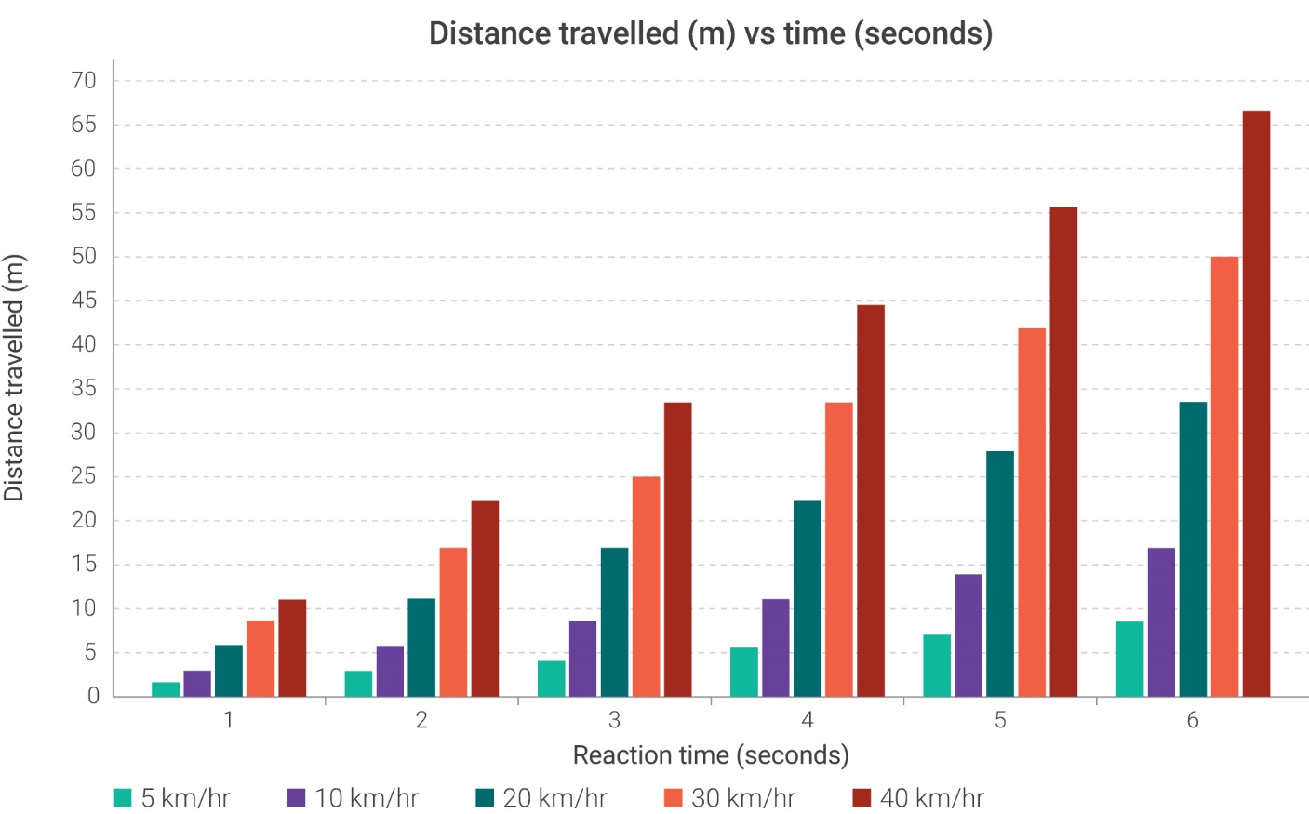

**Graph 1. Distance travelled vs operator reaction/mechanical delay time**

Primary haul roads and access roads, shall, and secondary haul roads and access roads should be designed in compliance with the following sections.

## 3.3 Cross fall/camber

The surface shape of the roadway should support water run-off from the road surface without adversely affecting the drivers steering control or increasing tyre wear. Cross fall or camber is the crossroad gradient perpendicular to the road direction. Crowned crossfall (road profile) should be provided and maintained, on all roads unless there are specific circumstances that warrant a one-way crossfall. Consideration should be given to:

* road gradient
* expected rainfall
* wearing surface material
* OEM vehicle specifications

Cross fall on mine roads should be between 3% and 4%. (see Figure 3. below crossfall rates of less than 2% and more than 6% shall not be used.

In applications where tyre wear may be an issue (such as long hauls), cross fall on loaded lanes should be kept to a minimum.

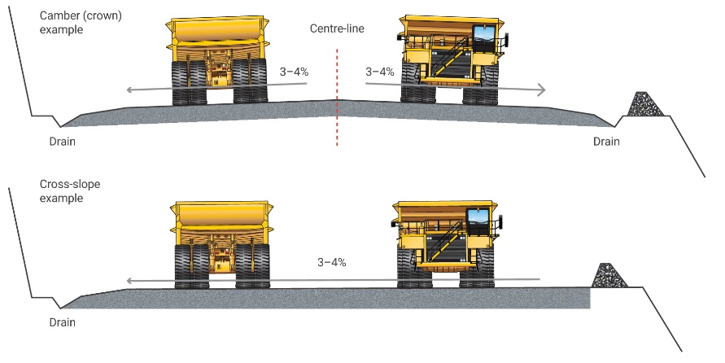

*Figure 3. – Cross Fall*

## 3.4 Road alignment (horizontal and vertical curvature)

The primary horizontal design consideration should be curves with the largest radius possible. A larger curve radius allows higher safe speeds and increased vehicle stability. Every effort should be given to removing the constraint requiring tighter curve radii before accepting a sub-optimal design.

Tight curves (such as switchbacks) shall comply with OEM minimum turn radius requirements for the design vehicle.

The minimum radius of a road curve is determined by the speed of vehicles (posted speed limit), the coefficient of lateral friction and super-elevation as per the equation below:

$$R=\frac{V^{2}}{127(e+f)}$$

**R –** curve radius [m] **f –** coefficient of side friction between the tyre and road surface

**V –** operating speed [km/h] **e –** superelevation [m/m width of road]

**Sight distances**

Sight distance is the distance an operator can see ahead along a road. This is particularly critical on the approaches to horizontal curves, vertical crests and intersections.

The stopping sight distance is the distance required for an operator to bring a vehicle to a stop before colliding with a hazard on the road surface.

The stopping distance of vehicles travelling along a road or approaching an intersection must be less than the sight distance available to the operator. The operator must be able to bring the vehicle to a full stop before colliding with an observed hazard on the road or a vehicle entering or crossing an intersection.

The required sight distances are based on:

* speed of travel
* vehicle characteristics (position of the operator, braking performance, payload, etc)
* condition of the road surface
* atmospheric conditions
* level of alertness of the operator, etc

Ideally, friction factors should be determined through on-site testing. This would determine the friction factors on different running surface materials, road conditions and for different vehicles.

In the absence of friction factors derived through site-specific testing, a friction factor of 0.47 should be taken as representative for typical, good, road conditions.

The stopping sight distance (SSD) also accounts for the reaction time of the operator. This is the time from when the operator can observe a hazard to the moment the brake pedal is engaged. In addition to this, the brake engaging time is the time required for the brakes to become fully engaged. The brake engaging time is generally only used for off road haul trucks used as the design vehicle. Based on these parameters, SSD is calculated as per the equation below.

$$SSD=\frac{\left(R_{t}+B_{t}\right)V}{3.6}+\frac{V^{2}}{254\left(d+0.01g\right)}$$

$R_{t}$– operator reaction time [s] $d$– longitudinal deceleration (friction) factor

$B_{t}$– brake engaging time [s] $g$– longitudinal grade [%] (+ upgrades, – downgrades)

$V$– operating speed [km/h]

The operator reaction time is usually taken as 2.5 s and the brake engaging time as 0.5 s (the latter may need to be adjusted based on the actual design vehicle performance).

The site should be able to demonstrate the factors and assumptions used in determining the SSD and other sight distance requirements.

The values in the table above assume a longitudinal deceleration factor of 0.47 (i.e. good, dry, compacted road surface) and a flat road alignment (i.e. no grade). Deviations from these conditions will result in different sight distance requirements.

The first diagram in the figure below shows that the required stopping distance around this curve exceeds the available sight distance. In this case the operator would not have the time to bring the truck to a stop before reaching the hazard located around the curve. The visibility is restricted by vegetation on the inside of the curve.

In the second diagram the required sight distance has been achieved by removing the vegetation from the curve. In certain cases, it may not be possible to remove obstructions. In these situations, the radius of the curve should be increased or, as a last option, signage installed to warn operators to reduce the speed around the curve.

The design of haul roads should aim to always provide sight distances equal or greater than the length of the required stopping distance.

**Inadequate and adequate sight distance**

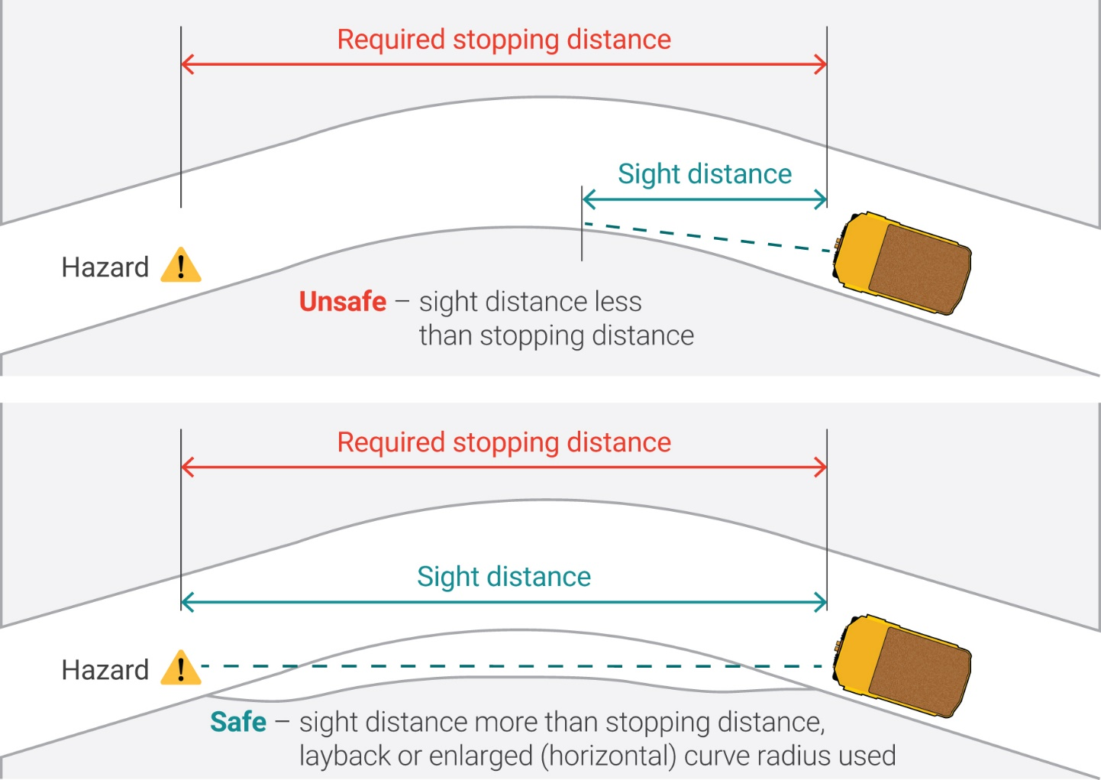

* horizontal compound curves are curves where the radius changes significantly through the curve, but the road maintains the same direction. Compound curves shall not be used. (refer to Figure 4 below).

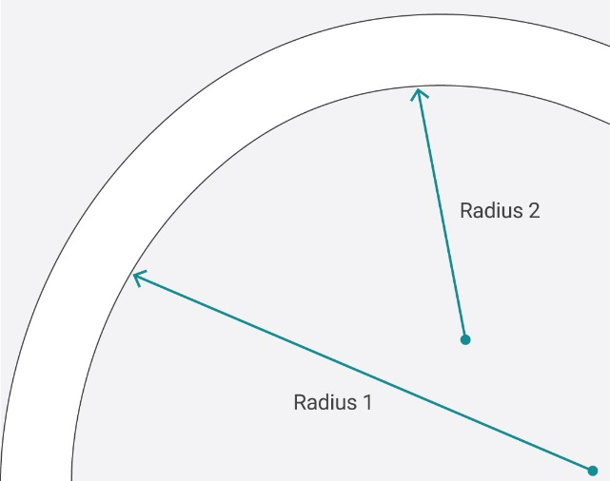

*Figure 4. – Compound curve*

* horizontal reverse curves (i.e., a curve in one direction subsequently followed by a curve in the opposite direction – refer to Figure 5. below) should typically be separated by a minimum straight section of road:
  + 60km/hr – minimum straight length – 36m
  + 40km/hr – minimum straight length – 24m
  + 20km/hr – minimum straight length – 12m.

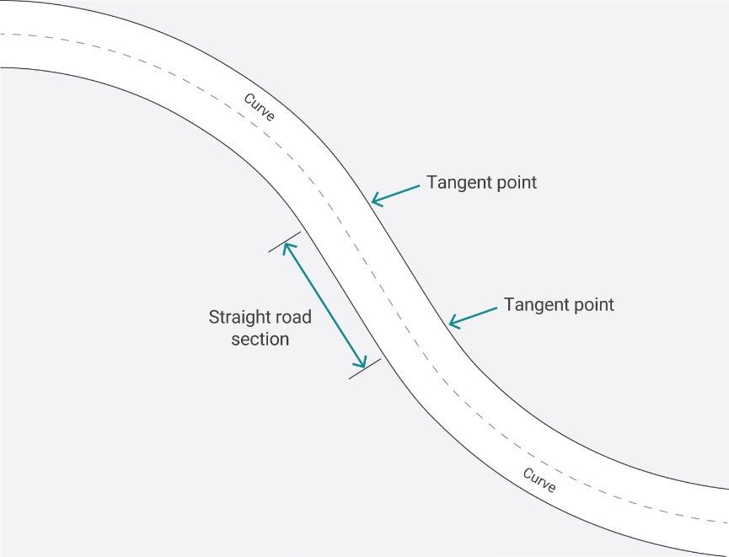

*Figure 5 – Horizontal reverse curve*

* horizontal and vertical curves should complement each other:
  + horizontal curves at the crest of vertical curves should be avoided as sight distance is generally restricted and it is difficult for drivers to perceive curves in such a situation.
  + sharp horizontal curves should be avoided at the base of ramps or long sustained downhill grades as vehicles are typically at their highest speeds at these locations.
* switchbacks should have the largest radius possible and be placed on flat sections of the ramp. They should not be placed on grade as the inside curve may exceed design gradient parameters.

## 3.5 Superelevation

Vehicles negotiating curves are forced radially outward by the centrifugal force. Counteracting forces are the friction between the tyres and the road surface and the vehicle weight.

Superelevation is the one-way crossfall (or banking) of a road surface towards the centre of a horizontal curve. This crossfall enables the design vehicle to negotiate the curve at the design speed with minimal side forces. Superelevation should be reduced on ascending grades and in slippery areas.

The level of required superelevation depends on the vehicle speed, radius of the curve and the side friction factor (friction between the tyre and the road surface) and is calculated from the following equation:

$$e+f=\frac{V^{2}}{127R}$$

$e$– superelevation rate [m/m] $V$– vehicle speed [km/h]

$f$– side friction factor $R$– curve radius [m]

The superelevation needs to be gradually developed throughout the superelevation development length to assist operators in manoeuvring their vehicle through the curve. One-third of the development length should be in the curve and two-thirds on the tangent as shown in Figure 5.

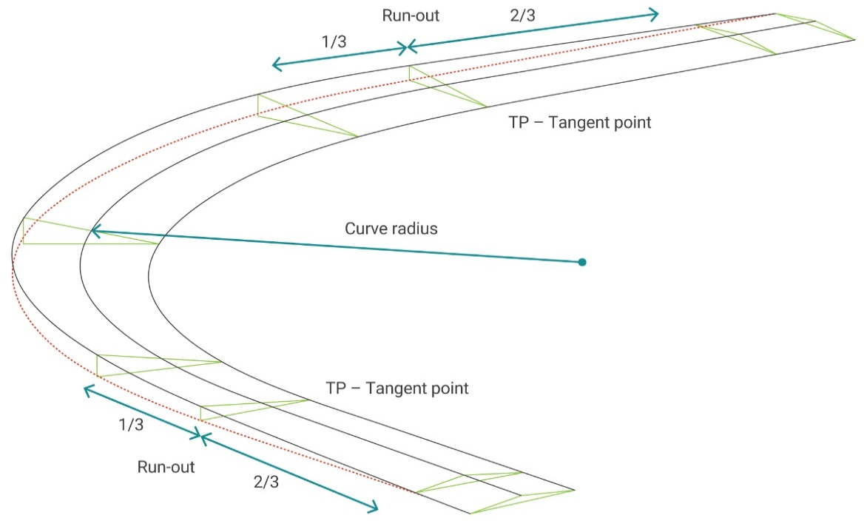

*Figure 5. – Superelevation and run-out schematic*

It is, however, acknowledged that designing, constructing and maintaining curves with precise superelevation rates may not always be practical. While the correct rate of superelevation should be provided wherever possible, it is a minimum requirement that all curves on primary and secondary roads shall be provided with a practically achievable and maintainable level of banking between 2 and 4%.

On higher speed roads, the superelevation may be increased up to 6%. Superelevation values above 6% are likely to cause problems with water scour damage to road surfaces and could cause problems with instability of vehicles. Rates above 6% shall not be used.

Apart from large radii curves or roads with low-speed limits, all road curves shall be provided with a practical superelevation rate.

Curves shall not be provided with negative superelevation (where the outside of the curve is lower than the inside of the curve) as this can have serious safety issues for passing traffic.

## 3.6 Grade

When determining the maximum gradients to be used at an operation, reference should be given to the manufacturer specifications for the existing or expected vehicle fleet. This includes all vehicles likely to use the mine roads, not only the mining haulage fleet. A decision may need to be made to:

* Design the ramps to accommodate the vehicle type with the lowest permissible operating gradient, or
* Restrict the mining fleet to only those vehicles that can operate on the selected gradient

Road gradient should be smooth, constant and not a combination of grades (or grade “breaks”) as shown in Figure 1.

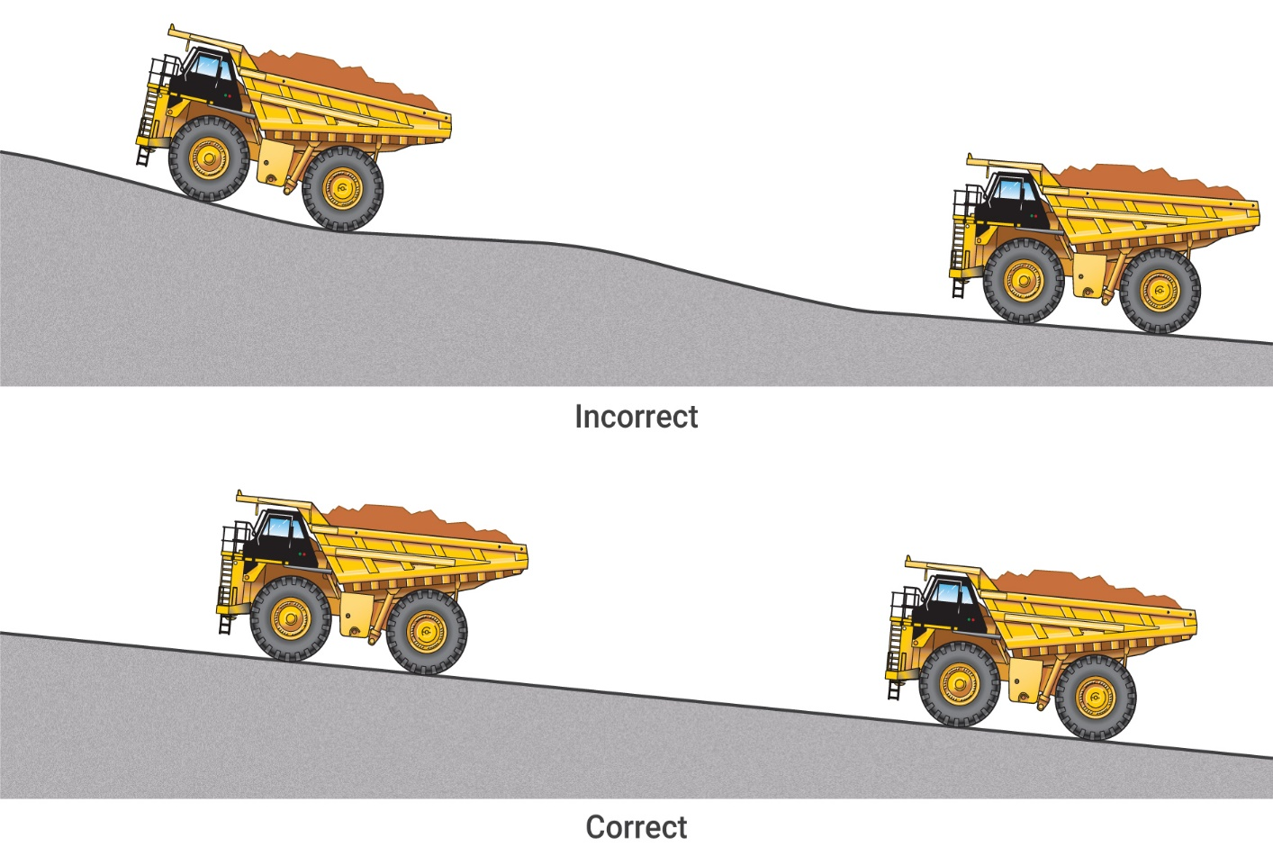

***Figure 1: Incorrect and correct ramp gradients***

Optimal operating conditions occur for maximum sustained grades of 7% – 9%. However, it is generally accepted to use 10% (1:10) as a maximum safe sustained grade.

Ramps with grades of 1:9 or 1:8 should only be used for machinery where these grades are within the OEM operational limits and subject to a formal risk assessment. In no instance shall OEM vehicle operating specifications be exceeded.

* an assessment of risk shall be undertaken to identify controls for managing design grades exceeding 10 % so the level of risk is at an acceptable level.
* underground mine design of 10% to 15% is a typical gradient, assessment needs to be conducted to integrate open pit to underground gradients.

Approaches to intersections where vehicles are expected to regularly stop (i.e. on the minor approaches facing Stop signs), a flat area should be provided with the length of one design vehicle.

Vertical curves

Vertical curves (crests) are inherently unsafe features and, consequently, road network planning and road design efforts should ensure that there are no vertical curves on the mine road network.

Vertical curves should provide smooth transitions from one grade to another. Their lengths should be adequate to drive comfortably and provide ample sight distances at the design speed.

As for all mine roads, it is essential that the sight distance provided to an operator is sufficient to enable a vehicle travelling at the design speed to stop before reaching a hazard. The distance measured from the operator’s eye to the hazard ahead must always equal or exceed the required stopping sight distance.

The first diagram in Figure 2 shows that the required stopping distance exceeds the available sight distance. In this case the operator would not have the time to bring the truck to a stop before reaching the hazard located around the crest.

In the second diagram the required sight distance has been achieved by lowering the crest. Where lowering a crest may not be possible, signage should be installed to warn operators to reduce the speed over the crest. Crests with substandard visibility may also be widened and/or a low centreline windrow installed along the crest to separate vehicles travelling in the opposite directions.

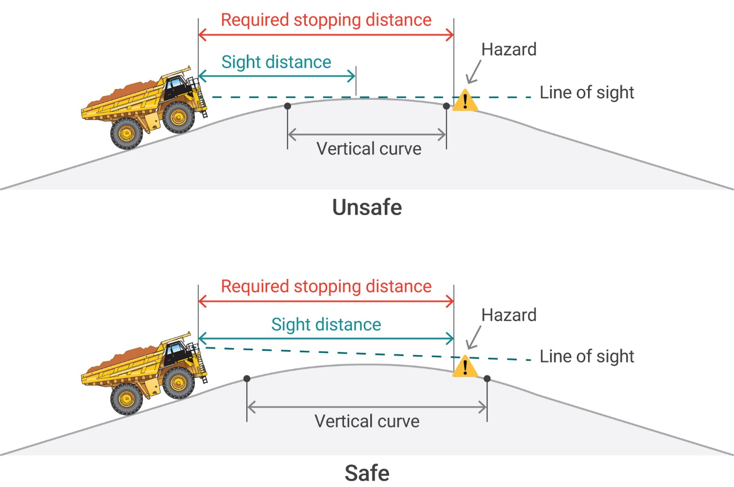

***Figure 2: Stopping sight distance on vertical curves***

## 3.7 Drainage

Mine roads should be constructed with adequate roadside drainage to ensure water is removed from the running surface and away from the road. Poor roadside drainage and water ingress into structural layers of a roadway is a common cause for mine road pavement failures.

Maintaining the crossfall to 3-4% ensures quick removal of runoff water from the running surface into the side drains. The side drains should be designed to lead the water off the road without causing erosion. Side drains should typically have a V or trapezoidal shape with a 0.5m depth with drain slopes of 1:3-1:4.

Where designated flood ways cross roadways (as either low level crossings or culvert crossings) the road base (and outlet locations in the event of a culvert crossing) should be constructed with suitable material to withstand significant erosion in the event of water flowing over the roadway.

Provision should be made for water to be directed off the road edge via drainage breakthroughs in the safety berms or grader run outs. Road maintenance activities (such as grading) must not affect the effectiveness of the drainage system by blocking the drains or outlets.

## 3.8 Intersections

The basic principles of good intersection design should be followed when designing and constructing all primary and secondary road intersections:

* intersections should be designed to accommodate the design vehicle movements – the design vehicle should be able to turn without encroaching into opposing lanes.
* preference should be given to three-way (T-intersection) over four-way intersections.
* the angle of intersecting roads shall be 90 degrees (+/- 5°) to maximise sight distance between drivers (‘Y’ junctions shall be avoided).
* gaps should be placed in windrows within 20m of an intersection to allow for drainage.
* windrows leading up to intersections for a minimum distance of 50m shall be lowered to 1m in height (unless acting as a barrier against on open face or similar hazard in which they should have standard height).
* intersections should be positioned in safe locations away from horizontal and vertical alignment changes (safe and unsafe locations of intersections in horizontal and vertical planes have been presented in Figure 3).
* ssD shall be provided on the minor approaches to the intersection (i.e. on the approach where the driver may need to stop before entering the through road)
* traffic splitter islands (1m high, 20m minimum length and set back 2m from the through road) should be installed to slow speeds of turning vehicles with Keep Left signs installed on islands.
* give Way or Stop signs should be installed on the left side of the intersection not more than 10m back from the through road and doubled up with a second sign on the traffic splitter island.
* termination (chevron) boards should be installed opposite the terminating leg of T intersections (at intersections where it has been determined that drivers may not clearly observe the termination of the road).
* minor approach roads to intersections should be constructed on a flat area for the minimum length of one design vehicle (both on inclines and declines).
* consistent delineation (such as Dingo Eyes, whirly birds and similar) should be installed at all intersections across a site.
* directional signage should be provided at intersections where it is determined the road layout may not be familiar to road users).
* wherever possible and practicable, LV slip/bypass roads should be installed to separate LV and HV turning movements (ensuring that the provision of bypass roads does not result in an increased level of risk).

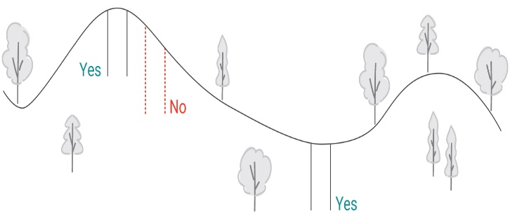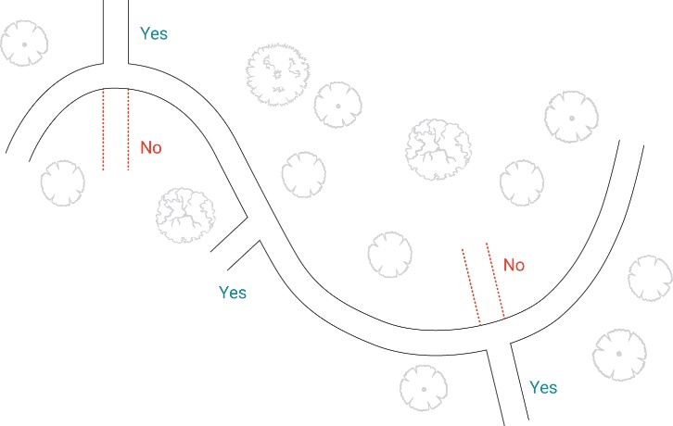

***Figure 3: Planning for intersection location***

**Four-Way Intersections**

Crossroads or four-way intersections should be avoided as they feature a high number of potential conflict points between vehicles. There will be instances, however, where a four-way intersection is the only, or the safer, intersection configuration. Four-way intersections can be replaced with two T-junctions (staggered junction).

All approach roads shall be divided down the road centre using 20m long splitter islands with Keep Left signs installed. One road shall be given priority by using intersection priority signs (Stop or Give Way signs).

The minor approaches to the intersection shall be designed so that the approaching drivers are provided with the SSD to the point of stopping before entering the through road.

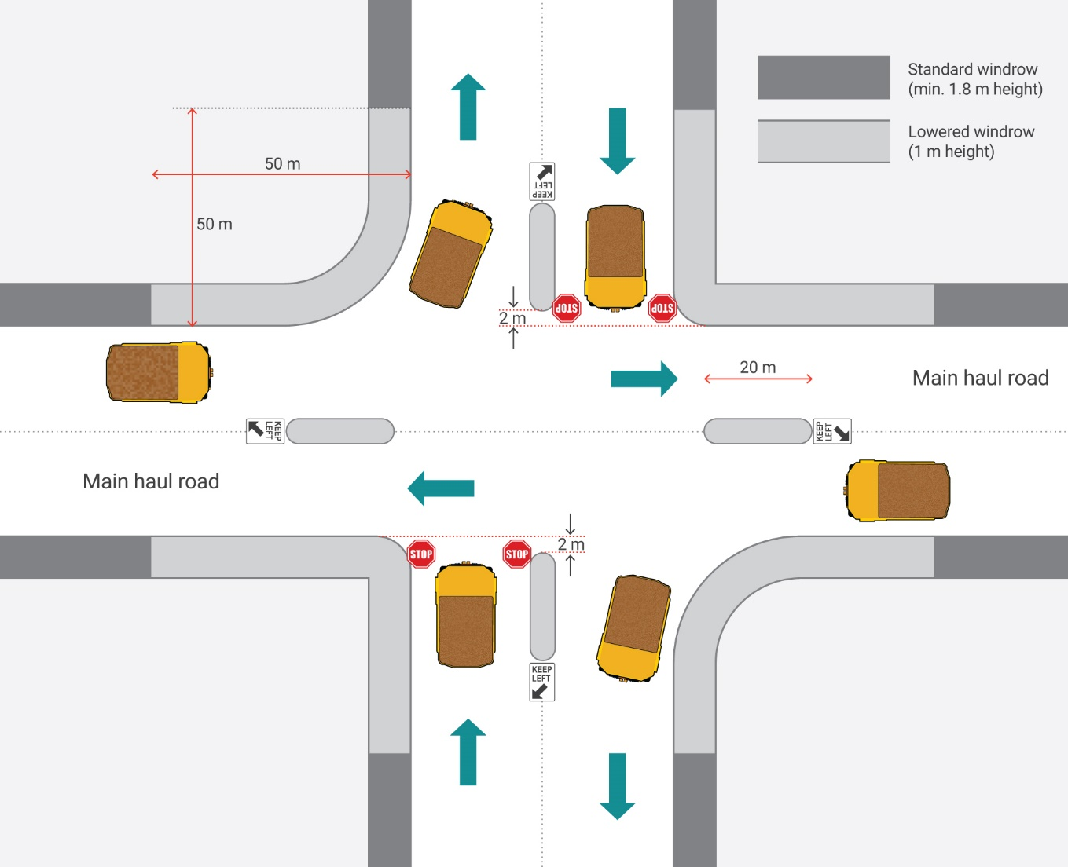

***Figure 4: Schematic configuration of a typical four-way intersection (note: this typical configuration shall be adjusted to the specific application in terms of road widths, windrow requirements, specific signage, etc.)***

**Three-Way Intersections**

T- Junction or three-way intersection is the preferred configuration of all intersections.

The general layout of a three-way intersection presented in Figure 5 and is applicable to all roads with the appropriately adjusted road dimensions.

The minor approach to the intersection shall be designed so that the approaching drivers are provided with the SSD to the point of stopping before entering the through road.

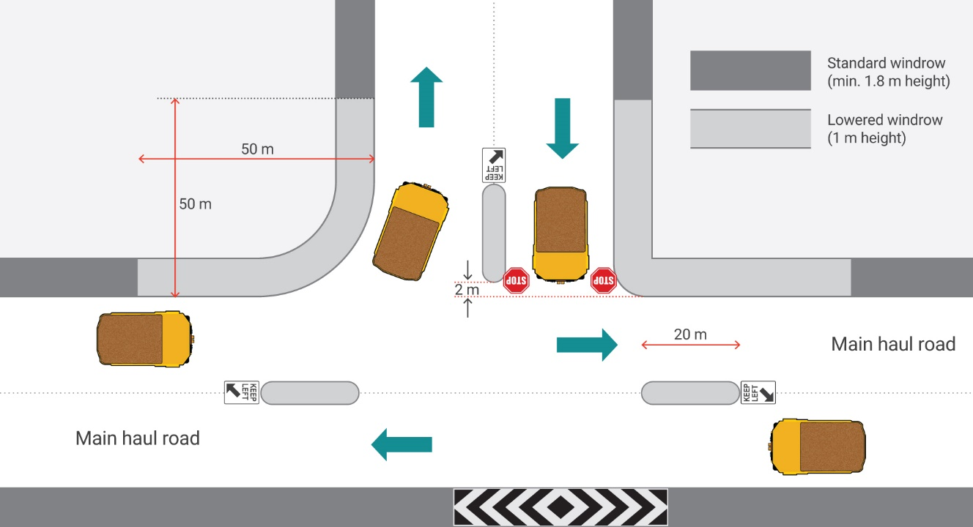

***Figure 5: Schematic configuration of a typical three-way intersection (note: this typical configuration shall be adjusted to the specific application in terms of road widths, windrow requirements, specific signage, etc.)***

**Staggered Intersections**

If planned for appropriately, four-way intersections can be replaced by left-right staggered intersections. Crossing vehicles have to first turn left (i.e. into the first lane on the through road) and then turn right. The left-right configuration avoids turning vehicles crossing two lanes.

For operating speeds of 60 km/h, the distance between the two staggered intersections should be 75 m (i.e. 4.5 s travel time) and for speeds of 40 km/h and below, the distance should be 50 m.

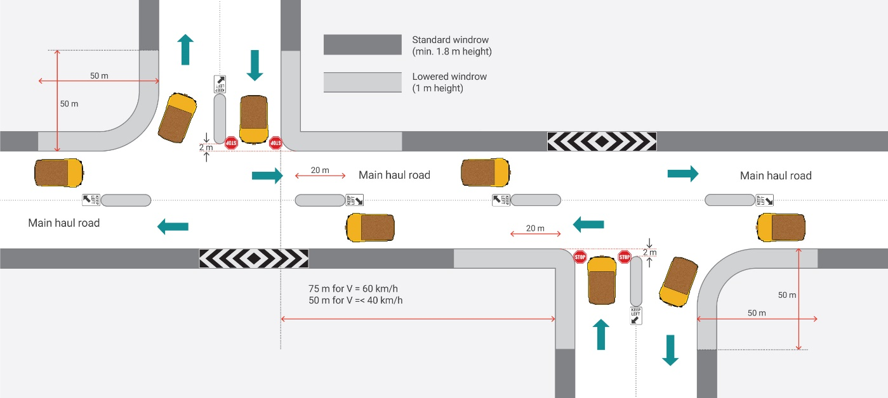

***Figure 6: Staggered intersection (note: this typical configuration shall be adjusted to the specific application in terms of road widths, windrow requirements, specific signage, etc.)***

**Change in traffic priority flow**

The configuration of intersections should generally accommodate and prioritise predominant traffic flows. However, the dynamic nature of mining operations often results in changed directions of primary traffic flows. In these cases, intersections shall be reconfigured to clearly designate the updated priority. Repositioning of traffic control signage is not a sufficient traffic management control for these situations.

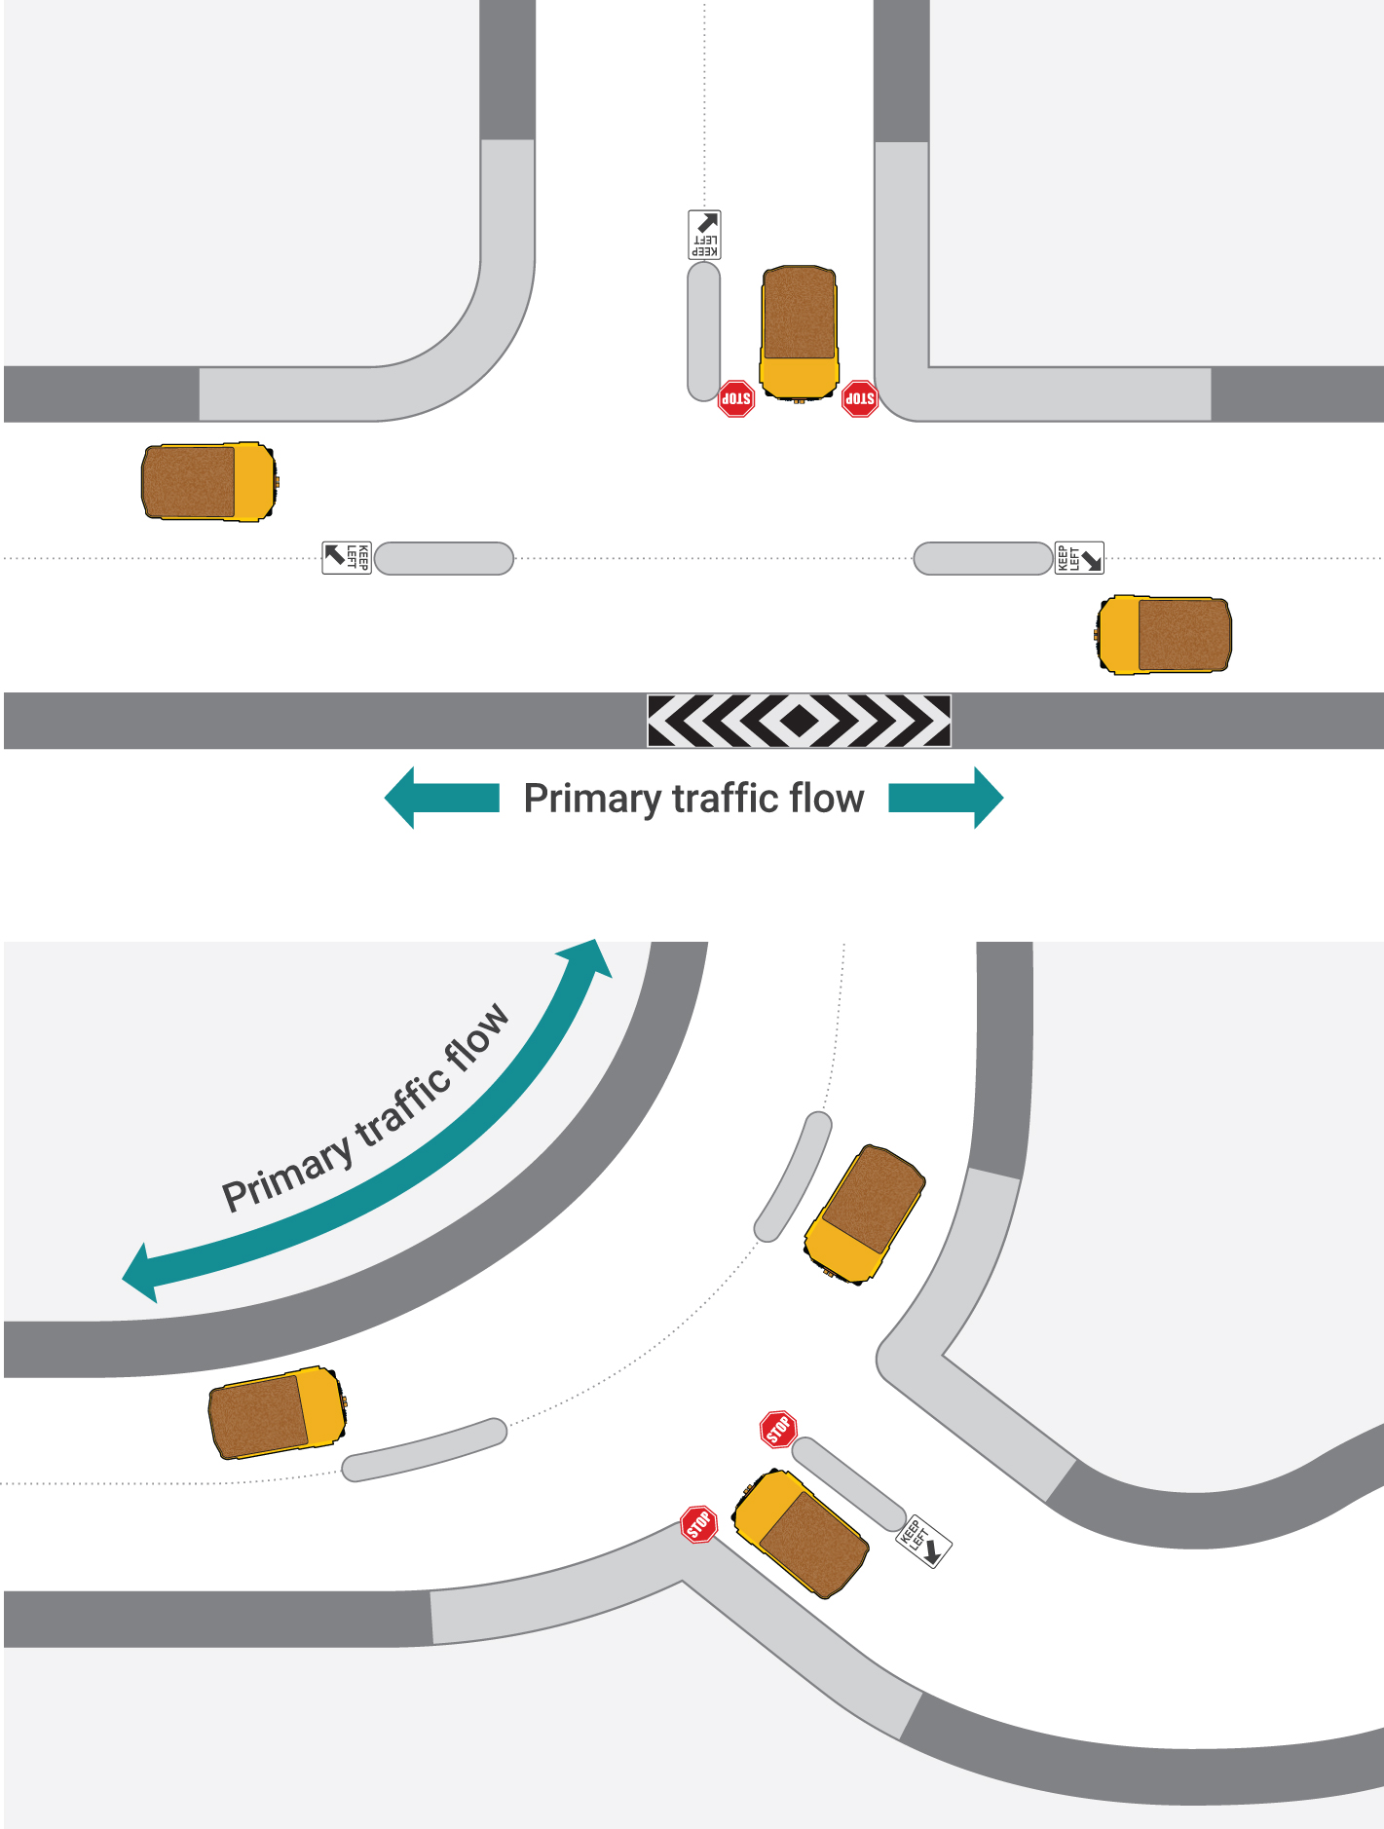

***Figure 7: Change in traffic flows should be accompanied by change in intersection configuration***

Intersections shall be positioned and designed to maximise sight distance on approach and throughout the intersection.

**Safe Intersection Sight Distance**

Safe intersection sight distance (SISD) is the minimum visibility which should be provided on the major road at any intersection. It provides sufficient distance for an operator of a vehicle on the major road to observe a vehicle on a minor road as it approaches. It avoids moving into a collision situation (in the worst case, stalling across the traffic lanes), and allows deceleration to a stop, before reaching the collision point. It is generally sufficient to enable LVs to cross a major road safely from a side road.

SISD is calculated in the same way as the SSD but with three seconds of observation time added to the distance travelled at the posted speed limit.

Sight distance shall be measured for the operator eye height of the lowest vehicle using the road (such as utilise 1.5m for a light vehicle) to largest vehicle with the longest stopping distance (such as truck). This means that the visibility should be checked both in horizontal and vertical plane.

HVs and poorer road surface conditions may require an increased stopping distance and hence an increased minimum sight distance.

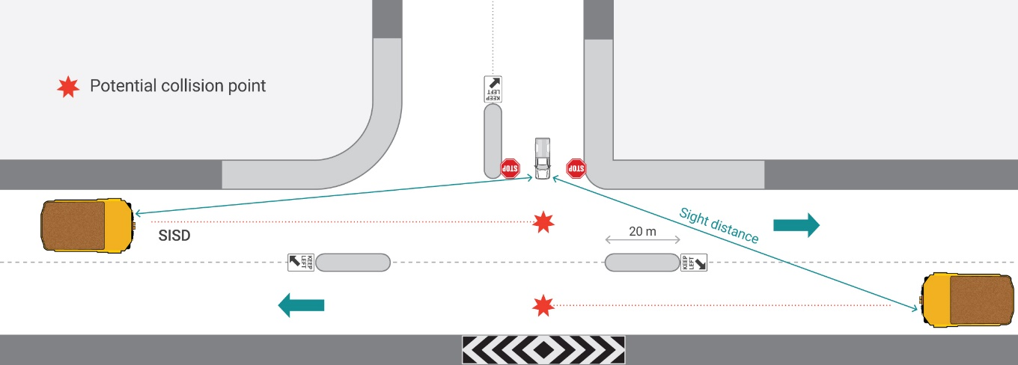

***Figure 8: Safe Intersection Sight Distance***

On sites that operate under Priority Control (i.e. vehicle priority at an intersection is not established with Stop or Give Way signs), SISD shall be provided on all approaches to an intersection.

## 3.9 Windrows

Mine roads shall be designed and constructed to address the risk of a vehicle accidently leaving the roadway. Where a roadside hazard exists such as a vertical drop-off (>0.5m) along the road edge or a steep or sustained shoulder grade steeper than 1X to 4Y ratio a suitable safety berm (or other physical barrier) shall be established in the affected area.

Windrows are used on mine roads to absorb some of the impact energy if hit by a vehicle, and to redirect an errant vehicle back on the road. Windrows are intended to redirect or deflect rather than take direct impact and stop a loaded truck from leaving the road. Steep configuration of windrows minimises the risk of trucks rolling over upon impact with a windrow.

The composition and the natural angle of repose of the materials used to construct windrows significantly influence how the windrows perform. The slope of the inner (road) side of the safety windrows should be preferably as steep as possible by using an engineered or stabilised material. A steep (inner) windrows face ensures better redirection of vehicles and reduces the possibility of a vehicle to climb and roll over.

Windrows should be considered a road hazard in their own right and their use should be based on a risk assessment. There are numerous examples where vehicles, large and small, have rolled over upon driving onto windrows. For this reason, they should only be installed where the risk of a vehicle driving beyond the windrow is greater than the risk of a vehicle overturning upon impacting the windrow. For example, if an errant vehicle can leave a road without impacting a hazard in the surroundings, a windrow may not be required.

Windrows should be typically installed where:

* embankment batters slopes exceed 1:4
* roadside drop-offs are greater than 0.5m
* there is an unacceptable risk of collision between vehicles and roadside hazards (trees, rocks, water bodies

The following requirements should be considered when designing windrows:

* standard-height windrows shall be constructed to the height equal to half the diameter of the design vehicle tyre
* in locations considered presenting a higher risk, windrows shall be constructed to 2/3 the height of the design vehicle, or higher
* windrows should be constructed with unconsolidated, durable and relatively homogenous material.
* old tyres, drums, concrete blocks, etc. shall not be used for constructing windrows.
* windrows should be kept clear of large rocks capable of damaging vehicles and cutting tyres.
* rocks should not be left at the base of windrows during road maintenance.
* breaks should be left in areas where water could pool to allow for drainage of the road surface.
* opportunities for frequent discharge of water in the surroundings should be identified with breaks left approximately every 75m to allow for the drainage of water off the road surface.

Increasing windrow height to 3m and more, and overall width of 7m and more may be required in areas that represent a higher level of risk such as:

* drop-off heights of more than 5m directly along the road edge
* high travel speeds or higher approach speeds
* windrows constructed with poorer quality materials
* where windrows control changes from a deflection mechanism to more of an impact absorption mechanism, for example when approach angles are less acute
* on roads used by 4x6 and 6x6 wheel drive articulated dump trucks as these have a higher ability to climb steep embankments

As the size and shape of windrows may be altered by erosion, material settling or by contact from mining equipment, windrows shall be regularly inspected and maintained to the required dimensions.

* standard trapezoidal safety berms on heavy haulage roads shall have a minimum height equal to or greater than 50% of the tyre diameter of the largest vehicle regularly using the road (Refer to Figure 4.14 below).
* standard triangular safety berms on heavy haulage roads shall have a minimum height equal to or greater than 66% (2/3) of the tyre diameter of the largest vehicle regularly using the road (Refer to Figure 4.14 below)
* the roadside facing batter angle of safety berms should be 45 degrees (1Vert. to 1Horiz.)

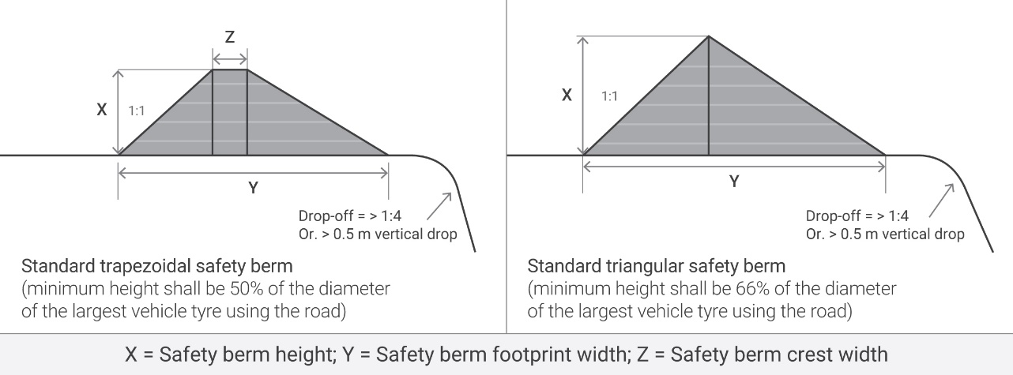

*Figure 4.14. Design requirements for standard Trapezoidal and Triangular safety berms*

The following table details typical safety berm dimensions for vehicles:

Table 5 Safety windrow

|  |  |  |  |  |  |  |  |
| --- | --- | --- | --- | --- | --- | --- | --- |
| Vehicle | Standard tyre size | Inflated tyre diameter | Standard trapezoid safety berm | | | Standard triangular safety berm | |
| x | y | z | x | y |
| MV/LV | Varies | 1.4m | 1.0m | 2.6m | 1m | 1.5m | 2.3m |
| Cat 777 | 27.00R49 | 2.7m | 1.4m | 4.1m | 1m | 1.8m | 4.2m |
| Cat 785 | 33.00R51 | 3.2m | 1.6m | 5.1m | 1.4m | 2.2m | 5.1m |
| Cat 789 | 37.00R57 | 3.5m | 1.8m | 5.5m | 1.4m | 2.4m | 5.6m |
| Cat 793 | 46.90R57 | 3.6m | 1.8m | 5.6m | 1.4m | 2.4m | 5.6m |
| Kom 930E | 53.80R63 | 3.8m | 1.9m | 6.0m | 1.6m | 2.6m | 6.0m |
| Cat 797 | 59/80R63 | 4.0m | 2.0m | 6.3m | 1.6m | 2.7m | 6.3m |
| Note: Safety berm footprint width is based on a roadside facing batter angle of 45° and an outer side batter angle of 37°. Some dimensions have been adjusted for standardization. | | | | | | | |

**Application of windrows**

The typical application of windrows is to prevent vehicles from driving off the edge of a road. However, windrows have several other applications as per the following:

**Separation windrows**

Windrows should be used to separate roadways (opposing lanes of traffic flow) in areas such as known fog zones, on left hand curves and particularly left hand curved downhill ramps. On some long haulage roads, separation windrows may be even more important than edge windrows due to the risk of head-on collisions between vehicles. In these circumstances the roadway should be separated by a median/centre safety berm that is at least half the height of the design vehicle tyre.

**Road dividers (splitter islands)**

Windrows should also be used as road dividers and median islands where extra traffic control is required or a particular localised hazard exists such as ramp crests, tight radius curves, intersection approaches, etc. Windrows used for this purpose should be constructed using crushed material to avoid tyre damage. This type of windrows shall be constructed and maintained at a height of 1 -1.2m maximum to allow visibility for LV operators.

**Delineation**

The purpose of delineation windrows is to assist with traffic flow by clearly defining running tracks and travel ways while reducing the surface area for road maintenance activities. Delineation windrows are used to provide a defined travel way and should be used on dumps, pit floors and active mining areas, and should have guideposts installed. They are not used for protection.

Delineation windrows should be approximately 0.3-0.5m high (i.e. ‘grader windrow’).

**Drill patterns**

Windrows used to delineate and separate drill patterns from adjacent roads and activity areas should be constructed to half the design vehicle tyre height when located adjacent to HV operating areas or 1m when separating from LV operating areas.

**Tip head/dump windrows**

The minimum height of tip head windrows is 1.8 m. A risk assessment should be completed for dumps higher than 10m and this may determine that increased height is required.

If not maintained properly, materials can accumulate at the toe of the windrow creating a ramp and lowering the effective height of the windrow. It is paramount that active tip head windrows are adequately maintained.

**Light vehicle windrows**

Where the use of windrows on roads used exclusively by LVs is warranted, these shall be constructed to a minimum 1m height.

Depending on the speed of vehicles, severity of the roadside hazards, volume of traffic, horizontal and vertical geometry (such as tight curves on a downgrade, crest, etc.), forward visibility, etc. the height of LV windrows at critical locations should be increased above the minimum height.

Roadside hazards along primary and secondary access roads can be protected by windrows and other types of barriers such as metal W-beam guard rails, concrete barrier, cable rails, bollards, water-filled barriers (for temporary use only), etc.

These barriers shall be designed and installed by specialised and qualified designers and installers and they shall be supported with an engineering certification that demonstrates the adequacy of that control measure for the application.

#### **Runaway provisions**

Safety features should be incorporated into road design to guard against the consequences of runaway vehicles. As previously noted, typical edge-of-road windrows should not be relied on, by themselves, to stop a large haul truck. However, other methods such as the use of escape lanes and/or arrestor beds can bring a runaway vehicle to a safe stop and prevent an accident.

Two types of runaway control are centre berms and escape lanes. Centre berms are piles of loose granular material placed strategically along the centreline of the road.

In the case of brake or retarder failure, the driver manoeuvres the vehicle in line with the berm, so the vehicle straddles the berm and is brought to a halt. Consider the following when installing centre berms:

* the nature and size of the equipment that might need to drive on to or straddle the centre bench
* using material to provide sufficient drag on the vehicle
* positioning of the centre berms so vehicles have limited time to pick up momentum
* adequate space between berms to allow the driver time to position the vehicle

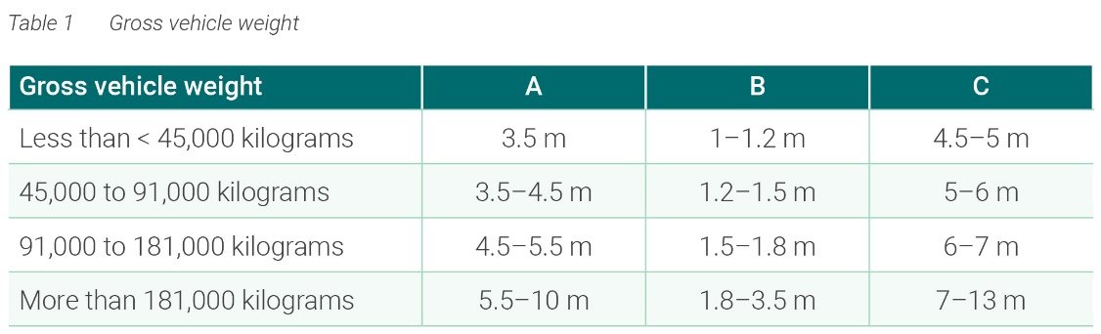

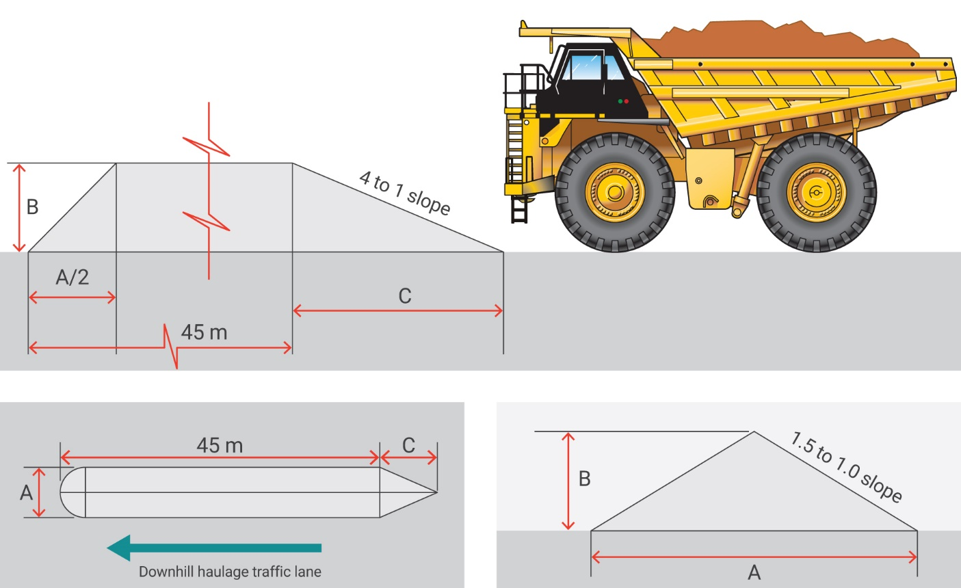

Escape lanes can be used where space is available. Consider the following when installing escape lanes:

* the size and expected speed of a runaway vehicle that might be required to enter the lane
* the alignment of the lane and the road

An operator of a runaway vehicle should be able to steer the runaway vehicle into the lane.

* size and length of the lane. The lane needs to be wide enough and of sufficient length to allow vehicle access and time for it to slow and stop
* construction material for the lane arrestor bed should offer a high rolling resistance and not tend to compact (such as loose gravel or crushed aggregate)

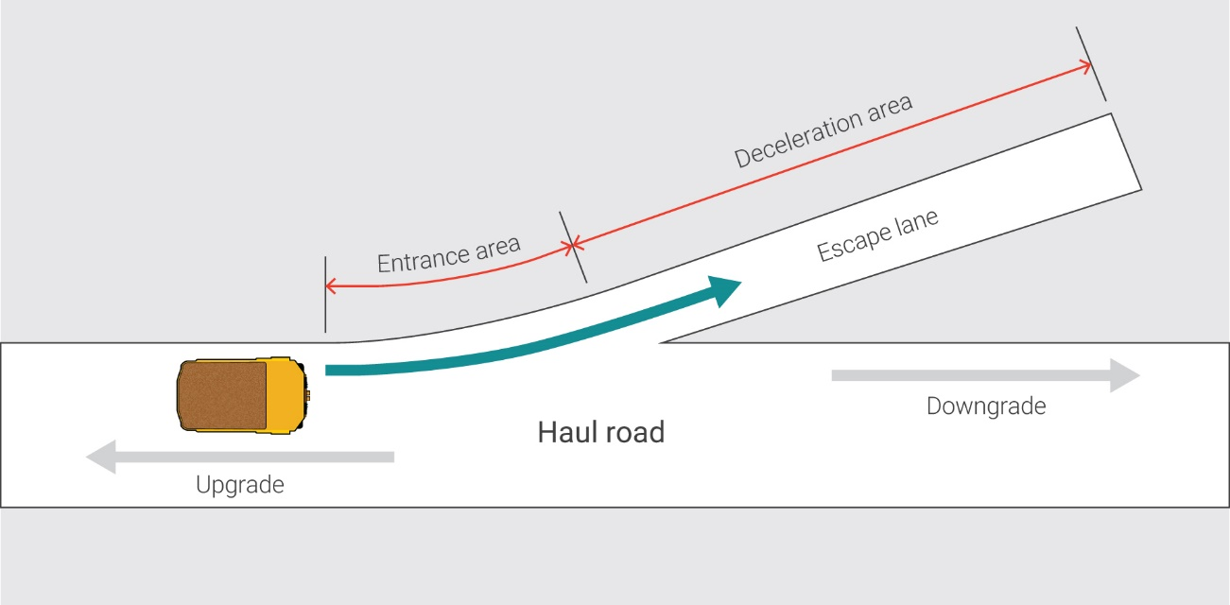

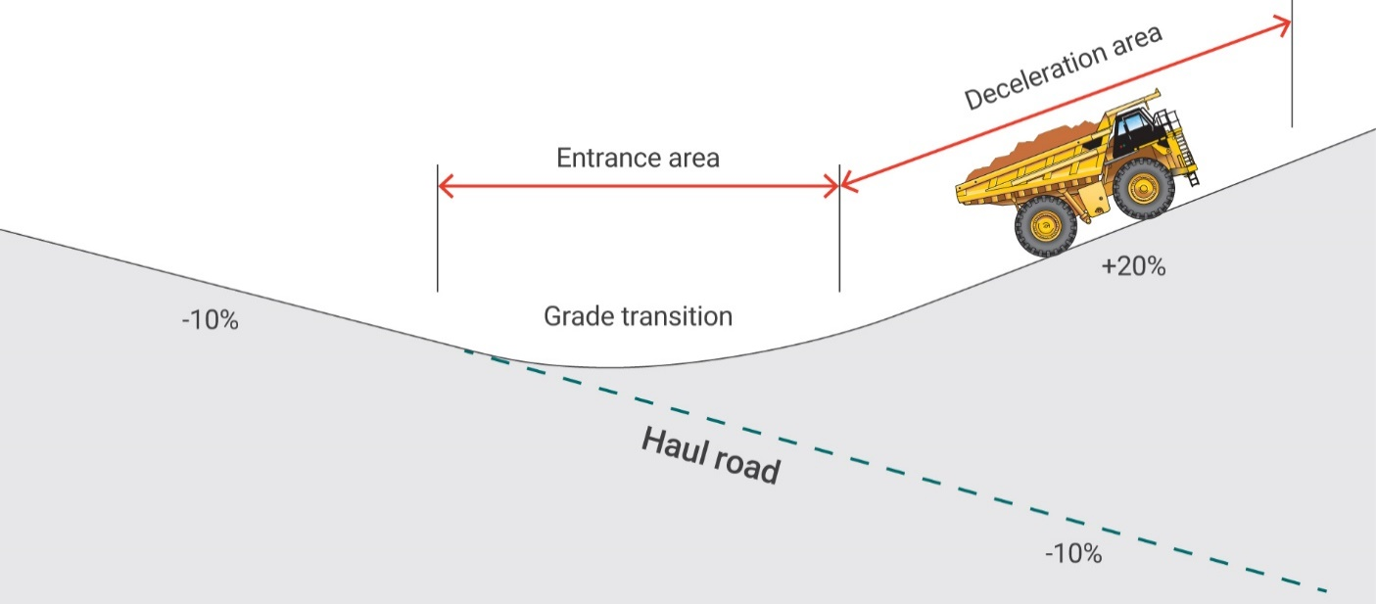

***Figure 9: Configuration of escape lane***

# 4. Traffic signs

Wherever possible, the use and the design of all traffic signs shall comply with the relevant standard that applies to the public roads in the jurisdiction where the mine is located. In Western Australia, signs shall comply with the *Australian Standard AS1742 (Traffic Control Devices for General Use)* and specific requirements by Main Roads WA. When ordering signs from suppliers, reference to the sign’s code from AS1742.2 should be made.

When installing signs, the following principles should be considered:

* signs should be installed on the left side of the road
* where additional emphasis is required or where there is risk for signs to be obstructed by vegetation, sun light, passing vehicles, etc. signs should be duplicated with a second sign installed on the other side of the road or on the median island
* signage should be adequately secured and facing traffic; ideally on rectangular profile steel poles driven into the ground
* regulatory and warning signs on roads used by large mobile machinery should be sufficiently large to be clearly visible to HV operators (based on signage Size B, as defined in AS 1742). Other roads or traffic areas should be provided with smaller sign sizes (Sign size A or B)
* the use of metal star pickets or concrete filled drums for sign installation should be avoided
* all traffic signs, with the exception of Keep Left signs that can be installed lower, should be installed at a minimum height of 1.8-2.0m between the road surface and bottom of the sign face
* there should only be one sign affixed to a post to ensure there is no confusion or dilution of the message conveyed by signs
* signs should not be placed in places where they obstruct driver visibility or create blind spots
* different signs should be installed 0.6 times the speed limit (such as 36m for 60km/h limit) apart to ensure that each sign is visible and their message is conveyed appropriately to drivers
* signs should be located 2-4m from the edge of the carriageway and not be installed high on windrows to minimise the risks for maintenance crews
* regulatory signs should be placed at the location where the specific regulation applies
* direction signs should be provided where considered to be necessary to assist non familiar drivers with wayfinding
* warning signs should be generally installed at a distance of 1.5 times the speed limit in advance of the hazard (with more details on the installation distances provided in AS 1742.2), with the distance determined by factors such as size, legibility of the sign, nature of the hazard and the prevailing speed (the driver should have enough time to take in the warning, react to its message and perform any necessary manoeuvre)

All road signs must be made of highly reflective material so that their colours and shapes are visible at night-time. The minimum reflectivity should be based on AS 1906.

Once installed, traffic signs should be maintained to ensure that they remain visible and relevant. Signs should be regularly inspected at night-time to ascertain their visibility under artificial lighting conditions.

Warning signs should only be used to avoid surprises to drivers. They are meant to designate unexpected situations. They should not be used often as otherwise their effectiveness can be significantly reduced. Warning signs should not be used if under normal conditions the driver can be expected to see and appreciate the potential hazard ahead.

**Application of specific signs**

Curve signs (W1-3) should only be installed where the maximum speed at which a curve may be comfortably negotiated under good road and weather conditions is more than 15km/h lower than the prevailing (posted) speeds.

Curve Alignment Markers (CAMs) (D4-6) should be used to augment the delineation of substandard curves and in conjunction with delineators. A minimum of three markers should be used on any one curve, while a minimum of two markers should always be visible to approaching vehicles.

Hazard Markers (D4-1-1, D4-1-2, D4-1-3) can be used to alert approaching traffic to the presence of an abrupt road narrowing or where there is a lateral shift, an obstruction in the road where all trafﬁc is required to pass to one side or vehicle paths at intersections.

Intersection Warning signs such as Crossroad (W2-1), Side Road Intersection (W2-4), Side Road Intersection on a Curve (W2-9) and similar, are intended to be used to warn drivers when the approach visibility to an intersection is inadequate, i.e. when a driver may not be able to notice the intersection with enough time to stop or avoid a hazard ahead. They are also used at intersections where an unusual layout is not readily discernible by approaching drivers. These signs shall not be used where direction signs, other devices or geometric cues give sufficient information to approaching drivers about the layout, importance or existence of the intersection or the intersection presents no greater hazard than other intersections in the vicinity.

Stop Sign Ahead (W3-1) and Give Way Sign Ahead (W3-2) should only be installed where it may not be obvious to an unfamiliar driver that they are approaching the termination of the road and they may not be able to stop the vehicle on time.

Where other cues are provided, such as reduced speed limits or termination boards, these signs should be deemed as not required and should not be installed.

The use of custom (non-standard) signs should be kept to a minimum and only used when the desired message cannot be conveyed using standard signs. When designing custom signs, it should be noted that a message is best conveyed through a graphical representation. Should a descriptive sign be required, the rule of maximum five words per line up to a maximum of five lines of text written in a text size which is legible at the required speed limit should be used. Non-standard signage should not be ambiguous or confusing – they should be used in accordance with their function and communicate their intent clearly. Minimum reflectivity must meet the requirements of AS 1906.

# 5. Design of parking facilities

The design of parking facilities should consider: 1. Gradients 4. Segregation for pedestrians 6. Shared zones 7. Segregation for buses 8. Driving out forwards 9. Signage 10. Driver change outs

Parking areas should be appropriately designed and configured to avoid risks created by the interaction of moving vehicles and pedestrians. In order to avoid these incidents, there are some basic principles that should be followed when designing LV and HV parking areas on mining operations:

**Separation of LV and HV parking areas, and separation of pedestrians**

LV and HV parking areas should be separated, and all parking facilities should have measures in place to separate vehicles from pedestrians.

**Demand and supply**

When planning new or reviewing existing parking areas, consideration should be given to the demand for parking. Oversupply of parking space can lead to poor parking discipline and conversion of parking areas to formal or informal storage and laydown use, creating safety issues. If, on the other hand, parking supply is insufficient for legitimate operational requirements, drivers will park unsafely or will drive around looking for a parking spot creating safety issues.

**Consistency**

The design of LV and HV parking areas should be as consistent as practically possible across an operation.

**Delineation**

Parking areas should be delineated to define their outline and to separate them from roadways. This can be achieved by using windrows, barriers or barricades.

**One-way circulation**

Parking areas should be built with a one-way traffic circulation to provide clarity of movement and reduce the possibility of collisions. One-way circulation should be supported by a clearly designated entrance and exit. These can be configured either as a single (or, in some instances, multiple) entry/exit access or a separate entry and a separate exit.

**Signage**

Appropriate signage shall be installed to regulate traffic movements in parking areas. Traffic signs should comply with the standards that apply on public roads in relevant jurisdictions. The one-way circulation through parking facilities should be achieved by installing No Entry signs at the entry and exit points of the facilities. Speed Limit signs may be required to remind drivers of the speed limit that applies within a facility.

**Fundamentally stable**

Vehicles shall be parked in a fundamentally stable position. This means that a vehicle cannot roll away or move when the vehicle is in neutral and the park brake has not been applied (or if the park brake fails). In order to ensure vehicles are parked in a fundamentally stable position, parking should ideally be built on a flat surface. Alternatively, measures such as wheel blocks, humps, drains or portable wheel chocks should be provided.

**Lighting**

Parking areas should be provided with direct or indirect lighting to assist drivers to park correctly and, most importantly, to increase the visibility of pedestrians as well as to assist pedestrians to avoid trip and slip hazards while walking to and from vehicles. Attention should be given to the positioning of the lighting sources so that they do not shine directly into operators’ eyes as this could create momentarily blindness.

**Speed limits**

The safety for vehicles and pedestrians should be reinforced by the use of appropriate speed limits. Car parks that are relatively short and/or where larger volumes of pedestrians can be expected should be sign posted with a 10 km/h speed limit. Larger parking areas can operate under a 20 km/h speed limit and 30 km/h speed limits should only be used in exceptional circumstances where parking areas require long travel distances and pedestrians are separated from vehicles.

**HV parking facilities in the mining areas**

HV parking areas should be designed so that there is a complete separation between HVs, LVs and pedestrians. Operations should develop a schematic of a typical HV parking facility and this should be used to design and construct new facilities as the mine develops.

HV facilities can be configured as drive-through or reversing facilities. It is important that the reversing parking facilities are provided with physical barriers to ensure that a reversing HV will not collide with another HV, a LV or pedestrian during the reversing manoeuvre.

If used, there should be a standard layout developed for hot-seat/changeover facilities within the mine. The design should consider physical separation between HVs and LVs/pedestrians, separation from other HV movements and measures to ensure the fundamental stability of the HV during the exchange of operators.

**LV Parking outside mining areas**

Outside of active pits and dumps, parking areas for LVs should be consistently designed and provided at locations where LVs regularly park (such as crib huts, offices, etc.)

LV car parks should have protected pedestrian walkways behind parked vehicles. Wheel blocks or drains should be provided to ensure that there is a minimum 1.5m (ideally 2m) clearance between parked vehicles’ rear axle and pedestrian walkways to create the necessary separation between pedestrians and vehicle trays.

Pedestrian walkways should ideally be elevated, 1.5-2 m wide, with formed surface constructed of compacted soil or concrete.

Car parks should not be located where reversing onto or from a through road is required.

Consideration should be given to the positioning of internal pedestrian crossings so that pedestrians are not hidden by parked vehicles when walking through the car park.

Parking areas on sealed surfaces should be designed and delineated in accordance with AS2890.1 *Parking Facilities, Part 1: Off-street car parking.* Appropriate measures should be provided to ensure fundamentally stable parking. These can include rubber wheel blocks and humps.

**Bus pick up and drop off facilities**

Where used, bus pick up and drop off facilities should be designed to:

* connect the main points at a mine
* minimise interaction of buses and pedestrians with passing vehicles
* ensure the visibility of pedestrians as they board and alight buses (such as lighting, positioning of bus stops).

# 6. Roads in the vicinity of powerline crossings and infrastructure

All locations where overhead power lines or structures cross mine roads shall:

* be passively measured by survey

For overhead structures (not power lines) have the maximum permissible vehicle height determined by applying a 1m minimum clearance distance.

For overhead conveyors have controls established to protect vehicles and pedestrians from potential falling material

Periodic survey of road heights should be undertaken to ensure clearance distance to overhead structures or power lines have not decreased over time by road maintenance.

When designing mine road routes, the hierarchy of controls should be considered when interacting with high voltage power lines:

* elimination – mine roads are kept well clear of power lines
* substitution – power lines are run under mine roads instead of above
* administration – signage warning of overhead power lines and clearance heights.

For power lines have the maximum permissible vehicle height determined by the Electrical Engineering Manager using the following minimum clearance requirements:

|  |  |
| --- | --- |
| Power Line Nominal Voltage (phase to phase) | Minimum Clearance |
| ≤ 1000 | 1.0m |
| > 1000 ≤ 33,000 | 3m |
| > 33,000 | 6m |

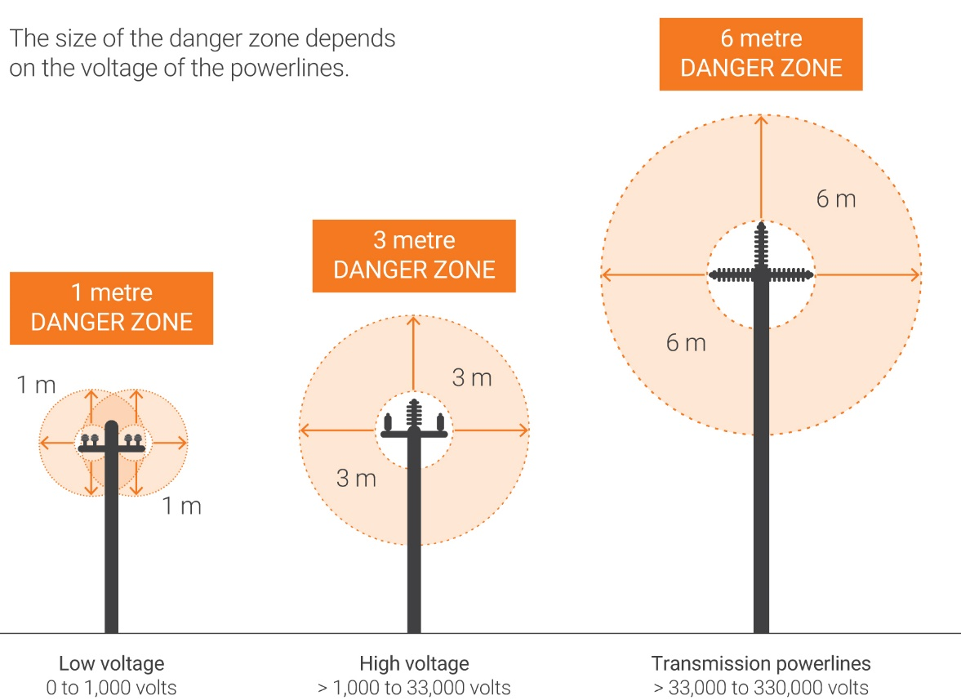

***Figure 10: Power line danger zones***

* power lines shall be recorded in a site register indicating:
  + crossing location coordinates
  + power line crossing number
  + survey height, date and time
  + power line voltage
  + maximum permissible vehicle height
* have signs installed to indicate the maximum permissible vehicle height and where applicable power crossing number.
* at power line crossing locations where the height of any vehicle capable of operating on that road exceeds the maximum permissible vehicle height of the crossing, have pre- warning clearance indicators installed

#### **Danger Zone**

A danger zone is a specific area surrounding live electrical apparatus that ordinary persons, equipment and materials must not enter. The size of the danger zone is determined by the voltage of the electrical apparatus.

Danger zone means anywhere that:

(a) is within 0.5 metres of a live insulated overhead power line or aerial bundled conductor line of a voltage of not more than 1,000 volts.

(b) is within 1.0 metre of a live uninsulated overhead power line of a voltage of not more than 1,000 volts.

(c) is within 3.0 metres of a live overhead power line, whether insulated or not, of a voltage exceeding 1,000 volts but not more than 33,000 volts; or

(d) is within 6.0 metres of a live overhead power line, whether insulated or not, of a voltage exceeding 33,000 volts

#### **Location and marking of overhead wiring (including aerial and catenary wiring)**

Overhead wiring should be positioned to avoid crossing roadways or access ways where cranes, high loads or heavy machinery may travel.

Where it is not possible to avoid access ways, an effective means shall be provided to minimize the risk of vehicular contact with the overhead wiring system.

This condition may be satisfied by the placement of flagged catenary wires or cables of suitable material across the access way-

(a) 6 m on either side of the overhead wiring; and

(b) 0.6 m below the lowest point of the overhead electrical cables or lower.

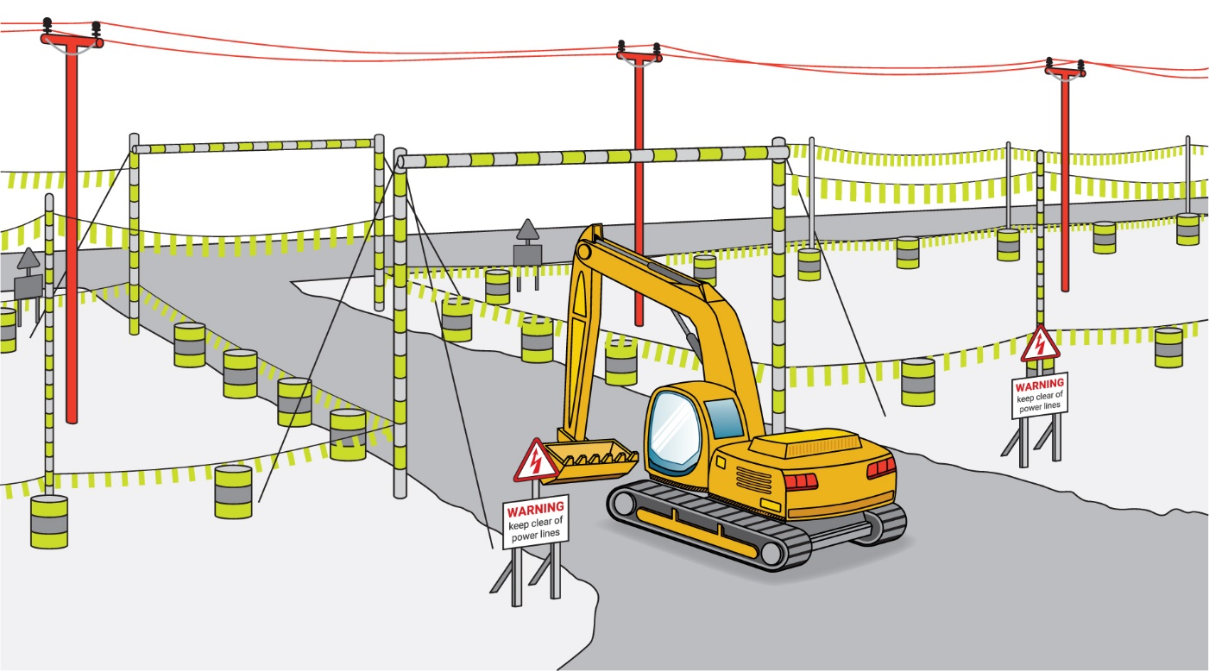

***Figure 11: Location of overhead wiring***

# 7. Buried services

Underground cables and pipes should be accurately located on a site plan and identified before digging.

Periodic survey of road heights should be undertaken to ensure standoff distance to buried services have not decreased over time by road maintenance.

**Cables installed underground shall** **be**:

* suitable for the environment in which they are placed
* provided with protection against inadvertent damage likely to be caused by manual or mechanical excavation work, and
* provided with suitable warnings, marking or other means to minimize the risk of inadvertent damage likely to be caused by manual or mechanical excavation works

**Identification of underground wiring**

Wiring systems installed underground shall be identified by orange marker tape complying with AS/NZS 2648:1. In order to provide early detection of the presence of underground wiring during excavation work, marker tape shall be positioned at approximately 50% of the depth of cover above the wiring system or any additional mechanical protection provided for that system.

**Proximity of services** – **below ground**

Any service trench that contains more than one individual service is generally referred to as a shared or common trench. Common trenches are a practical solution for the conveyance of multiple services and appear to be more commonly used within multi-unit developments.

The separation between any underground drain or water service pipe with an electrical supply cable shall be at least:

* 100mm for water service pipe not greater than DN65, provided the electrical supply cable is indicated along its length with orange marker tape complying with AS/NZS 2648.1 and is mechanically protected; or
* 300mm, where the water service pipe is greater than DN65 and the electrical supply cable is indicated along its length with marker tape complying with the requirements of AS/NZS 2648.1 and is mechanically protected; or
* 600mm where the electrical supply cable is neither indicated nor protected.
* all underground wiring systems suitably marked with warning tape shall be spaced not less than 100mm from other underground services.

#### **Bollards**

High visibility bollards, berms or segregation barriers should be installed where vehicles interface with surface infrastructure such as buildings, structures, service and corridors/or ground level or underground hazards such as covered sumps, soak wells and drains not designed to support the weight of vehicular traffic.

#### **Railway crossings**

The approval for mining road crossings with railways shall be obtained from the relevant railway infrastructure owner. The railway owner will outline the requirements and standards for the design of railway crossings.

# 8. Emergency management

The hazards and risks from roads and other areas where mobile plant operate on a mine site, and often at remote locations, mean that being prepared is critical to the health and safety of personnel. Emergency management involves understanding the likelihood of an emergency situation and its potential consequence, and being prepared to mitigate its effects, respond effectively and recovering afterwards. Effective emergency management means that there are plans in place for all foreseeable emergency scenarios, so the response is comprehensive and coordinated. These form the overall emergency plan for the mine, which is part of the mine safety management system for the mine.

The critical element of preparedness is the development of emergency response plans for identified emergency scenarios. All personnel should be familiar with the emergency response plan before entering the site, to ensure they understand their responsibilities and what to do in an emergency.

Emergency plans should be regularly tested to ensure their effectiveness. Both “desk-top” tests and emergency response drills involving all onsite personnel should be carried out. The drills can be used to evaluate how people respond. Debriefings conducted as soon as practicable after an emergency or drill will help identify potential improvements to the emergency response plan.

Procedures should be established for the use of emergency vehicles on a mine site. There are specific laws governing emergency lights on vehicles. The Mine Operator must ensure that Department of Transport requirements for Emergency Vehicle Status is complied with and that personnel are trained in the correct driving under operational conditions for emergency vehicles.

Refer to Department on Mines, Industry Regulation and Safety Emergency Management code of practice for details on how to develop and assess your emergency plan.

# 9 Monitoring and review

## 9.1 Monitoring

Once the controls for roads and other vehicle operating areas are established, it is important to ensure they remain effective and are maintained. To achieve this, regular inspection and monitoring systems should be established. The inspection and monitoring systems may include:

* review of effectiveness of training provided through in-field task observations
* operator and personnel hazard identification reports
* shift or daily inspections using structured inspection checklists
* Health and Safety Representative checks
* review to determine the effectiveness of the underground transport or proposed principal mining hazard management plan
* regular inspection and maintenance of roads and other vehicle operating areas, signage and traffic controls
* whole-body vibration testing audits
* auditing by external competent people

## 9.2 Audit

An audit will determine whether controls for roads and other vehicle operating areas are in place, including:

* mine workers understanding their responsibilities
* training has been carried out
* equipment is available, including monitoring equipment
* inspections have been carried out
* there have been appropriate responses to any triggers that have occurred
* required reports have been completed

The audit will provide information regarding how well the plan is being maintained. The audit plan should include the:

* frequency of the audits
* scope of the audit
* audit methodologies
* competency of the auditor
* responsibility for seeing the audit is conducted
* reporting protocol for the audit
* responsibility for acting on the audit report
* performance standards, which should be for the audit to find 100% compliance with legislation

DMIRS has developed several audit documents that can be used to assist mine operators in auditing their traffic management systems.

The ‘traffic management’ system audit documents cover:

* traffic management fundamentals
* traffic management
* mining operations and equipment selection
* surface and underground operations with site deliveries, and
* management of mobile equipment maintenance

## 9.3 Review

It is important to continually monitor risks and check control measures to ensure they remain effective. Control measures should also be reviewed when an incident occurs, or when any changes may raise a new or different risk associated with the road or other vehicle operating area.

In undertaking the review, workers using the road or vehicle operating area, and their site health and safety representatives, should be consulted and the following questions considered:

* are the control measures working effectively in both their design and operation?
* how effective is the risk assessment process?
* are all hazards being identified, managed and effectively controlled until rectified?
* are workers actively involved in the risk management process? Are they openly raising health and safety concerns and reporting problems promptly?
* what has been the effect, if any, of new work methods or changes in equipment?
* are safety procedures being followed?
* has the instruction and training provided to workers been successful?
* if new legislation, information or technology becomes available, does it indicate current controls may no longer be the most effective?

# Appendices

## Appendix 1 – Legislative provisions

The parts of the Western Australian *Work Health and Safety Act 2020* and the *Work Health and Safety (Mines) Regulations 2022* that are applicable to this code of practice are listed below.

***Work Health and Safety Act 2020***

**Part 2, Division 1 – Introductory**

s. 17 Management of risks

s. 18 What is reasonably practicable in ensuring health and safety.

**Part 2, Division 2 – Primary duty of care**

s. 19 PCBU, duties of

**Part 2, Division 3 – Further duties of persons conducting businesses or undertakings.**

s. 20 Duty of persons conducting businesses or undertakings involving management or control of workplaces.

s. 21 Duty of persons conducting businesses or undertakings involving management or control of fixtures, fittings or plant at workplaces.

s. 55 Duties of persons conducting businesses or undertakings that supply plant, substances or structures.

s. 26A Duty of persons conducting businesses or undertakings that provide services relating to work health and safety.

**Part 3, Incident notification**

s. 38 Duty to notify of notifiable incidents.

s. 39 Duty to preserve incident sites.

s.274 Approved code of practise

***Work Health and Safety (Mines) Regulations 2022***

**Chapter 3, Part 3.1 Managing risk to health and safety.**

r.34 Duty to identify hazards

r.35 Managing risks to health and safety

r.36 Hierarchy of control measures

r.37 Maintenance of control measures

**Chapter 5** – **Plant and structures**

**Part 5.1** – **General duties for plant and structures**

**Part 10.2 Managing risks, Subdivision, 1Control of risk.**

r.617 Managing risks to health and safety

r.618 Review of control measures

r.621 Duty to establish and implement mine safety management system

r.627 Identification of principal mining hazards and conduct of risk assessments

r.631 Movement of mobile plant

r.631C Quarry Operations

r. 631 & 631E Operation of autonomous plant

Schedule 19 Cl.4 Roads and other areas where mobile plant operate.

*Note: The only authorised versions of the Act and regulations are those available from the State Law Publisher (*[www.slp.wa.gov.au](http://www.slp.wa.gov.au)*), the official publisher of Western Australian legislation and statutory information.*

## Appendix 2 – Selected standards

Examples of Australian Standards ([www.standards.org.au](http://www.standards.org.au)) that may apply to emergency management and response are listed below.

*Note: This list is not exhaustive but gives an indication of the many aspects to be considered.*

### Safety lifecycle (risk assessment)

AS/NZS ISO 31000 *Risk management – Principles and guidelines*

AS/NZS 4024.1302 *Safety of machinery – Risk assessment – Reduction of risks to health from hazardous substances emitted by machinery – Principles and specifications for machinery manufacturers*

ISO 12100 *Safety of machinery – General principles for design – Risk assessment and risk reduction*

ISO 26262  *Road vehicles – Functional safety*

ISO 21448 *Safety of the intended functionality*

AS/IEC 61508.1 *Functional safety of electrical/electronic/programmable electronic safety-related systems – General requirements*

AS ISO 5006 *Earth-moving machinery – Operator's field of view – Test method and performance criteria*

ISO 13849 *Safety of machinery – Safety-related parts of control systems*

AS ISO 16001 *Earth-moving machinery – Hazard detection systems and visual aids – Performance requirements and tests*

AS 17757 *Earth-moving machinery – Autonomous machine safety (ISO 17757MOD)*

AS ISO 19014 *Earth-moving machinery – Functional Safety (Series)*

ISO 20474 *Earth-moving machinery – Safety (series)*

ISO 21815 *Earth-moving machinery – Collision Avoidance (Series)*

AS 1742 *Manual of uniform traffic control devices*

AS 1743 *Road signs – Specifications*

AS 2294.1 *Earth Moving Machinery – Protective Structures – General*.

AS 1657 *Fixed platforms, walkways, stairways and ladders – Design, construction and installation*

AS 1744: *Standard Alphabets for Road Signs*

AS/NZS 1906.1 *Retro-reflective materials and devices for road traffic control purposes – Retro-reflective sheeting*

AS 1940 *Storage and handling of combustible liquids*

*AS 2359.13 Powered industrial trucks – brake performance and component strength*

AS/NZS 4871.6 *Electrical Equipment for Mines and Quarries*

## Appendix 3 – Further information and guidance

### Safe Work Australia

Safe Work Australia ([www.safeworkaustralia.gov.au](http://www.safeworkaustralia.gov.au))has model codes of practice that may be useful, including:

### Department of Energy, Mines, Industry Regulation and Safety

The Department of Energy, Mines, Industry Regulation and Safety ([www.dmirs.wa.gov.au](http://www.dmirs.wa.gov.au)) has codes of practice, guidelines, significant incident reports and safety bulletins that may be useful, including:

<https://www.commerce.wa.gov.au/sites/default/files/atoms/files/221188_cp_msms.pdf>

https://www.wa.gov.au/system/files/2023-02/231149_GL_IncidentNotification.pdf

<https://www.commerce.wa.gov.au/publications/code-practice-work-health-and-safety-consultation-cooperation-and-coordination>

<https://www.dmp.wa.gov.au/Documents/Safety/MSH_AuditGuide_TrafficManagement.pdf>

Recognised Standard 19 – Design and construction of mine roads (resources.qld.gov.au)

ICMM Health and Safety Critical Control Management Good Practice Guide

<https://www.icmm.com/en-gb/publications/health-and-safety/health-and-safety-critical-control-management-good-practice-guide>

ICMM Critical Control Management Implementation Guide

<https://www.icmm.com/en-gb/publications/health-and-safety/critical-control-management-implementation-guide>

Resources Safety and Health Queensland – Minerals, mines and quarries [QGN 27 – Collision prevention (rshq.qld.gov.au)](https://www.rshq.qld.gov.au/__data/assets/pdf_file/0007/1346821/qld-guidance-note-27.pdf)

NSW Resources Regulator – Health and safety at quarries – guide – Nov. 2018 [nsw-resources-regulator-mines-and-quarries-book-complete-v6.pdf](https://www.resourcesregulator.nsw.gov.au/sites/default/files/documents/nsw-resources-regulator-mines-and-quarries-book-complete-v6.pdf)

NIOSH – Center for Motor Vehicle Safety – Behind the wheel at work – <https://www.cdc.gov/niosh/motorvehicle/ncmvs/newsletter/ncmvsnewsletterv5n1.html>

Safe Quarry – Coal Pro – UK mining resource [Layout 1 (safequarry.com)](https://www.safequarry.com/pdf/CoalProHealthandSafetysub-committeeTrafficManagementDocument.pdf)

Resources Safety and Health Queensland – Tyre fires, pyrolysis and explosions – [weblink](https://www.rshq.qld.gov.au/safety-notices/mines/tyre-fires,-pyrolysis-and-explosions)

Guidance Note QGN 27 – Collision Prevention – Resource Safety & Health Queensland – [link](https://www.rshq.qld.gov.au/__data/assets/pdf_file/0007/1346821/qld-guidance-note-27.pdf)

## Appendix 4 – Glossary

To reduce confusion and ambiguity, it is recommended that standard terminology is applied. For the purposes of this document, the following terms are defined.

**Bollards** – High visibility thick posts or segregation barriers installed where vehicles interface with surface infrastructure such as buildings, structures, service corridors, etc. and/or ground level or underground hazards such as covered sumps, soak wells and drains not designed to support the weight of vehicular traffic.

**Delineator** – Markers erected to define the edge of the running surface of a road.

**Grade** – The gradient on a ramp is the grade line profile along the road centre line. It is measured from the horizontal, +ve representing up grade and –ve representing down grade.

**Hazard** –in relation to a person, anything that may result in injury to the person or harm to the health of the person.

**Light vehicles (LV)** – Vehicles up to 4.5 tonnes gross vehicle mass.

**Light vehicle roads** – Light vehicle roads are roads that are used by light and medium vehicles for access around the perimeter of the pit, within pit areas and on the surface.

**Median/centre safety berm** – a safety berm that is placed along the centreline of a roadway to separate and/or define traffic flow.

**Medium vehicles (MV)** – On highway type vehicles greater than 4.5 tonnes gross vehicle mass. Typically refers to buses with more than 11 seats, light trucks, mobile cranes, crane trucks, service trucks, water trucks, explosive trucks, prime movers and multiple combination trucks.

**Mobile plant (MP)** – Means plant capable of being moved under its own power. Examples are draglines, shovels, excavators and off highway mining trucks.

**OEM** – original equipment manufacturer

**Permanent haul roads** – Major arterial roads used by haul trucks and the majority of mining traffic.

**Pit haul roads** – Roads that are used by haul trucks and other mine traffic in and around pit areas including, in pit haul roads and ramps, bench roads, dump roads and ramps, etc.

**Practicable** –means reasonably practicable, having regard to the severity, degree of risk and state of knowledge of any potential injury or harm to health, and the availability, suitability and cost of removing or mitigating the potential injury or harm to health (*Mines Safety and Inspection Act 1994* s.4)

**Risk** –in relation to any injury or harm, the probability of that injury or harm occurring.

**Roadway** – The part of a road intended for vehicles, in contrast to the pavement or verge.

**Safety bund** – Also be referred to as a berm, safety bund wall, bund wall, bund, or windrow is a triangular or trapezoidal shaped mound of earthen material used to redirect wandering vehicles and/or to absorb some of the impact energy if a vehicle hits them. They are a standard safety feature on a haul road, dump crest, pit wall crest or other areas where a vertical drop or collision hazard exists.

**Shoulder** – Road edge that is not considered the running surface for vehicles.

**SISD** – Safe intersection sight distance

**SSD** – Safe stopping distance

**SSE** – Site senior executive

**Super-elevation** – The cross gradient applied to switchbacks, corners and curves. It allows a vehicle taking a corner to counteract the ‘centrifugal’ forces by directing the vehicle weight towards the centre of the curve, like a velodrome.

**Vehicles** – The collective group of mobile plant, medium vehicles and light vehicles.

## Appendix 5 – Recommended content of a site traffic management plan (TMP)

A site TMP should include (but is not limited to) the following:

* + - * General provisions
        + purpose
        + scope
        + responsibility and accountability
        + management of change
        + auditing and updating
        + terminology
        + references
        + register of non-compliance
      * Vehicles
        + pre-start checks and fault reporting
        + minimum requirements
        + implementation and management of safe-driving technologies
        + mobile phones and portable electronic devices
        + autonomous vehicles
      * Operational requirements
        + fitness for work
        + permits and authorisations
        + off-site driving
        + driving rules
        + overtaking and following
        + speed management
        + communication
        + emergency procedures
        + interaction and separation of light vehicles, heavy vehicles and pedestrians
        + access to restricted areas and road closures
        + parking
        + breakdowns, recovery and towing
      * Roads
        + road hierarchy
        + geometric design
        + structural design
        + signage
        + delineation
        + intersection design and controls
        + roads in the vicinity of infrastructure
        + design of parking areas
        + inspection and maintenance of roads
        + dust management
      * Pedestrians
        + pedestrian routes
        + pedestrian crossings

The assorted topics listed above can also be developed as separate procedures or standards. For example, a mine can develop a separate mining road design standard and refer to this document in the TMP.

## Appendix 6 – General information

## What are the key considerations for road and traffic management at a mine site?

Road and traffic management must consider the design and characteristics of roads, the vehicles selected for operations, operating procedures, training and competency of operators and interactions between mobile plant, other plant, and pedestrians.

Under the Work Health and Safety (Mines) Regulations 2022 (WHS Mines Regulations) roads and other areas where mobile plant operate are a principal mining hazard. Principal mining hazard management plans must be developed in order to manage these risks as part of the mine safety management system for the mine.

Controls must be developed to eliminate or reduce interactions between different types of vehicles and mobile plant, interactions between mobile plant and fixed plant and structures, mobile plant and pedestrian interaction.

Under the WHS laws, transport infrastructure, such as temporary or permanent roads or pathways, is considered to be a structure.

With regard to traffic management, powered mobile plant is defined as any machinery, equipment, appliance, container, implement or tool, or any component and fitting, which is provided with some form of self-propulsion.

## Who has health and safety duties for road and traffic management at a mine site?

There are several duty holders who have a role in managing the risks of roads and traffic at mine sites. These include:

* persons conducting a business or undertaking (PCBUs), including the mine operator
* PCBUs involving the management or control of fixtures, fittings or plant
* designers, manufacturers, importers and suppliers of plant, substances or structures
* installers, constructors, and commissioners of plant, substances or structures
* WHS service providers
* officers
* workers
* other persons at the workplace

Workers and other persons at the workplace also have other duties under the WHS Act, such as the duty to take reasonable care for their own health and safety at the workplace.

A person can have more than one duty and more than one person can have the same duty at the same time.

### Persons who conduct a business or undertaking involving the management or control of fixtures, fittings or plant

**WHS Act s.19(3)**

Primary duty of care

**WHS Act s.21**

Duty of persons conducting businesses or undertakings involving management or control of fixtures, fittings or plant at workplaces

**WHS Mines Regulations r. 203**

Management of risks to health and safety

**WHS Mines Regulations r. 204**

Control of risks arising from installation or commissioning

**WHS Mines Regulations r. 205**

Preventing unauthorised alterations to or interference with plant

**WHS Mines Regulations r. 206**

Proper use of plant and controls

**WHS Mines Regulations r. 207**

Plant not in use

**WHS Mines Regulations r. 208**

Guarding

**WHS Mines Regulations r. 209**

Guarding and insulation from heat and cold

**WHS Mines Regulations r. 210**

Operational controls

**WHS Mines Regulations r. 211**

Emergency stops

**WHS Mines Regulations r. 212**

Warning devices

**WHS Mines Regulations r. 213**

Maintenance and inspection of plant

The Work Health and Safety Act 2020 (WHS Act) requires all persons conducting a business or undertaking (PCBU), including the mine operator, to ensure, so far as is reasonably practicable, that the health and safety of workers and other persons is not put at risk from any work carried out as part of the business or undertaking. This means eliminating or minimising risks to health and safety, so far as is reasonably practicable, and includes:

* provision and maintenance of safe and healthy work environment
* provision and maintenance of safe plant and structures
* provision and maintenance of safe systems of work
* safe use, handling and storage of plant, structures and substances
* methods for the identification of, and managing the impact from, psychosocial hazards
* provision of adequate facilities for the welfare of workers at work
* provision of any information, instruction, training and supervision necessary to protect all workers from risks to their health and safety
* monitoring, including proactive control of workplace conditions and the effects on workers’ health

The WHS Mines Regulations include specific duties for PCBUs involving the management or control of plant including requirements to:

* manage the health and safety risks associated with plant
* prevent unauthorised alterations to or interference with plant
* use plant only for the purpose for which it was designed unless the proposed use does not increase the risk to health or safety

There are generally a number of people involved with plant during its lifecycle, from its design through to its use and eventual disposal. Throughout this process a person can have more than one duty, and more than one person can have the same duty at the same time. For example, if you own and operate plant in your workplace and you decide to modify it yourself, you will have the duties of a designer and manufacturer as well as a person with management or control of plant at the workplace. Further information is available in Safe Work Australia’s Guidance material for the safe design, manufacture, import and supply of plant.

### Designers, manufacturers, importers and suppliers of plant or structures

**WHS Act s. 22**

Duties of persons conducting businesses or undertakings that design plant, substances or structures.

**WHS Act s. 23**

Duties of persons conducting business or undertakings that manufacture plant, substances, or structures.

**WHS Act s. 24**

Duties of persons conducting businesses or undertakings that import plant, substances, or structures.

**WHS Act s. 25**

Duties of persons conducting businesses or undertakings that supply plant, substances, or structures.

**WHS Act s. 26**

Duties of persons conducting businesses or undertakings that install, construct or commission plant or structures.

Designers, manufacturers, importers and suppliers of plant, substances or structures must ensure, so far as is reasonably practicable, the plant, substances, or structure they design, manufacture, import or supply is without risks to health and safety. This duty includes carrying out testing and analysis as well as providing specific information about the plant or substance. To assist in meeting these duties, the WHS Regulations require:

* manufacturers to consult with designers of the plant
* importers to consult with designers and manufacturers of plant
* the person who commissions construction work to consult with the designer of the structure.

**Installers, constructors, and commissioners of plant, substances, or structures**

**WHS Act s. 26**

Duties of persons conducting businesses or undertakings that install, construct or commission plant or structures

Installers, constructors and commissioners of plant must ensure, so far as is reasonably practicable, that the way in which the plant or structure is installed, constructed or commissioned ensures that the plant or structure is without risks to the health and safety of persons at the workplace. This includes, persons who install or construct the plant or structure at a workplace; or who use the plant or structure at a workplace for a purpose for which it was installed, constructed or commissioned; or who carry out any reasonably foreseeable activity at a workplace in relation to the proper use, decommissioning or dismantling of the plant or demolition or disposal of the structure; or who are at or in the vicinity of a workplace and whose health or safety may be affected by a use or activity referred to in this paragraph.

**WHS service providers**

**WHS Act s. 26A**

Duty of persons conducting businesses or undertakings that provide services relating to work health and safety

Any WHS service provider must, so far as is reasonably practicable, ensure that the WHS services are provided so that any relevant use of them at, or in relation to, a workplace will not put at risk the health and safety of persons who are at the workplace.

For further information, see the Interpretive guideline: [Duty of persons conducting business or undertakings that provide services relating to work health and safety](https://www.wa.gov.au/system/files/2021-12/211112_GL_HealthSafetyServices.pdf)

### Officers

**WHS Act s. 27**

Duty of officers

Officers, for example company directors, have a duty to exercise due diligence to ensure the PCBU complies with the WHS Act and WHS Regulations. This includes taking reasonable steps to ensure the business or undertaking has and uses appropriate resources and processes to eliminate or minimise risks to health and safety. Further information on who is an officer and their duties is available in the Interpretive guideline: The health and safety duty of an officer.

### Workers

**WHS Act s. 28**

Duties of workers

Workers have a duty to take reasonable care for their own health and safety and to not adversely affect the health and safety of other persons. Workers must comply with reasonable instructions, as far as they are reasonably able, and cooperate with reasonable health and safety policies or procedures that have been notified to workers. If personal protective equipment (PPE) is provided by the business or undertaking the worker must, so far as they are reasonably able, use or wear it in accordance with the information, instruction and training provided.

### Other persons at the workplace

**WHS Act s. 29**

Duties of other persons at the workplace

Other persons at the workplace, like visitors, must take reasonable care for their own health and safety and must take care not to adversely affect other people’s health and safety. They must comply, so far as they are reasonably able, with reasonable instructions given by the PCBU to allow that person to comply with the WHS Act.

## What is involved in managing risks associated with road and traffic management?

**WHS Mines Regulations Part 3.1 r. 32–38**

Managing risks to health and safety

**WHS Mines Regulations r. 203**

Management of risks to health and safety

A PCBU must manage the risks by using the following systematic process:

* identify hazards – find out what could cause harm
* assess risks – understand the nature of the harm that could be caused by the hazard, how serious the harm could be and the likelihood of it happening. This step may not be necessary if you are dealing with a known risk with known controls
* eliminate risks, so far as is reasonably practicable
* control risks – if it is not reasonably practicable to eliminate the risk, minimise the risk by implementing the most effective control measures that are reasonably practicable in the circumstances in accordance with the hierarchy of control measures, and ensure they remain effective over time
* review control measures to ensure they are working as planned

Further guidance on the risk management process is in the Code of Practice: How to manage work health and safety risks.

### Psychosocial risks

**WHS Act s. 4**

Definitions

**WHS Mines Regulations r. 55A**

Meaning of psychosocial hazard

A PCBU must ensure that, so far as is reasonably practicable, workers and other persons are not exposed to risks to their psychological health and safety at work. A PCBU must eliminate psychosocial risks in the workplace, or if that is not reasonably practicable, minimise these risks so far as is reasonably practicable.

Further information on how to manage psychosocial hazards in the workplace can be found.

in the [Code of Practice: Managing psychosocial hazards at work.](https://www.safeworkaustralia.gov.au/doc/model-code-practice-managing-psychosocial-hazards-work)

The WHS Act defines health as physical and psychological. Psychosocial hazards may heighten risks associated with psychological harm and can arise from or relate to:

* + the design or management of work
  + the work environment
  + plant at the workplace, or
  + workplace interactions or behaviours

Common psychosocial hazards include stress, fatigue, bullying, violence, aggression, harassment (such as sexual, or racial harassment) and burnout, which can be harmful to the health of workers (Figure 1.1). Both short and long-term exposure to psychosocial hazards may cause harm. For example, while exposure to severe, short-lived (event-based) psychosocial hazards such as experiencing violence at work may result in harm to health (such as acute-stress disorder, post-traumatic stress disorder), it is important to recognise that workers can also experience harm to health (such as vicarious trauma, depression and anxiety disorders, sleep disorders, cardiovascular and musculoskeletal disorders, suicide) from repeated or cumulative exposure to psychosocial hazards. People may experience multiple psychological and physical symptoms of harm as a result of exposure.

In addition to adverse health outcomes for workers, exposure to psychosocial hazards and risk factors in the workplace can also affect performance and increase the risk of accidents or incidents.

Psychosocial hazards and the appropriate controls will vary for every workplace and sometimes between groups of workers depending on the:

* organisational context (such as type and size of the business, financial business pressures, organisational structure and culture, environmental conditions, supply chain, contracting arrangements)
* nature of the work (such as workload, roles and responsibilities, time constraints, production pressures, hazardous work, and environment).

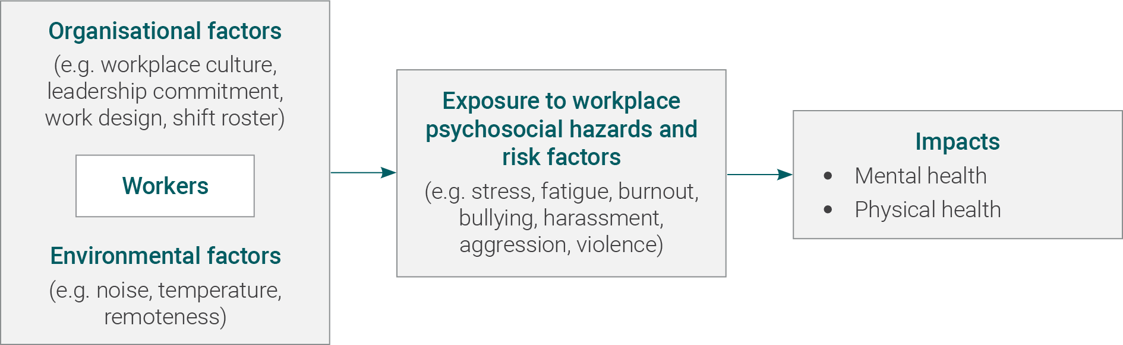

Figure 1.1 The influence of workplace conditions on workers’ health.

### Consulting workers

**WHS Act section 47**

Duty to consult workers

**WHS Act section 48**

Nature of consultation

As a PCBU, you must consult, so far as is reasonably practicable, with workers who carry out work for the business or undertaking and who are (or are likely to be) directly affected by a health and safety matter.

This duty to consult is based on the recognition that worker input and participation improves decision-making about health and safety matters and assists in reducing work-related injuries, diseases and illnesses.

The broad definition of a ‘worker’ under the WHS Act means a PCBU must consult, so far as is reasonably practicable, with contractors and subcontractors and their employees, on-hire workers, outworkers, apprentices, trainees, work experience students, volunteers and other people who are working for the PCBU and who are, or are likely to be, directly affected by a health and safety matter.

Workers are entitled to take part in consultations and to be represented in consultations by a health and safety representative who has been elected to represent their work group.

Workers usually know the hazards and risks associated with the plant they use. By drawing on the experience, knowledge and ideas of workers it is more likely hazards will be identified, so that effective control measures can be implemented.

Workers should be encouraged to report hazards and health and safety problems immediately so the risks can be managed before an incident occurs.

It is important to consult workers as early as possible when planning to introduce new plant or change the way plant is used.

### Consulting, cooperating and coordinating activities with other duty holders

**WHS Act section 46**

Duty to consult with other duty holders.

A PCBU must consult, cooperate and coordinate activities with all other persons who have a work health or safety duty in relation to the same matter, so far as is reasonably practicable.

There is often more than one business or undertaking involved in managing risks of plant in the workplace.

Each may have responsibility for the same health and safety matters, either because they are involved in the same activities or share the same workplace.

In these situations, each duty holder should exchange information to find out who is doing what and work together in a cooperative and coordinated way so risks are eliminated or minimised, so far as is reasonably practicable.

Further guidance on consultation requirements is available in the [Code of Practice: Work health and safety consultation, cooperation and coordination.](https://www.safeworkaustralia.gov.au/sites/default/files/2022-03/model%2520Code%2520of%2520Practice%2520-%2520WHS%2520consultation,%2520cooperation%2520and%2520coordination%2520-%2520February%25202022.pdf)

**Information, training, instruction and supervision**

**WHS Act section 19**

Primary duty of care

**WHS Mines Regulations r. 39**

Provision of information, training and instruction

**WHS Mines Regulations r. 204**

Control of risks arising from installation or commissioning

The WHS Act requires that a PCBU ensure, so far as reasonably practicable, the provision of any information, training, instruction, and supervision that is necessary to protect all persons from risks to their health and safety arising from work carried out as part of the conduct of the business or undertaking.

The PCBU must ensure that information, training, or instruction provided to a worker are suitable and adequate having regard to:

* the nature of the work carried out by the worker
* the nature of the risks associated with the work at the time of the information, training and instruction
* the control measures implemented

The PCBU must also ensure, so far as is reasonably practicable, that the information, training and instruction are provided in a way that is readily understandable for the person to whom it is provided.

Workers must be trained and have the appropriate skills to carry out a particular task safely. Training should be provided to workers by a competent person.

Before a PCBU’s workers or other persons use the plant in a workplace, a PCBU must, so far as is reasonably practicable, provide them with information, training, instruction and organise ongoing supervision as necessary to protect them from risks arising from the use of the plant.

As a PCBU you must also provide the necessary safety information to persons who are involved in installing, commissioning, testing, maintaining, or repairing plant, as well as decommissioning, dismantling, or disposing of plant. This should include information on the types of hazards and risks the plant may pose to the people when they are carrying out these activities.

This information may be supported with safe work procedures including instructions on:

* the correct use of guarding and other control measures
* how to safely access and operate the plant
* who may use an item of plant, for example, only authorised or licensed operators
* how to carry out inspections, shut-down, cleaning, repairs and maintenance
* traffic rules, rights of way, clearances, speed limits, and no-go areas for mobile plant
* procedures when plant malfunctions
* emergency procedures
* the proper use, wearing, storage and maintenance of PPE

Emergency instructions relating to an item of plant should be clearly displayed on or near it.

Training programs should be practical and ‘hands on’ and appropriate to the particular needs of workers. For example, literacy levels, work experience and specific skills required for safe use of the plant should all be considered.

Supervisors should take action to correct unsafe work practices associated with plant as soon as possible. Otherwise, workers may think unsafe work practices are acceptable.

## Appendix 7 The risk management process

**WHS Mines Regulations r. 5C**

Meaning of mine operator

**WHS Mines Regulations r. 7A**

References to person conducting a business or undertaking includes references to mine operators

**WHS Mines Regulations r. 34**

Duty to identify hazards.

**WHS Mines Regulations r. 35**

Managing risks to health and safety

**WHS Mines Regulations r. 36**

Hierarchy of control measures

**WHS Mines Regulations r. 37**

Maintenance of control measures

**WHS Mines Regulations r. 38**

Review of control measures

**WHS Mines Regulations r. 297**

Management of risks to health and safety

**WHS Mines Regulations r. 617**

Managing risks to health and safety

See also regulations 631, 631A, 631B, 631C, 631D, 635, 640, 641, 641A, 642A, 643A, 646, 657, 658 and 675EA in relation to complying with this regulation

**WHS Mines Regulations r. 621**

Duty to establish and implement mine safety management system.

**WHS Mines Regulations r. 621A**

General requirements for mine safety management system

Managing risk involves eliminating the risk, so far as is reasonably practicable. If this cannot be done, the risk must be minimised, so far as is reasonably practicable, by the use of effective controls that are based upon the hierarchy of control.

Effective risk management starts with a commitment to health and safety from those who operate and manage the business or undertaking. It also needs the involvement and cooperation of workers. The mine operator should create a culture where workers will be more likely to actively contribute to health and safety performance improvement activities.

Thought must be given to what could go wrong in a workplace and the possible consequences. Then all steps must be taken that are reasonably practicable to eliminate or minimise health and safety risks arising from a business or undertaking at a mine.

Risk management involves:

* identifying hazards – find out what could cause harm to health and safety
* assessing risks – understand the nature of the harm that could be caused by the hazard, how serious the harm could be and the likelihood of it happening making the changes necessary to eliminate the hazard or minimise the risk of injury or harm
* managing risks – so far as is reasonably practicable, eliminate the hazard and associated risk or, minimise the risk through the implementation of effective risk control measures based upon the hierarchy of control
* reviewing – control measures to ensure they are working as planned.

To start the risk management process, it is important to identify who should take part, the legislative requirements and information that may assist with the process.

## Identify the hazards

You must ensure an effective method is in place to systematically identify and regularly assess hazards to workers at your site. Identifying hazards can be achieved by dividing operations or systems into groups or even sub-groups.

To identify other hazards and to assess them, as well as assessing the principal hazards, there are a number of ways to undertake that process:

* physical inspections, testing and analysis: Inspect the workplace and identify where someone could get hurt. Conduct exploration drilling and test and analyse rock type and strength
* mine feasibility and planning studies
* task and process analysis: Identify the hazards involved in each task. This should include what happens when intervention is required (such as breakdowns). Identify hazards at each stage of the production process
* relevant matters and considerations from Work Health and Safety (Mines) Regulations
* use best practice guidelines and standards
* hazard and operability study (HAZOP)
* accident investigation analysis: Identify hazards and causes of harm from investigations involving similar types of work
* near miss, audit, or inspection analysis: Trends or common problems can be identified from near-miss reports, audits, or inspections. Analysis of these reports may show locations that are more dangerous and indicate problems with the design and layout of that work area or the way work is carried out there
* work environment monitoring (such as noise assessment, air quality assessment (dust))
* analytical techniques for calculating the hazard (such as geotechnical data for ground stability)
* historical mining activity that could potentially impact mining operations as the mine develops.

#### **Risk analysis and assessment**

The mine operator’s arrangements for managing risk must include an ongoing process for the selection and use of suitable methods for hazard identification and risk assessment. The risk management process should also establish the tolerable risk.

Managing risk involves eliminating the risk, so far as is reasonably practicable. If this is not able to be done, the risk must be minimised, so far as is reasonably practicable, by the use of effective controls that are based upon the hierarchy of control.

Some hazards pose such high levels of risk that control measures are prescribed by the WHS Act and WHS (Mines) Regulations. As a minimum, these prescribed controls must always be used, and be supplemented by additional controls to assist in further minimising the risk. Emerging hazards need to be risk assessed and the effectiveness of existing risk assessments and implemented controls evaluated, with the mine safety management system (MSMS) being updated to reflect any operational changes.

The risk level for each hazard is then determined by the potential consequence of an event and the likelihood of that consequence occurring. It is important to assess the effectiveness of existing controls prior to estimating consequence and likelihood.

Those undertaking a risk assessment must have the necessary information, training, knowledge and experience of:

* the operational environment (scale, complexity and physical environment of mining activities)
* operational processes (maintenance systems, work practices, interaction, separation)
* risk assessment training

#### **Hierarchy of risk control**

A combination of controls may be used to minimise risks, so far as is practicable, if a single control is not sufficient for the purpose. In many instances, it is likely that a combination of control measures will be needed.

When selecting controls, a mine operator should prioritise the implementation of preventative controls, where practicable. Any controls that minimise or otherwise lessen (mitigate) the consequences of the incident are only supplementary to prevention.

Where practicable, a risk must be eliminated, otherwise, the mine operator, in minimising risks to health and safety, must implement effective risk control measures to minimise risks so far as is reasonably practicable, by:

* substituting, wholly or partly, the hazard that creates a risk with something that gives rise to a lesser risk
* isolating the hazard from any person exposed to it
* implementing engineering controls.

The MSMS should contain reference to any design principles, engineering standards and technical standards relied upon for control measures. If a residual risk remains, the mine operator must further minimise the remaining risk by:

* implementing administrative controls
* ensuring personal protective equipment (PPE) is provided and used

The steps involved in risk management are shown in Figure 1.

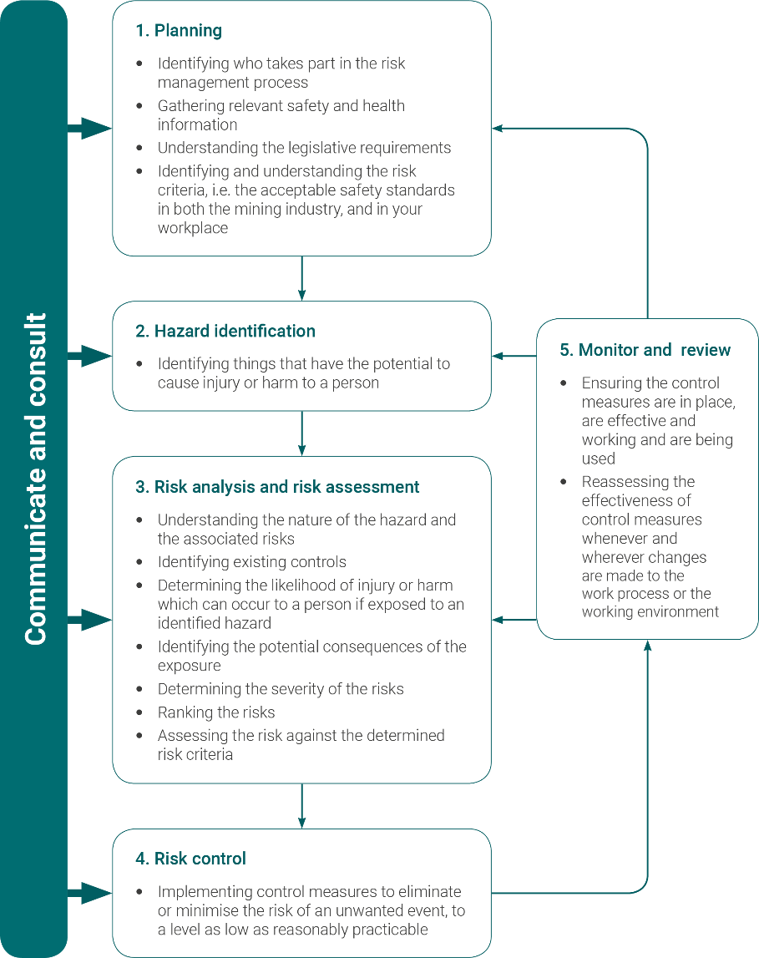

Figure 1 The risk management process (based on the international risk management standard   
AS/NZS ISO 31000 Risk management – Principles and guidelines)

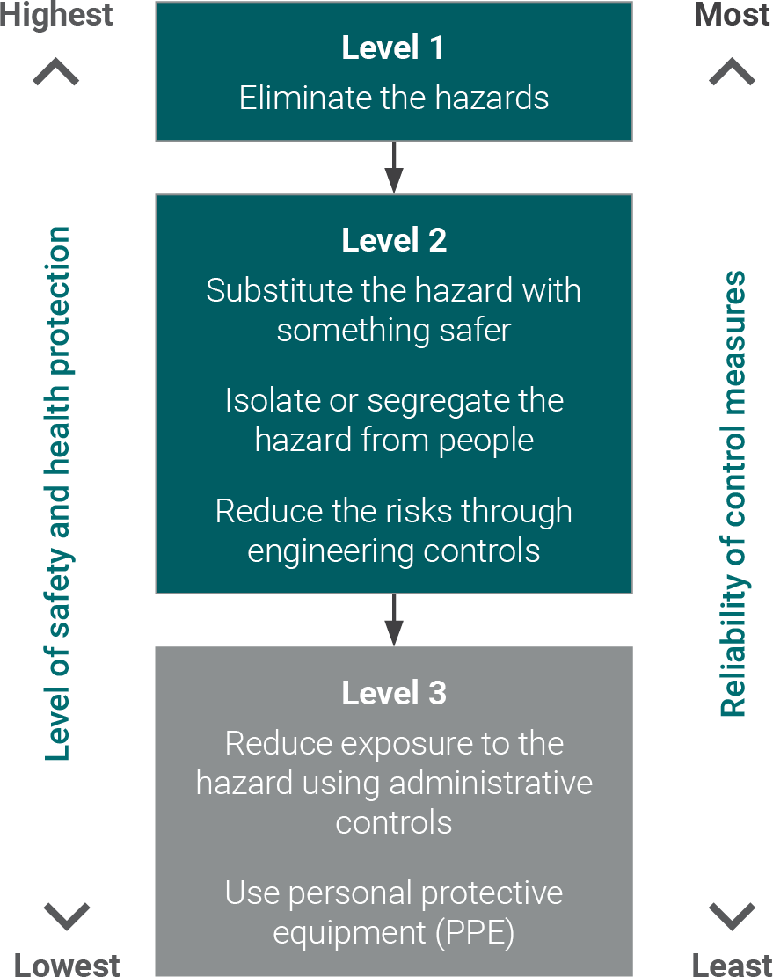

Figure 2 Hierarchy of control

#### **Monitoring and review**

To ensure the effectiveness of controls is maintained, a monitoring and review program should be implemented that includes inspections, testing and auditing of the controls documented in the traffic management plan. Chapter 5 of this code provides guidance on how to monitor, audit and improve the controls for road and traffic management in a mine site.

As part of the site’s validation process, responsibilities and accountabilities should be clearly defined and assigned, and may include independent auditing. The findings of the monitoring and review process should be used to:

* confirm the recommendations of previous reviews were actioned
* confirm responses were appropriate for any incidents or issues that arose
* verify compliance with specifications (inspection, monitoring, quality control)
* confirm site practices comply with the traffic management plan.

If significant gaps are identified, this should prompt a review of the risk assessment process

#### **Communication and consultation**

The WHS Act and WHS Mines Regulations prescribe the matters on which the mine operator and PCBUs must consult with workers.

As such, duties exist for the mine operator to consult with workers in relation to:

* the development, implementation and review of the MSMS for the mine
* conducting risk assessments for principal mining hazard management plans
* preparing, testing and reviewing the emergency plan for the mine
* the implementation of the workers’ safety role
* developing and implementing strategies to protect workers and other persons at the mine from any risk to health and safety.

The MSMS should set out how this safety role for workers will be achieved at the mine in practice. This may involve the mine operator considering how to give workers the opportunity to contribute, given, for example, factors such as the different types of work undertaken at the mine or how to involve contractors and their workers.

## Principal mining hazard management

**WHS Mines Regulations r. 627**

Identification of principal mining hazards and conduct of risk assessments.

A principal mining hazard (PMH) is any activity, process, procedure, plant, structure, substance, situation, or other circumstance relating to the carrying out of mining operations that has a reasonable potential to result in multiple fatalities. These may be in a single incident or a series of recurring incidents.

Principal hazards have been identified in legislation for special consideration because they are hazards that have the potential to cause an incident with very serious consequences, even when the likelihood of that incident occurring may be low.

The management of PMH’s is an important component of the MSMS, as they require special consideration due to the potential to create incidents with serious consequences.

The risks associated with PMH’s are not always obvious and much like the overall hazard, what is a risk today may not be so in the future or new risks may be introduced. Therefore, PMHs must be identified and then assessed both separately and in combination in order to identify any interactions that may flow from one risk to another.

#### **Risk assessment methods for an identified PMH**

Once a PMH has been identified, the mine operator must use appropriate risk assessment methods to investigate and analyse each PMH identified before developing the PMHMP.

Each risk assessment method and analysis process or technique has limitations and requires different levels of resources and detail. Some processes may be better suited to particular PMHs and types of mining operations than others.

Whatever the process chosen for a PMH, it should be logical, comprehensive, systematic, and repeatable, if it is to be effective.

A process is ‘comprehensive’ and ‘systematic’ when it includes all operations, activities, areas or phases of operations and addresses all aspects of the hazard (likelihood and consequence) carefully and applies the same process at each step.

The risk assessment must be conducted by a person or group that is competent to conduct the assessment, having regard to the nature of the hazard.

#### **Risk Controls**

Mine Operators should ensure that control measures identified in risk assessments are clearly defined to ensure that they are measurable and auditable, and to ensure that their intent or specification is clearly documented in the PMHMP.

The processes around identifying and assessing principal hazards are intended to ensure that the best control measures are adopted for managing the risks associated with the hazard.

Control measures are acts, objects (engineered) or systems (combination of act and object) that prevent or mitigate an unwanted event. Examples of control measures include automated devices, physical barriers and wearing Personal Protective Equipment (PPE). Control measures are required for the safe operation of the mine.

Control measures need to be designed appropriately for their purpose, put in place (installed, procedures developed and training provided), used by personnel and maintained to ensure the control measures work when needed. Maintaining a control measure might include testing and inspection of equipment items or reviewing procedures to ensure they reflect current practice and are understood by the people who use them.

#### **Critical Control**

Critical controls are controls that are crucial to preventing or mitigating the consequences of a PMH. The absence or failure of a critical control will significantly increase the risk of an PMH occurring, despite the existence of the other controls. They are considered important enough to warrant additional monitoring and reporting to ensure they are implemented and maintained to high levels of effectiveness.

Selecting the critical controls involves assessing all the controls to identify if they are critical. Selecting the critical controls is an important step. When selecting the critical controls consider how you identify them.

It is important to determine which of the control measures are critical to the management of the PMH, particularly if there are multiple control measures. The criticality of a measure has an important bearing on the maintenance frequency, test regime and management action if the measure has to be disabled. Some factors that might be considered that might indicate a critical control measure are:

* control measure is relied on to control a number of different significant hazards.
* control measure is relied on to prevent the most likely cause of significant incidents.
* control measure is relied on to reduce or mitigate incidents having potentially very severe consequences.
* other control measures that provide backup are known to be of poor reliability or effectiveness.
* there are a small number of barriers for a significant hazard.

#### **Control effectiveness**

For all control measures, a range of performance indicators is required, particularly for those controls deemed critical. The performance indicators measure both how well the controls are performing and how well the management system is monitoring and maintaining the controls. The performance indicators for control measures will generally relate to some standards or target levels of performance. The measures may be qualitative or quantitative and may include absolute targets allowing no deviation or targets which may have scope for limited tolerable deviation.

Define the critical controls’ objectives, performance requirements and how performance is verified in practice:

* define objectives and performance requirements for each critical control
* identify current activities that affect the critical control’s performance
* describe activities to verify performance and reporting requirements
* identify what would trigger immediate action to stop or change the operation and/or impose the performance of the critical control.

#### **Documenting your reason for controls**

Controls may be accepted for implementation, some may be rejected, and others may require further investigation before a decision can be made. The WHS (Mines) Regulations require the mine operator to document which control measures have been accepted for implementation and why, as well as which ones have been rejected and why. There are likely to be some control measures which require further investigation – these must be recorded too. Ensure a person is made responsible for implementation or further investigation and a due date is assigned.

The mine operator should be able to demonstrate that hazards associated with mining operations and traffic management are controlled so far as is practicable, with the risk assessment and management process formally documented in the operation’s hazard and risk registers. The documentation of this information forms the basis of the site’s traffic management plan and mine safety management system.

## Developing a principal mining hazard management plan

**WHS Mines Regulations r. 628**

Preparation of principal mining hazard management plan

Under the WHS Mines Regulations, roads and other areas where mobile plant operate are a principal mining hazard. A principal mining hazard management plan must be developed as part of the mine safety management system (MSMS) for the mine.

A principal mining hazard management plan (PMHMP) is a document that sets out how the mine operator will manage risks to workers’ health and safety associated with the PMH.

The mine operator must prepare a PMHMP for each PMH that has been identified at the mine. This not only includes the PMHs listed in the regulation, but also any additional hazards that the mine operator has identified, which have a potential to cause multiple fatalities in a single incident or a series or recurring incidents.

#### **Content of a principal mining hazard management plan**

Before preparing the PMHMP, the mine operator should consider how the PMHMP is to be established, implemented and integrated with other plans. The mine operator must ensure that the development and review as necessary, of the PMHMP, is undertaken in consultation with relevant workers and representatives.

Before the PMHMP is prepared, the mine operator should therefore consider:

* the relevant information required
* the size, nature, complexity and location of the operation
* identifying associated factors contributing to a PMH
* available engineering, operational and organisational control measures
* existing plans, procedures, and other controls
* any legacy monitoring data
* the intended audience – the PMHMP should be written in plain language that is easy to understand

The PMHMP must:

* identify and describe the hazard at the mining operation
* assess the risks of health and safety to workers from exposure to the hazard
* describe the control measures and implementation required to manage the risks associated with the hazard

#### **Preparing a principal mining hazard management plan**

When preparing a PMHMP, it must:

* provide for the management of all aspects of the risk controls relevant to the PMH
* be set out and expressed in a way that is easily understandable and made readily accessible for management, supervision and workers who use the PMHMP

With consideration to the above, the PMHMP must:

* describe the nature of the PMH to which the plan relates
* describe how the PMH relates to other hazards at the mine
* describe the analysis methods used in identifying the PMH to which the plan relates
* include a record of the risk assessment conducted in relation to the PMH
* describe all control measures to be implemented to manage risks to health and safety associated with the PMH
* describe the investigation and analysis methods used in determining the control methods to be implemented
* describe the arrangements in place for providing the information, training, instruction and supervision in relation to the nature of the PMH and the control measures implemented
* refer to any design principles, engineering standards and technical standards relied upon for control measures for the PMH
* set out the reasons for adopting or rejecting all control measures considered

All PMHMPs must form part of the MSMS for a site or organisation. In practice, these plans can be integrated by:

* updating the risk management procedure to include all hazards
* referencing PMHMPs in other relevant procedures
* referencing relevant work instructions, policies and procedures

The mine operator of a mine must ensure that each PMHMP is reviewed and where necessary revised if deficient or a risk control measure specified in the plan is revised. If a PMHMP is revised, the mine operator must record the revisions, including any revision of a risk assessment, in writing in the plan.

## PMHMP Review

**WHS Mines Regulations r. 629**

Review

**WHS Mines Regulations r. 623**

Performance standards and audit

Performance standards provide a reference comparison designed to enable operators to determine how effective are the planning, execution and implementation of the mine site’s PMHMP risk management.

Risks covered in the PMHMP must be controlled to as low as is reasonably practicable.

An example of a performance measure is an exposure standard that must not be exceeded. This is essentially a standard for personal exposure monitoring and health monitoring of workers.

When preparing a PMHMP, operators should include triggers for shutdown, review or investigation and ensure that any actions required for absent or ineffective control measures are documented.

#### **Use of trigger action response plans**

A trigger action response plan (TARP) is an integral part of a PMHMP that provides guidance on the actions to be taken by workers when a change in mine site conditions occur that are no longer considered normal.

However, a TARP should be put in place only after a risk assessment has verified the selection of the most effective control measures in relation to the hazard.

For a TARP to be applied effectively it should:

* consider actions to be taken at specified levels of risk, relative to the risk posed by the hazard
* be simple and robust to ensure immediate actions are understood and able to be implemented by workers
* consider the workers and equipment required to implement actions

#### **Auditing the PMHMP**

Competent people should undertake audits of the PMHMP on a regular basis. Operators should consider both internal and external audit programs. Audits need to examine the adequacy, implementation and compliance with the PMHMP.

The areas that may be audited include:

* hazard identification and risk assessment
* control effectiveness or verification data
* incident and injury reporting data
* workplace inspection data
* compliance with occupational exposure limits and biological indices.

The final audit report needs to include the findings of the audit, recommendations and the actions that will be taken to correct the issues raised. The person(s) responsible for implementing the corrections should be stated in the audit report.

Records of the audit of the PMHMP must be kept in accordance with requirements of the MSMS. Records should be made available to worker representatives.

## Roads and other areas where mobile plant operate

**Schedule 19 cl.4**

To determine if roads and other areas where mobile plant operate are a principal hazard, consider the following factors to decide if they can result in multiple deaths in a single incident, or can cause a series of recurring incidents. (Note: the probability of such an event actually happening is not relevant in determining if it is a principal hazard.):

* how a road or other vehicle operating area might feasibly fail and the likely consequences of a failure (such as collapse, slips).
* the type of vehicles using the road or other vehicle operating area
* the activities that are undertaken and the consequence of any interactions between vehicles and pedestrians, structures, or other vehicles. For example:
  + vehicles carrying passengers
  + light and heavy vehicle interactions
  + travelling under overhead power lines
  + loading over a cab where a driver may be present
* how a vehicle may lose control and the likely consequences (such as driver falling asleep, mechanical failure, dump over tip head, subsidence)
* the hazards on the road or other vehicle operating area (such as sharp corners, steep gradients, large drop-offs, etc.)
* any other hazard involving mobile plant

Use competent people for technical input and advice when considering whether the principal hazard exists as required.

A comprehensive and systematic risk assessment must be completed for the roads and other vehicle operating areas principal hazard. You must consider each principal hazard individually and also cumulatively with other hazards at the mine; for example, consider the impact of mechanical failure of mobile plant that uses roadways.

The PMHMP must include a risk assessment of the roads and other mobile plant operating areas.

The following matters from Schedule 19 (cl.4) of the WHS Mines Regulations must be considered in developing control measures to manage the risks associated with roads and other areas where mobile plant operate:

* the impact of road design and characteristics, including:
  + the road layout
  + the road width
  + the road gradient, including the change of gradient and the road’s cross slope
  + drainage
  + lighting
  + the road delineation (guideposts and road markings)
  + the driver line of sight when using the road
  + the radius of the curvature of the road
  + the side treatments of roads
* design of areas where mobile plant operates, including:
  + parking areas
  + the proximity of roads to overhead power lines and buildings and other structures
  + maintenance workshops
  + intersections
  + interaction with public roads and railways
* maintenance of roads and areas where mobile plant operate
* selection of mobile plant with safety features fit for the use for which the mobile plant is selected and the plant’s operating parameters, including driver line of sight, reversing sensors, cameras, mirrors, flashing or rotating lights and anticollision devices
* maintenance of mobile plant, including:
  + preventative maintenance
  + a system for reporting of early defects
  + a system for corrective actions
* traffic management, including dealing with:
  + the interaction between heavy and light mobile plant
  + pedestrians and mobile plant, including heavy mobile plant
  + temporary obstructions
  + changes in operating conditions
  + blind spots
  + visibility issues caused by dust, haze or a lack of light
  + interaction between externally controlled plant with other plant and pedestrians
  + communication
* operating procedures, including in relation to:
  + parking mobile plant on slopes and in production areas
  + driving in hazardous areas
  + issuing a warning before reversing or moving
  + dumping material from a height
* training and competence of persons carrying out maintenance on mobile plant
* training and competence of persons using roads and areas where mobile plant operate, including:
  + training on the use of mining roads
  + training on rules for using roads at the mine
  + authorisations to operate specific mobile plant in all or part of the mine
* providing and maintaining hazard and traffic control signs
* the interaction between mobile plant at an underground mine or quarry, including:
  + side and top clearance from workings
  + clearance from rock support, power lines, pipes, vent bags and other overhead items
  + hazards arising from using mobile plant near open holes or voids with a steep fall
  + control of traffic near sharp bends or narrow openings
* changes in operating conditions.

## Safety in design

Opportunities to create safer workplaces are most effective when identified, assessed and documented in the earliest phases of the product life cycle.

The most effective risk control measure is to eliminate the hazard. This is often cheaper and more practical to achieve early at the design or planning stage, rather than making changes later in the life cycle.

There are five principles that affect safe design.

**Principle 1: Persons with control**

The people who make decisions should be competent and understand that their decisions will affect the design of products, facilities, or processes, which means they can promote health and safety at the source.

**Principle 2: Product life cycle**

Safe design applies to every stage in the life cycle from conception through to disposal. It involves eliminating hazards or minimising risks as early in the life cycle as possible.

**Principle 3: Systematic risk management**

The consistent application of hazard identification, risk assessment and risk control processes is required to achieve safe design.

**Principle 4: Safe design knowledge and capability**

Knowledge and capability in safe design should be either demonstrated or acquired by persons with control over design.

**Principle 5: Information transfer**

Effective communication and documentation of design and risk control information between all persons involved in the phases of the life cycle is essential for the safe design approach.