Section 1: Submission details
Feedback form:
Consultation Regulatory Impact Statement

Dangerous Goods Safety Act 2004 and regulations reforms

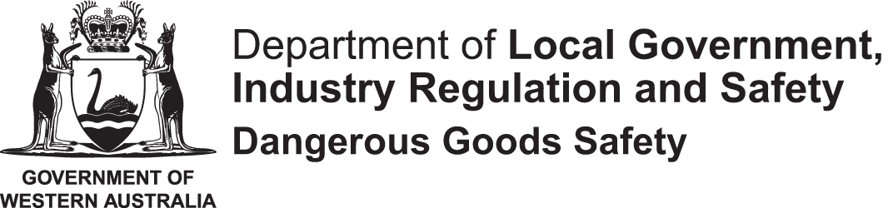

Full name
Organisation name
Email
Telephone
Role | ☐Individual  ☐Spokesperson (i.e. for dangerous goods operator)  ☐Representative (i.e. for industry representative or union body)  ☐Employee of dangerous goods operator
Please indicate the type of organisation you represent (select one of the following categories) | ☐Dangerous goods licensee  ☐Industry representative body  ☐Union body  ☐Other (enter details) | ☐Dangerous goods transport  ☐Accredited dangerous goods consultant  ☐Major hazard facility

Section 2: Permission details
Internet publication
A summary of public submissions may be published on the WorkSafe website, including any personal information of authors and/or other third parties contained in the submission.
Please tick this box if you do not consent to having the content of your submission published.
Anonymity
Please tick this box if you want to remain anonymous (that is, you do not consent to having your name or your organisation’s name published).
Third party personal information
Please tick this box if your input contains personal information of third party individuals, and strike out the statement that is not applicable in the following sentence:
The third party consents / does not consent to the publication of their information.

Before submitting as an email attachment please rename this file as follows: DG REFORMS - <YOUR NAME / ORGANISATION>

Respondents are asked to indicate their level of support using the following scale:

1 Strongly object | 2 Object somewhat | 3 Neither support nor object | 4 Support somewhat | 5 Strongly support

Proposal |  | Level of support | Comments and suggestions
Act amendments
3.1.1 | Include an object to the DGS Act.
3.1.2 | Match financial penalties with the equivalent offences in the WHS Act.
3.1.3 | Match imprisonment penalties with the equivalent offences in the WHS Act.
3.1.4 | Introduce a manslaughter offence.
3.1.5 | Include a provision to disallow insurance or other indemnities against fines.
3.1.6 | Include provisions for enforceable undertakings.
3.1.7 | Include an offence of assaulting, threatening, or intimidating a dangerous goods officer (DGO).
3.1.8 | Include an offence to impersonate a DGO.
3.1.9 | Amend the time limits applicable to issue an infringement notice.
3.1.10 | Remove the need to gazette DGO appointments.
3.1.11a | Amend the entry warrant rules in the DGS Act to include reference to obtaining assistance from a police officer.
3.1.11b | Amend the investigative powers in the DGS Act as they relate to obtaining documents or records to match those in the WHS Act.
3.1.12 | Include a confidentiality of information provision in the DGS Act.
3.1.13 | Include provision in the DGS Act to ensure no conflicts with the WHS Act.
3.1.14 | Align the statute of limitations for prosecutions under the DGS Act with the WHS Act – two years.
3.1.15 | Remove the need for approved codes of practice to be tabled in Parliament.
Regulation amendments - general
3.2.1 | Combine the DGS General Regulations, DGS S&H Regulations, DGS Explosives Regulations, DGS SSAN Regulations and DGS MHF Regulations into a single set of Dangerous Goods Safety Regulations.
3.2.2 | Allow operators flexibility to hold a single licence for multiple activities conducted at, or associated with, a site, or to hold multiple licences.
3.2.3 | Exempt operating battery energy storage systems from licensing.
3.2.4 | Regulate rural dangerous goods locations or small quantity dangerous goods locations under the WHS Regulations instead of the DGS SH Regulations.
3.2.5 | Exempt persons from needing to hold a fireworks operator licence or pyrotechnics (special use) licence if they hold a relevant contractor licence.
3.2.6 | Embed the effect of Dangerous Goods Exemption Notice No. 79 of 7 October 2022 into the DGS Explosives Regulations.
3.2.7 | Reduce the licence threshold for hydrogen facilities to 500 L.
3.2.8 | Align references to medical assessment standards between the DGS Transport Regulations and DGS Explosives Regulations.
3.2.9 | Align the duties for manufacturers and importers of explosives with those for other dangerous goods.
Major hazard facility regulation amendments
3.3.1a | Replace the term ’safety report’ with ’safety case’ in the DGS MHF Regulations.
3.3.1b | Adopt the wording for ‘modification’ from the Model WHS Regulations as the basis for defining what is a notifiable change in the DGS MHF Regulations.
3.2.2a | Widen definition of operator in the DGS MHF Regulations to mirror that in the model DGS WHS Regulations (i.e. include reference to the power to shut a facility down).
3.2.2b | Include in the DGS MHF Regulations the power for the Chief Officer to determine the operator if not satisfied that the nominated operator has both management control and the power to direct that the facility be shut down.
3.3.3a | Amend the explosives storage sites exemption under regulation3(2)(b) of the DGS MHF Regulations to allow ancillary licenced activities without triggering the potential for MHF classification.
3.3.3b | Amend the description of Class C MHFs to remove reference to dangerous goods storage.
3.3.3c | Remove the Class D MHF classification.
3.3.4 | Remove the major hazard facility classification for all explosives sites.
3.3.5 | Expand the options for revoking MHF classification to match all the elements of regulation 19 of the DGS MHF Regulations, and take into account factors other than just the quantity of Schedule 1 substances.
3.3.6 | Include the concept of validation in the DGS MHF Regulations as per regulation 67 of the WHS PAGEO Regulations.
3.3.7 | Require mandatory formal five-year safety report review.
3.3.8 | Substitute the term ‘notifiable quantity’ for ‘critical quantity’ in the DGS MHF Regulations.
Other proposals or suggestions

